Program Review Self-Study

Early Childhood Studies Major

February, 2025

Department of Early Childhood Studies
College of Education, Counseling & Ethnic Studies
Sonoma State University
Table of Contents
Section 1: Program Context and Curriculum 1
1. Brief Description of the ECS Major 1
2. Align Program Goals with Core Values and Strategic Priorities 2
3. Program learning outcomes (PLOs) alignment with WASC Core Competencies 4
4. Curriculum Alignment & Sequencing with PLOs 9
5. Program-Specific Pedagogical Approaches & Instructional Strategies 10
6. Other Learning Opportunities & Alignment with PLOs 14
7. Interdisciplinary Contributions & Program Integration with General Education 15
Section 2: Assessment 20
1. Assessing Student Performance in Program Learning Outcomes (PLOs) 20
Assessment activities 20
2. Summary of Student Learning Assessment 25
1) From Signature Assignments 25
2) From Senior Portfolio 36
3) From Exit Survey Data 44
3. Curriculum Changes Based on Assessment Findings 49
4. Other Evaluated Program Goals 51
5. Considerations for Assessment Improvement 52
Section 3: Faculty 54
1. ECS Faculty Specializations, Scholarship, & External Funding 54
2. Alignment with Program Curriculum, Mission, and Quality 57
3. Faculty Composition and Trends: Analyzing Changes, Challenges, and Capacity for Program Sustainability 59
1) The student-faculty ratio for teaching 61
2) Tenure Density 62
3) ECS advising 64
4. Evaluating Faculty Support: Workload, Mentorship, and Professional Development Opportunities 64
1) Availability of and participation in professional development opportunities 65
2) Mentoring 65
3) Debrief and Planning (DAP) meeting 66
4) Time allocation for course development, research, scholarship 66
5. Faculty Trends Going Forward 66
Section 4: Program Resources 68
1. Student Support at the Program & Institutional Level 68
2. Campus Support Services 68
3. Support for Student Research & Community Engagement 70
4. Library & Information Resources that Support Curricular & Research 71
5. Technology Resources that Support Teaching, Learning & Research 71
6. Instructional Spaces & Facilities 71
7. Staff Support for Program Operations 72
8. Future Budgetary Considerations & Resource Needs 73
Section 5: Student Success 74
1. Student Trends and Enrollment Strategy 74
1) Student Race/Ethnicity 81
2) Underrepresented minority (URM) Trends 82
3) Considerations on Future Enrollment Strategies 83
2. Retention and Graduation Trends & Improvement Plans 84
1) Retention trends 84
2) Time to Degree for FTFY ECS Students 86
3) Time to Degree for the Transfer ECS Students 87
4) Degrees Conferred 89
5) Considerations for Improving Retention and Graduation Rates in ECS 90
3. Student Applications, Admits, and Enrollments Trends 91
4. Student/Alumni Perceptions of the Program 93
Section 6 Reflection and Plan of Action 99
1. Program Strengths/Growth since the Previous Review 99
1) Student Success & Retention 99
2) Curriculum & Learning Experiences 99
3) Faculty & Research Excellence 100
2. Areas for Improvement/Challenges 100
1) Student Support & Retention 100
2) Advising & Academic Support 101
3) Curriculum & Fieldwork 101
4) Faculty Workload & Institutional Support 101
3. Potential Collaborations 102
4. Next Steps/Action Plans 102
1) Action Plans with Existing Resources 102
2) Actions Requiring Additional Resources 103

Section 1: Program Context and Curriculum

Brief Description of the ECS Major
The Early Childhood Studies (ECS) major started in Fall of 2012.
The B.A. with a major in Early Childhood Studies requires completion of a total of 120 units. Units fall into the following categories:
- 48 GE Units (For more information on GE units, see Sonoma State University General Education Website)
- 56-69 Major Units
- 35 ECS Core units for all concentrations
- Concentration requirements
- 21 units for the Early Care and Education Concentration
- 20 units for the Community, Health, and Social Services for Children Concentration
- 34 units for the Elementary Pre-Credential Concentration
- 34 units for the Special Education Teaching Concentration
- Electives from across the University (the number varies depending on how many courses double-count toward major electives and GE.)
The program currently offers four concentrations:
- The Early Care and Education concentration (ECE) prepares students for a career in Early Education settings, including: infant, toddler, and preschool classrooms; administrator of an Early Education program; Support services in education-related agencies that serve young children and their families. This option is also appropriate for students who want to pursue a Multiple Subject or Special Education teaching credential (requires completion of a post-baccalaureate Credential program)
- The Community, Health, and Social Services for Children Concentration (CHSSC) prepares students to work with children and adolescents in private and public, non-education programs. Students work with an advisor to prepare for a career in entry-level positions in social services or to pursue graduate studies in Social Work, Counseling, Child Life Specialist, or other fields.
- The Elementary Pre-Credential Concentration (EPC) prepares students to enter a Multiple Subject (Elementary) or Education Specialist (Special Education) Credential program after completion of the BA degree. Students complete coursework in Child Development, Education, and the subjects taught in elementary classrooms. Students who complete this concentration meet the subject matter requirement and the prerequisites for the Sonoma State University Multiple Subject and Education Specialist credential programs.
- The Special Education Teaching Concentration (SET) prepares students to earn a baccalaureate degree in ECS major and begin the Special Education Teaching Credential at the same time by taking coursework toward the credential courses within the undergraduate major. This concentration is organized to meet the subject matter requirements and prerequisites for SSU Multiple Subject and Special Education teaching credentials. Earning the full teaching credential will require 1-2 semesters of coursework after the BA is complete, including student teaching.
See the list of required core courses and electives in the Major Information Packet online at https://ecs.sonoma.edu/early-childhood-studies/early-childhood-studies-undergraduate-handbook
The Department of ECS offers a Master's (MA) program designed to deepen students' knowledge and expertise in early childhood education. The MAECE Program Learning Outcomes describe what graduates should be able to do after completing the program. These measures highlight the knowledge, skills, and dispositions all students are expected to have upon graduating from a specific program. However, this report will focus exclusively on the undergraduate program, and the MA program will not be addressed in detail.

Align Program Goals with Core Values and Strategic Priorities
Early Childhood Studies Mission Statement:
“The Department of Early Childhood Studies prepares knowledgeable and caring professionals who are committed to contributing to a society through high-quality education and social services for all children and families.”
The Bachelor of Arts Degree in Early Childhood Studies at Sonoma State University is dedicated to providing graduates with the knowledge, skills, and dispositions needed to work effectively with children in early childhood (birth to age 8). Students study multidisciplinary theories, research, and best practices, with an emphasis on diversity and social justice, in particular anti-racist and equity-centered approaches and socio-cultural factors that affect young children’s development. They learn how to apply theories and research from Anthropology, Child Development, Education, Health, Psychology, Sociology, and Ethnic Studies to promote the cognitive, social, emotional, and physical development of diverse young children in their communities from a diverse background. Students study the science of assessing children’s growth and development, and they acquire skills in effectively communicating these findings to families and community partners and developing intervention plans. The program also focuses on preparing professionals to be leaders and advocates on behalf of all children and families. ECS graduates work in a variety of fields, including as teachers (preschool, elementary, and special education), child life specialists, staff in community agencies, therapists, and social workers.
The Early Childhood program seeks to prepare graduates who:
- Are agents of individual growth and social change as well as models and advocates of the broader intellectual and social values of a democratic society
- Are knowledgeable and thoughtful about the field of early childhood education
- Promote physical, cognitive, social, emotional, and moral growth and learning in their professional work with young children, as well as respecting and encouraging the contributions of families and caregivers in the care and education of children and youth
- Design and carry out inclusive practices that respect human differences and aim to include all children and families
- Continually use inquiry, observation, study, and reflection to improve their professional practices.

The California State University system offers students two kinds of degrees related to Early Childhood Development and Education: Early Childhood Studies and Child Development. Three campuses offer a degree in Early Childhood Studies: CSU Channel Islands (housed in the School of Education), CSU Pomona (housed in the College of Education and Integrative Studies), and Sonoma State (housed in the School of Education formerly, now in the College of Education, Counseling, and Ethnic Studies). Among 23 CSU campuses, all except for CSU Maritime offer a degree in Early Childhood Studies, Child Development, or Child and Adolescent Development. These child development degrees are housed in Liberal Studies Departments, Schools of Social Sciences, and Schools of Education.
Similar to most of these programs across the CSU system, the SSU Early Childhood Studies program expects our students to work in the field of early care and education, pursue an elementary or special education teaching credential, or pursue graduate school for a career in social services, counseling, child life specialist, and more (such as in Speech and Language Pathologist, Behavioral Analyst, and Early Intervention Specialist). Faculty members in our program have been preparing students to teach in preschool (PK), Kindergarten (K), and elementary classrooms for decades. Accreditation by the Western Association of Schools and Colleges (WASC), campus and system practices, and various local and national accreditation systems ensure that ECE/CD programs use evidence-based evaluation to assess higher education’s desired learning outcomes and student competencies.
Our program mission is aligned with the mission of Sonoma State University and the College of Education, Counseling, and Ethnic Studies. The SSU mission focuses on preparing students to be life-long learners, appreciate diverse cultural perspectives, be active citizens and leaders, be prepared for fulfilling careers, and contribute to the well-being of the world community. Based on the SSU’s mission, there are four care values: Diversity and Social Justice; Sustainability and Environmental Inquiry; Connectivity and Community Engagement; Adaptability and Responsiveness. Those core values are integrated into each of the SSU’s strategic priorities: Student Success; Academic Excellence and Innovation; Leadership cultivation; and Transformative Impact (https://strategicplan.sonoma.edu/priorities).
The College of Education, Counseling, and Ethnic Studies is in the process of developing their new mission statement due to the SSU’s academic organization in 2024. The mission statement of the School of Education states to “The mission of the College of Education, Counseling, and Ethnic Studies at Sonoma State University is to advance excellence in the education and counseling professions, and to prepare students to become leaders and advocates for social justice.” (https://eces.sonoma.edu/about-us)
The courses that make up the ECS degree are designed to enable students to develop academic excellence, the knowledge, skills, and dispositions they need to meet the objectives of both Sonoma State University and the College of Education, Counseling, and Ethnic Studies. For example, all courses emphasize the importance of critical thinking, leadership skills and creative problem solution, and clear communication. Across our courses, instructors ask students to consider the perspectives of diverse families and communities, and support students to understand their role as advocates for children and families. In addition, the degree fulfills the criteria set forth by the National Association for the Education of Young Children (NAEYC, 2011). Alignment with these criteria allows our program to react quickly to evolving state requirements for ECE teacher certification since state requirements will themselves be closely aligned with the NAEYC criteria.

Program learning outcomes (PLOs) alignment with WASC Core Competencies
The program learning outcomes (PLOs) of the undergraduate Early Childhood Studies Program (see table 1-1 & 1-2 below) are aligned with the National Association for the Education of Young Children (NAEYC) standards for Initial Early Childhood Professional Preparation (NAEYC, 2011) and address WASC Core Competencies in written and oral communication, quantitative reasoning, critical thinking and information literacy. Table 1-1 presents POLs from (Fall 2023 and later) Table 1-2 presents PLOs from (Spring 2023 and earlier)
- Written communication: Most of the required courses in the major have a wide range of written assignments that are aligned with specific PLO’s, ranging from the discussion posts in Canvas to the elaborated and involved research reports in the upper division coursework. We designed these assignments to hone students’ writing skills, and evaluate them using the Standards for Critical and Thoughtful Writing (see Student handbook page 45). All signature assignments and course assignments are evaluated using the Professional Writing Rubric. For additional support as students develop their writing skills, we recommend that they also frequently visit the SSU Writing Center.

- Oral Communication: In all ECS courses students are required to make oral presentations to the class, in addition to participating in small group class discussions and reporting back to the class. For example, in EDEC 201 Foundations of Early Care and Education, students prepare and present a career study in class. In EDEC 270 Children and Families in Diverse Societies, students map types of capital with a particular community, in which young children live, work, and/or play, then present the project to class. In EDEC 460, Introduction to Research in Early Childhood Studies students prepare a report and a presentation about a topic they researched. The program-wide emphasis on building oral communication skills culminates in EDEC 478 with the Presentation of their Senior Portfolio to a group of faculty members and professionals from the community (see assessment rubric).

- Quantitative reasoning: All ECS students have to complete 48 units of GE courses, which include 3-4 units of Mathematical Concepts and Quantitative Reasoning in lower division GE courses and 3-4 units of Scientific Inquiry & Quantitative Reasoning in upper division GE courses. Students also learn to evaluate, at a beginning level, the quantitative aspects of early childhood research in major core class EDEC 460 Introduction to Research in Early Childhood Studies. Depending upon individual concentrations, students have options to take additional units in quantitative reasoning. For example, students under the Elementary Pre-credential concentration take MATH 150 and 300A.
- Critical Thinking: A key goal of the Early Childhood Studies Department is to support students as they continue to develop their critical thinking skills. Professionals who work with children and families embrace opportunities throughout their careers to thoughtfully analyze and resolve meaningful challenges, making a positive impact on those they serve. Therefore, in all ECS courses, we expect that students use and build upon the skills they learned in their freshman critical thinking class (Area A3 of the SSU GE pattern).
In addition, all ECS core courses use the Early Childhood Studies Framework for Critical Reflection to guide both the assessment of student work and the design of learning activities. This framework indicates key concepts students should consider as they complete readings and assignments for their ECS coursework (see page 42 of ECS Student Handbook). Students are introduced to the Critical Reflection Framework in EDEC 178 Introduction to the Early Childhood Studies Major and Portfolio. All signature assignments are assessed on critical thinking using a common rubric (see rubric).
- Information Literacy: Starting their freshmen year, students gradually identify and apply principles and strategies to find, evaluate and use a variety of empirical resources. They demonstrate their ability to use a variety of research sources, both print and electronic in English 101, and in all EDEC courses. They interpret research, applying their findings and interpretations to construct their own reports and narratives, especially when they take English 101, EDEC 201, EDEC 460, and EDEC 435. They understand the importance of citing research sources, using recognizable and accepted conventions for doing so in ENGL 101, EDEC 178, EDEC 201, and all EDEC courses.
Table 1-1. Early Childhood Studies Major Program Learning Outcomes (Fall 2023 and later)
Early Care and  Education  Concentration  (Previously Early Childhood Education Concentration) | Community, Health, and Social Services Concentration  (Previously Early Childhood Development  Concentration) | Elementary Pre-Credential Concentration | Early Childhood Studies: Special Education Teaching Concentration  (Previously Integrated Teacher Education Program in Special Education [ITEP-SE])
PLO1. Students apply their understanding of child development theories and research to effectively promote child growth, health, and learning in ways that are equitable and socially just.
PLO2. Students analyze and reflect on components for building just and reciprocal family and community relationships in their work with young children.
PLO3. Students practice ethical assessment that is developmentally appropriate, culturally sustaining, and linguistically responsive to support the positive growth and development of children; they communicate these findings effectively and professionally.
PLO4. Students observe, analyze, design, and reflect on developmentally appropriate and socially and environmentally just curricula and environments. These culturally and linguistically sustaining curricula and environments align with state early learning standards for children in programs serving infants, toddlers, preschoolers, and TK-3 students. | PLO4. Students analyze and reflect on developmentally appropriate, culturally and linguistically sustaining, and socially just practices that promote and protect the development and health of children and their families. These practices align with professional standards in fields such as social work, mental health, child life, and early care and education. | PLO4. Students observe, analyze, design, and reflect on developmentally appropriate and socially and environmentally just curricula and environments. These culturally and linguistically sustaining curricula and environments align with state early learning standards for children in programs serving infants, toddlers, preschoolers, and TK-6 students. | NA
PLO5. Students exhibit the following knowledge, skills, and dispositions:
understanding and upholding ethical, equitable, and professional standards; engaging in continuous, collaborative learning to inform practice; accessing professional resources; integrating informed and critical perspectives into their work with young children; and engaging in informed advocacy to promote anti-racist and just practices in programs that serve young children and their families.
PLO6. Students observe and practice their developing skills in different kinds of early childhood educational settings. | PLO6. Students observe and practice their developing skills in different kinds of programs that support children and families. | PLO6. Students observe and practice their developing skills in different kinds of childhood educational settings  PLO7. Students develop subject matter competence appropriate for a beginning teacher in the following disciplines: Human Development, Language Studies, Literature, Mathematics, Science, Social Studies, History, Arts, and Physical Education. | PLO6. Students observe and practice their developing skills in different kinds of educational settings.
In addition to the above PLO’s, students in the ECS Major are expected to meet the following learning objectives in all courses:
- Produce writing that meets the ECS Standards for Critical and Thoughtful Writing.
- Demonstrate intellectual rigor in all course assignments, utilizing the ECS Framework for Critical Reflection.

Table 1-2. Early Childhood Studies Student Learning Outcomes (Spring 2023 and earlier)
Concentration  Early Childhood Education | Concentration 2  Early Childhood Development | Concentration 3  ITEP in Special Education
SLO1. Students are knowledgeable about theories and research related to child development and growth, and they are able to effectively promote child development and learning. | SLO1. Students are knowledgeable about theories and research related to child development and growth, and they are able to effectively promote practices that support optimal child development and health (including mental health). | SLO1. Students are knowledgeable about theories and research related to child development and growth, and they are able to effectively promote child development and learning.
SLO2. Students understand the components and importance of building family and community relationships in work with young children. | SLO2. Students understand the components and importance of building family and community relationships in work with young children. | SLO2. Students understand the components and importance of building family and community relationships in work with young children.
SLO3. Students understand the importance of and are able to observe, document, and assess the growth and development of young children; students are able to effectively communicate these findings to families. | SLO3. Students understand the importance of and are able to observe, document, and assess the growth and development of young children; students are able to effectively communicate these findings to families. | SLO3. Students understand the importance of and are able to observe, document, and assess the growth and development of young children; students are able to effectively communicate these findings to families.
SLO4. Students know how to use developmentally and culturally appropriate and effective approaches with young children, and they reflect upon professional practices. | SLO4. Students know how to use developmentally and culturally appropriate and effective approaches with young children, and they reflect upon professional practices. | SLO4. Students know how to use developmentally and culturally appropriate and effective approaches with young children, and they reflect upon professional practices.
SLO5. Students design, implement, and evaluate effective curriculum that aligns with state early learning standards for children in programs serving infants, toddlers, and preschoolers. | SLO5. Students identify and evaluate effective practices in programs that promote and protect development and health of infants, toddlers, preschoolers, and children in the middle childhood years. | Students design, implement, and evaluate effective curriculum that aligns with California Standards for the Teaching Profession for children with special needs.
SLO6. Students see themselves as professionals and exhibit the following knowledge, skills, and dispositions: understanding and upholding ethical and professional standards; engaging in continuous, collaborative learning to inform practice; understanding where to find professional resources; integrating informed and critical perspectives into their work with young children; and engaging in informed advocacy for young children and their families. | SLO6. Students see themselves as professionals and exhibit the following knowledge, skills, and dispositions: understanding and upholding ethical and professional standards; engaging in continuous, collaborative learning to inform practice; understanding where to find professional resources; integrating informed and critical perspectives into their work with young children; and engaging in informed advocacy for young children and their families. | SLO6. Students see themselves as professionals and exhibit the following knowledge, skills, and dispositions: understanding and upholding ethical and professional standards; engaging in continuous, collaborative learning to inform practice; understanding where to find professional resources; integrating informed and critical perspectives into their work with young children; and engaging in informed advocacy for young children and their families.
SLO7. Students observe and practice their developing skills in different kinds of early childhood educational settings. | SLO7. Students observe and practice their developing skills in different kinds of programs that support children and families. | SLO7. Students observe and practice their developing skills in different kinds of educational settings.
In addition to the above SLO’s, students in the ECS Major are expected to meet the following learning objectives:  1. Produce writing that meets the ECS Standards for Critical and Thoughtful Writing (standards are on page 19-20).  2. Demonstrate intellectual rigor in all course assignments, utilizing the ECS Framework for Critical Reflection (framework is on page 21-22). | In addition to the above SLO’s, students in the ECS Major are expected to meet the following learning objectives:  1. Produce writing that meets the ECS Standards for Critical and Thoughtful Writing (standards are on page 19-20).  2. Demonstrate intellectual rigor in all course assignments, utilizing the ECS Framework for Critical Reflection (framework is on page 21-22). | In addition to the above SLO’s, students in the ECS Major are expected to meet the following learning objectives:  1. Produce writing that meets the ECS Standards for Critical and Thoughtful Writing (standards are on page 19-20).  2. Demonstrate intellectual rigor in all course assignments, utilizing the ECS Framework for Critical Reflection (framework is on page 21-22).

California Teacher Performance Expectations (TPEs) – these apply only to students in the ITEP-Special Education Concentration

Curriculum Alignment & Sequencing with PLOs
The program learning outcomes (PLOs) for the ECS program have evolved to better align with the varied concentrations, reflecting a shift toward more nuanced and specialized objectives. The current PLOs, effective from Fall 2023, emphasize a broader, equity-focused approach to early childhood care and education, integrating social justice, cultural sustainability, and equity practices across all concentrations. For example, PLO1 now specifically references "equitable and socially just" child development practices across all concentrations. PLO2 has been broadened to include not just family and community relationships but also reflection on the components of building "just and reciprocal" relationships. In PLO3 and 4, we adopted "culturally sustaining" approaches, reflecting a shift toward practices that support children’s cultural and linguistic backgrounds as a core component.
In addition, the current PLOs highlight competencies unique to each concentration. For example, the Early Care and Education and Elementary Pre-Credential concentrations have PLO4 focusing on curricula aligned with state early learning standards, while the Community Health and Social Services (CHSS) concentration tailors PLO4 to practices aligned with professional standards in fields like social work and mental health. The Special Education Teaching (SET) concentration differs by excluding this curriculum design focus.
In this curriculum map, we aligned courses with specific PLOs for each concentration to ensure that students engage with the learning outcomes in a structured way. For example, across concentrations, EDEC 110 and 178 are prerequisites to other major courses. For EDEC 110, students are introduced to foundational concepts (noted by the "I" in the map), such as understanding child development theories (PLO1) and observing and analyzing developmentally appropriate practices (PLO2). This helps ensure that students are systematically introduced to key concepts early in the program, with later courses building on this foundational knowledge.
We map the curriculum so that lower-level courses introduce key concepts while upper-level courses build on them through practical application, progressively deepening student engagement with the PLOs. By offering introductory ("I") and more advanced ("D" for developing, "M" for mastering) levels of engagement across the program, the curriculum is designed to ensure that students master all PLOs by the end of their program. The map allows faculty and administrators to clearly see where gaps or redundancies may occur and to make adjustments as needed.
In each course, course objectives are listed in each syllabus and aligned with the respective PLOs (see course syllabi). This example for EDEC 201 Foundations of Early Care and Education illustrates how course objectives are connected to PLO’s.
- Describe how views of childhood, theories of child development, and classrooms supporting young children have changed over time, including historical antecedents and the role of influential thinkers in advancing social justice for children and families. (PLO1 and PLO4)

- Identify practices and principles in a variety of early childhood settings that foster children’s development and learning and include the varying cultural experiences of children. (PLO1, PLO4 and PLO6)
- Demonstrate knowledge of the role of early childhood professionals in children’s lives and the ethical and professional principles that guide them. (PLO1 and PLO6)
- Investigate different careers that involve working with young children. Construct a preliminary professional philosophy and career plan. (PLO1, PLO2, PLO4 and PLO6)
- Explore contemporary issues and concerns that affect children and their families with a focus on unequal practices and structures that impact the well-being of diverse populations. (PLO1, PLO2, PLO4 and PLO6).
- Demonstrate intellectual rigor in all course assignments, utilizing the ECS Framework for Critical Reflection, found in the ECS Student Handbook. (PLO6).
- Produce writing that meets the ECS Standards for Critical and Thoughtful Writing, found in the ECS Student Handbook. (PLO6)

This structured progression enables students to gradually develop their curriculum design skills, taking on increasingly complex challenges and gaining greater autonomy as they advance through the concentration. For example, PLO4 in Early Care and Education concentration focuses on students' ability to "observe, analyze, design, and reflect on developmentally appropriate and socially and environmentally just curricula and environments." PLO 4 is addressed progressively across different courses in the concentration as follows:
- In EDEC 290/290L and EDEC 291/291L, students engage with PLO4 at the "Developing" (D) level. These courses allow students to start developing their ability to work with curricula and environments in ways that align with early learning standards and are culturally and linguistically appropriate.

- In EDSP 432, students engage with PLO4 at the "Mastery" (M) level. Here, they are expected to demonstrate their ability to design and reflect on curricula and environments that are socially and environmentally just, drawing on their foundational knowledge and skills.

Program-Specific Pedagogical Approaches & Instructional Strategies
The pedagogical methods used are inspired by the constructivist and sociocultural approach to learning and teaching and aim to fulfill the social justice mission of the Department and the College of Education, Counseling, and Ethnic Studies.
- Active student engagement and community-based practices: Across the department, we value active student engagement with an instructor-student ratio of up to 1:30. We utilize hands-on pedagogies, such as video analysis and subsequent discussion, mini-project design, and group poster work, where students collaborate with their peers to deepen their learning to answer questions collaboratively. Students also develop critical thinking questions about the readings using question stems. As they progress through the ECS program, we scaffold their learning, encouraging them to bring questions based on assigned readings that reflect their interests and identities. We also incorporate the Socratic method in small group sessions to promote meaningful interactions and diverse perspectives, enhancing collaborative problem-solving and creative thinking skills
- Learning community: Learning communities help build and expand students’ professional and personal networks and promote academic achievement, retention, and motivation. We offer two first-year and one second-year learning community courses (EDEC 178, EDEC 160 A/B for first-year students, EDEC 260 for second-year students). In addition, some EDEC courses implement mindfulness practices and connection circles to help students build a sense of community, manage stress and anxiety, and enhance learning engagement.
- Relational Learning and Peer Mentoring: We prioritize building positive, collaborative relationships between instructors and students, shifting away from a traditional teacher-centered model. This student-focused approach fosters an environment where learners feel valued, actively participate, and take responsibility for their own growth, while instructors serve as facilitators. To further support this relational framework, we employ peer mentors in learning community courses, providing first-year and second-year students with guidance and a sense of community. Through shared experiences, both mentors and mentees develop leadership and communication skills, ultimately enhancing their academic and professional competencies.
- Reflective practices: Students reflect on their own learning and help each other use these reflections to set goals across the courses. In EDEC 478, Senior portfolio class, students have a semester-long opportunity to reflect upon their signature assignments and their growth in mastering the ECS PLOs and write a series of reflection entries to assess their growth on a given learning outcome. At the end of EDEC 478, students will gather the reflection entries for their senior portfolio presentation, and give a short presentation to showcase their milestones.
- Integrating prior knowledge: Building on students’ prior knowledge and experience is central to our curriculum, introducing new content by connecting it to students' backgrounds. We promote opportunities for students to relate their understanding of issues and construct new knowledge through self-reflection and culturally responsive approaches that value their diverse experiences. Utilizing funds of knowledge, we recognize these backgrounds as strengths. Many courses also include a field component, incorporating active, hands-on learning strategies that enhance learner engagement and agency.
- Critical thinking: In all ECS courses, we implement the Critical Thinking Wheel (CTW) to guide assignments and discussions, providing a framework for critical analysis. For example, In EDEC 201, students use the CTW to firstly craft speaker’s notes, then eventually compose research papers. In many courses, active discussion was used to guide students as they explored and reflected on their own beliefs and opinions. Through hands-on activities, individualized discussion, and whole-class conversations, students deeply develop skills concerning critical thinking, interdisciplinarity, integration and information literacy.
- Field experiences and supervised practicum: We have several field experience courses that provide students with valuable opportunities to deepen their understanding of child development through hands-on learning (e.g. EDEC 220, 290/290L, 291/291L, 347, 437, and EDSP 432). Students engage in observation and assessment, applying theories and research in practice. They learn various observation techniques to assess a child’s growth, prepare child development syntheses, and interview families of children with support needs. Additionally, students design ideal environments and activities for different age groups, such as infants, toddlers, and preschoolers, while identifying community resources for families. In courses like EDEC 290L and 291L, students gain practical experience in planning and implementing justice-oriented, inclusive, and developmentally appropriate curriculum for young children from birth to 36 months.
- Critical pedagogy: We encourage students to reflect on how their professional practices influence the broader societal system. In the advocacy course (EDEC 435), for instance, students design and implement community advocacy projects, such as writing letters to elected officials, revising workplace curricula or policies, and collaborating with local agencies to achieve shared goals. In EDEC 450, students explore theories of second language acquisition by investigating a familiar school district. They analyze the strengths and limitations of resources and policies supporting multilingual learners and their families, linking their learning to broader systemic implications. This comprehensive approach deepens students' understanding of how their personal practices shape and are shaped by broader societal outcomes.
- Inclusive Practices and Diverse Perspectives: Our faculty’s diverse expertise, cultural backgrounds, and linguistic experiences shape both what and how we teach, ensuring that students benefit from multiple perspectives. By promoting inclusive education and celebrating the varied identities of our students, we foster a sense of belonging and encourage engagement with different viewpoints—leading to a deeper understanding of course material and its real-world implications. In Fall 2023, we removed impaction status to expand equitable access for historically underrepresented and low-income communities, as well as first-generation college students. This decision aligns with our mission to support all students in their educational journeys. We continue to analyze student demographics and assessment data to inform our practices and strengthen our inclusive academic community.
- Universal design: We use universal methods that support students’ various learning approaches and differential needs, including offering visual support, scaffolding the use of a professional language, and assignments that support their learning. Driven by adult development theories such as self-determination theory, instructors often give students choices in formats to articulate their ideas. Some examples are visual representations, videos, group presentations, and infographic presentations. Student assignments allow students to communicate their ideas based on their strengths and receive feedback from their peers.
- Equity-centered approach: We address systemic and institutional barriers faced by children with mild to moderate support needs, multilingual learners, and those from underrepresented groups. These themes are integrated throughout our courses, with students held accountable for applying these concepts through signature assignments aligned with Student Learning Outcomes. We emphasize that a "one size fits all" curriculum does not foster learning and equity. Students are encouraged to understand and appreciate diverse backgrounds, challenge barriers, and develop critical thinking skills. We invite them to consider the impact of various strategies on different groups in society, focusing on income and minority status—prompting questions about who wins and who loses. In addition, we ask students to consider how non-visible features of a classroom might affect how they view a topic and how they learn. For example, the arrangement of desks may hamper a true give-and-take of ideas or reliance on all-white authors ignores the contributions of all ethnic groups to an area of study.
- Support transfer students: Transfer students, who tend to be first-generation college students, should be supported to easily move into the major and have their lower division early childhood coursework recognized for our ECS major. To address this, we aligned the program with the early childhood courses at the community college level under the Curriculum Alignment Project (CAP 8). We collaborate with local community colleges and other community partners in the field to make sure that the prospective transfers know about the pathway from their junior college to our program as well as academic student support resources available at the SSU campus (i.e., Counseling Services, Disability Services, and the Learning and Academic Resource Center). Additionally, we offer both in-person and online orientation sessions, assist with course registration, and provide ongoing follow-up with faculty advisors to ensure a smooth and successful transition.
- Targeted preparation: The ECS major offers four concentrations—ECE, CHSSC, EPC, and SET—designed to equip students with the knowledge, skills, field experiences, and dispositions needed for a range of career options. To further prepare students for success after graduation, we offer courses such as EDEC 492, "Pursuing a Career in Teaching," and EDEC 483, "Pursuing a Career Working with Children & Families," where students explore graduate programs, learn application processes, and develop professional cover letters and resumes. Additionally, three introductory courses through CSU Fully Online, taught by certified Child Life Specialists with clinical experience, help students qualify for Child Life Specialist Certification. Our curriculum also provides clear pathways for students to enter credential programs. Throughout the program, students build essential skills in reflective practice, critical thinking, and effective communication with young children. We enhance career readiness by inviting guest speakers—including early intervention specialists and speech-language pathologists—and by sending job announcements to connect students with professional opportunities.
- Varied teaching modality: Courses in our program are taught through a variety of modalities, including face-to-face, synchronous, asynchronous, and bi-synchronous online. The varied modality enhances student accessibility to learning that meets their needs, strengths, and responsibilities in their life. Most faculty engaged in professional development to learn about strategies and techniques for high-quality and effective teaching practices across modalities.
- Intentional learning environment: We developed a thoughtfully designed classroom that fosters collaboration and hands-on learning. For example, table arrangement facilitates group work, equipment supports multimedia content, ample space, and features like sinks and storage enable us to incorporate hands-on activities and engage in experiential learning.
- Alternative assessment: In our program, we employ a combination of alternative assessment methods. For example, in EDEC 160, self-assessment is utilized where the instructor asks students to grade themselves on their participation in Socratic seminars, encouraging personal accountability and self-reflection. In EDEC 411, we implement degrading, allowing students to receive constructive feedback on their work, which they can use to enhance their understanding and skills. Additionally, we incorporate communal feedback loops, where instructors provide an overview of what the entire class excelled at and areas for improvement, fostering a sense of community among learners.

Other Learning Opportunities & Alignment with PLOs
  - Community experiences: Students in the early childhood education program gain valuable practical knowledge through various community experiences and site visits that prepare them for their future careers. In EDEC 201, they shadow a professional in early childhood education, gaining firsthand insights into the profession while touring the environment and asking questions to deepen their understanding. During their career exploration, students visit additional sites, focusing on gathering information rather than shadowing a professional for a full day. Similarly, in EDEC 435, students attend meetings within the early childhood education community, and in EDSP 432, they observe a full-inclusion classroom and interview parents.
  - Field Experiences: Two core courses in the program include a field experience component, allowing students to observe and engage with local programs for children and families while applying concepts learned in class. Field placements are available in preschools and public schools (Transitional Kindergarten to grade three). We have designed field experiences to align with different concentrations. For example, in the ECE concentration aimed at students pursuing careers in teaching young children, students complete three field experience courses, two of which involve supervised practicum. Together, these courses offer at least 114 hours of experience covering ages from infancy to early primary grade. In the CHSS Concentration, students are required to complete 45 hours of field experience at an approved agency or organization that supports children in non-educational or non-childcare settings.
  - Study abroad: We support students in study abroad programs and help them to choose courses that can be applied to the ECS major. For example, we have identified the courses offered by the Community, Health and Social Services Concentration in Denmark and the Early Childhood Program in Australia that can be applied to the ECS major. We also work collaboratively with the International Office to provide consultations for students on choosing appropriate courses.
  - Research experience: We encourage students to engage in faculty research. A few examples of faculty-student research collaboration are: Drs. Amini Virmani and Rabadi-Raol mentored undergraduate students through Koret Scholarship. Dr. Schonleber engaged student researchers on a project on how early childhood educators' perceptions of their ability to teach natural sciences changed through professional development. It is the goal of our faculty members to continue to include students in research projects.

Interdisciplinary Contributions & Program Integration with General Education
The Early Childhood Studies (ECS) program serves other programs at Sonoma State University in multiple ways. First, we offer a Minor in Early Childhood Studies, which provides students from any major with the opportunity to specialize in early childhood development and learning. This minor is beneficial for those interested in careers working with young children in fields like education, social work, psychology, nursing, and more. The minor requires five core courses and six elective units (totaling 24 units), with the option for students to tailor electives toward earning a California Child Development Permit or meeting prerequisites for the Multiple Subjects Teaching Credential program. The ECS minor thus plays an integral role in supporting students from various disciplines who wish to integrate early childhood expertise into their professional pursuits. We also offer an Education minor for students who want to work with older elementary, middle school, or high school students. It is also a great choice for anyone who is generally interested in education or who anticipates that education might be a significant part of their career (museum docent, park ranger, trainer, etc.)
The ECS program offers five courses that are required for the Minor in Education. This minor provides students with focused experience and foundational knowledge in the field of education, making it ideal for those interested in teaching in both public and private schools. Additionally, it is valuable for students pursuing educational roles in non-classroom environments such as parks and recreation programs, museums, or other educational settings. This contribution underscores the ECS program’s role in supporting broader educational pathways and career preparation for a diverse range of students.
Secondly, the ECS program contributes directly to the GE program through courses like EDEC 110 Understanding Development: Birth through Adolescence, which fulfills GE Category E (Life-Long Learning & Self Development). This course allows students from across the university to study child development and apply theoretical knowledge to diverse childhood experiences. We also offer EDEC 250, 260 and 160A/B that meet GE requirements.
The ECS program also contributes to credential programs by offering two key concentrations that feed into the Multiple Subject and Educational Specialist credential programs. The Elementary Pre-Credential Concentration (EPC) and the Special Education Teaching Concentration (SET) provide students with the subject matter knowledge and prerequisites needed for these credential programs. Through these concentrations, ECS helps prepare future educators with the necessary skills to pursue teaching credentials after completing their bachelor’s degrees.
Other programs, such as special education, psychology, arts, history, and mathematics, also contribute to the ECS Major. ECS students are required to take university electives from a wide variety of departments to meet their major and concentration requirements. For instance, students in the EPC concentration must take up to 20 units from other departments, while the Special Education concentration requires 33 units of coursework outside the ECS program.
- Program Progress since the Last Review
The last program review highlighted several strengths in the ECS Department, including a high-quality, intentionally designed curriculum aligned with NAEYC standards, effective use of assessment data to drive continuous improvement, and strong leadership contributing to rapid program growth (see the previous review report here). The review also identified areas needing improvement:
- Faculty and Advising: There was an uneven quality in faculty instruction and advising. Students reported inconsistent experiences across courses and challenges, particularly among transfer students who received limited support during their transition to SSU.
- Classroom Environment: The current classroom spaces were found to be inadequate for the hands-on, messy, and collaborative learning essential for preparing early childhood professionals.
- Field-Based Learning: The capacity of the existing Children’s School is insufficient to meet new field placement requirements driven by state standards. This shortfall places additional pressure on faculty and limits students’ opportunities for essential practical experiences.
Based on these findings, the review recommended the following actions:
- Enhance Faculty Hiring: Increase funding for tenure/tenure-track positions, focusing on recruiting diverse candidates to reduce workload disparities and improve teaching and advising consistency.
- Improve Advising Services: Allocate dedicated funds to enhance advising, especially for transfer students, to support smoother transitions and bolster four-year graduation rates.
- Upgrade Classroom Facilities: Provide dedicated, well-equipped classroom spaces that support hands-on, collaborative learning activities. These spaces should also have consistent room assignments and sufficient storage.
- Expand Field-Based Learning: Consider constructing a new Children’s School to accommodate additional lab placements and appoint a field placement coordinator to ensure placements meet state requirements and quality standards.
In response to the recommendations, we made the following changes outlined in Table 1-3.

Table 1-3. Program Progress regarding Last Review Recommendations
Areas | Prior Review Recommendation | Program Progress
Faculty Hiring | Continue funding for hiring additional tenure/tenure-track faculty from diverse backgrounds to ease workload disparities and ensure consistent quality in teaching and advising. | The department has a robust and specialized faculty team (see Section 3 for more details). However, we need to expand our tenure-track positions further.
The Uneven Quality of Faculty for Advising | Allocate funds to improve advising for transfer students and overall advising consistency throughout the academic journey. | Advising has been restructured into a collaborative system between professional advisors and faculty.  The Dean of the College of Education, Counseling, and Ethnic Studies helps us hire a program staff advisor for the department. As a Spanish/English bilingual/bicultural advisor, she is a strong asset, especially for Spanish-speaking students.  We have made a deliberate effort to support transfer students. Our exit surveys show high satisfaction (95.5%). However, some challenges persist regarding consistency due to relatively high faculty advising loads.  We developed EDEC 378, a first-year course designated for newly admitted transfers.
The Uneven Quality of Faculty for Teaching | Students shared that the quality of faculty was often uneven. This disparity was evident in the students’ comments regarding having different experiences based on who the instructor was. | The department has taken the following steps.  - More availability in professional development opportunities; more encouragement in participation in PD opportunities  - More systematic mentoring support for junior faculty and newly hired lecturers  - More rigorous use of the debrief/planning meetings (DAP meetings)
Availability of Courses for Diverse Career Pathways |  | The department took the following actions to address this concern.  - Developed two new concentrations (EPC, SET)  - Curriculum enhancement through more diverse field placement settings, development of three online courses for the child life certification pathway.  - Removed some of the barriers through removal of the impaction criteria.  - Implementation of low/no cost courses  - Flexible course scheduling options, such as hybrid and evening courses, to accommodate non-traditional and working students
Classroom Spaces | Provide dedicated, well-equipped classroom spaces that support hands-on, collaborative learning experiences. | Improvements in classroom spaces, such as those in Stevenson Hall, have been implemented to accommodate active and hands-on learning better.
Field-Based Learning | Expand field placements by considering a new Children’s School and creating a dedicated field placement coordinator role to ensure high-quality, safe placements. | Per the recommendation, we worked with the Deans of the School of Education (now the College of Education, Counseling, and Ethnic Studies) to create this position with an assigned time (two units each semester).  Expanded field placement sites have been established, particularly in non-teaching areas. An endowed faculty liaison with the Children’s School has been developed to strengthen collaboration.  We developed supervised practicum courses and implemented them to enhance field-based learning experiences.

Section 2: Assessment

Assessing Student Performance in Program Learning Outcomes (PLOs)
Program assessment has been a vital component in the ECS’s vision since we designed the major. Over the years, we have been engaged in continual and rigorous assessment and evidence-based program revisions. Throughout each semester, instructors integrate assessment activities into their teaching, ensuring that course-level learning objectives align with PLOs. These objectives culminate in signature assignments designed to assess PLOs. At the end of each semester, instructors input assessment scores for these assignments. The assessment coordinator then collects these scores along with student work artifacts for data analysis. Data is subsequently presented to the department for discussion, gap identification, and improvement suggestions.
Additionally, students undergo PLO assessments via their senior portfolios, integrating learnings from various program courses. Seniors at the last semester are surveyed to gauge program experiences and learning indirectly. This cyclical process repeats each semester, forming the foundation of a 7-year review cycle. Figure 1 provides a visual description of the major components and procedures of the assessment in our program.

Assessment activities

Learning outcomes.
After we formulated the overarching program goals upon the design of the major, the Department defined Program Learning Outcomes (PLOs). Another set of PLOs was created each time we added a new concentration. We also revised the PLOs in the 2020-2021 Academic Year to better reflect on themes that continuously appear from past discussions in the program and the field in general, such as diversity and anti-racism.

Assessment tools/measures.
The PLOs have driven the program assessment and curriculum changes when needed. Our assessment data includes 1) assessment scores and student work samples through Signature Assignments and Senior Portfolio, and 2) results from Exit Surveys completed by graduating students (more detailed description of the assessment data is discussed below)

Timing/Who is responsible for assessment and analysis?
Assessment data is collected every semester by the ECS Program Assessment Coordinator, who is responsible for working with faculty members to gather assessment data and to perform data management/analysis/presentation in a HIPAA compliant electronic folder that allows us to protect students’ identifiable information.

Information flow for use and dissemination.
The department examines the assessment data and analyses at department meetings, where we make evidence-based decisions regarding curriculum changes and pedagogical recommendations. Once we implement changes on a given course or program-wide, the implementations are assessed for any further improvement.

Examples for the significant changes include:
- development of the two new concentrations: Community, Health, & Social Services for Children and Elementary Pre-credential concentrations.
- discussion on department-wide strategies to improve retention and on-time graduation rates. For instance, we learned that students would benefit significantly when the department chair makes sure that students who are in their last semester in the B.A. will have a seat in the Early Childhood courses they need to graduate. This is achieved through the granting of permission codes for students who need a given course in order to graduate on time. The permission code requests are evaluated by the advisor, who makes the request to the department chair.
- development of new courses based on students’ perceptions of the program, including satisfaction with the major and course offerings. Specifically, we developed courses on infant-development, multilingual learners, language development, and trauma-informed practices, to name a few.
- development of department-wide recommendations on pedagogies (e.g., activities, assignments, and organization of the Learning Management Systems [LMS]) to promote active learning that addresses a diverse student body (e.g., second language learners, first-generation students, and transfer students).
The PLOs have driven the program assessment and curriculum changes whenever needed. To establish this cycle, we collect assessment data each semester, and incorporate the findings into our ongoing program improvement effort.
As described above, it is a circular process which spans from the establishment of the PLOs to implementation of the PLOs on developing courses and assessment tools, such as signature assignments that correspond with the PLOs, Exit survey, and ECS Senior Portfolio. Upon development of new courses and assessment tools, we examine the assessment data at department meetings for changes on courses, pedagogies, and assessment tools. We attach a chart that visually describes the assessment process below (Figure 2-1)
Figure 2-1. Assessment process of the ECS major: Assessment Activities, Feedback Loops and Resulting Changes

Early Childhood Studies B.A. Program Assessment Process
Senior Portfolio
Revise/Create
Courses
Create Concentrations
Create Policies & Procedures

Analyze Data at Department Meetings Every Semester to Inform
Design Signature Assignments aligned with PLOs
Design Courses with Learning Objectives aligned with PLOs
Program Learning Outcomes (PLOs) (NAEYC Standards)
Exit Survey
Signature Assignments
Specifically, we collect the three types of assessment data: 1) Signature Assignment Data, 2) Senior Portfolio Artifact, and 3) Exit Surveys completed by graduating students.

Signature Assignments
Key required courses in the major include signature assignments that are aligned with specific PLOs. Signature assignments, guidelines and assessment rubrics were collaboratively designed by faculty, and they are consistently used in each section of a course. When students complete the signature assignments, they are assessed by course instructors using the rubrics, and data are entered into google forms, which are then downloaded into EXCEL for analysis. Each PLO is associated with specific NAEYC standards; The scores were as follows 1= Below Expectations, 2= Approaching Expectations, 3= Meets Expectations, 4= Exceeds Expectation. Table 3 (below) presents a summary of the signature assignments in ECS courses and the PLO’s they address.

ECS Senior Portfolio
Throughout the course of study as an ECS major, students prepare a portfolio in an electronic format by using a HIPAA protected Google Folder and Google Slide. This process begins when students take EDEC 178 (where they learn how to build a professional portfolio), and culminates during the last semester in the course EDEC 478: ECS Senior Portfolio (see Portfolio Guidelines).
The portfolio is a collection of a student’s work where they demonstrate the growth over time as an Early Childhood professional. A portfolio identifies what an emerging professional knows, and the areas in which she/he is still developing. It reveals the student’s understanding of professionalism in work with young children and their families by connecting the student’s work to the standards addressed by the National Association for the Education of Young Children (NAEYC), the California Early Childhood Educator Competencies, and the student learning outcomes of the Early Childhood Studies baccalaureate program at Sonoma State University. The portfolio provides documentation of additional skills associated with a B.A. degree, specifically those represented in the SSU General Education learning outcomes, such as critical thinking, oral communication skills, and breadth of knowledge across various disciplines.
A significant component of the portfolio is represented by the signature assignments that demonstrate knowledge, skills, and professionalism related to each of the SLO’s. Each assignment addresses ECS SLO’s and will be completed in one of the core courses. Most courses (except EDEC 178, EDEC 420, and EDSP 432) have a signature assignment.
Senior Portfolio instructors evaluate student reflections and report back at department meetings about how well the students are able to provide evidence in their portfolios of having achieved the PLOs. This information is used to adjust different aspects of the program in relation with the ECS PLOs. For example, we found that students did not explicitly refer to the importance of play, which resulted in changes in each of the courses to make the role of play more visible. Revisions to the PLOs to emphasize play and diversity were also made.

Exit Survey
The ECS department implements an Exit Survey to graduating students. At the end of their final semester, graduating students respond to this survey, where they rate the extent to which they believe they have achieved each PLO, as well as report on their degree of satisfaction with other aspects of the program. Faculty members review the exit survey results every semester, at department meetings. Other topics addressed are:
- Reasons for selecting the major
- Plans after graduation
- Extent to which they feel prepared in regards to the different PLO’s
- Satisfaction with field experience
- How the major influenced professional goals
- What values and dispositions were developed
- Strengths and weaknesses of the program.
Table 2-1. ECS PLOs and Signature Assignments
Portfolio Entry | Early Care and  Education  Concentration (Previously Early Childhood Education Concentration) | Community, Health, and Social Services Concentration  (Previously Early Childhood Development  Concentration) | Elementary Pre-Credential Concentration (Pending Chancellor Office approval) | Early Childhood Studies: Special Education Teaching Concentration  (Previously Integrated Teacher Education Program in Special Education [ITEP-SE])
Philosophy statement  (EDEC 460) | PLO1. Students apply their understanding of child development theories and research to effectively promote child growth, health, and learning in ways that are equitable and socially just.
Important Understanding # 1  (EDEC 270 and/or EDEC 450) | PLO2. Students analyze and reflect on components for building just and reciprocal family and community relationships in their work with young children.
Important understanding #2 (EDEC 220) | PLO3. Students practice ethical assessment that is developmentally appropriate, culturally sustaining, and linguistically responsive to support the positive growth and development of children; they communicate these findings effectively and professionally.
Important understanding #3  (EDEC 290/290L [stared at Fall 2024]  EDEC 291/291L [or EDEC 237] & EDEC 437 for ECEC)  (EDEC 247 & 447 for CHSS track)  (EDEC 238 & 437 for Pre-Cred Concentration) | PLO4. Students observe, analyze, design, and reflect on developmentally appropriate and socially and environmentally just curricula and environments. These culturally and linguistically sustaining curricula and environments align with state early learning standards for children in programs serving infants, toddlers, preschoolers, and TK-3 students. | PLO4. Students analyze and reflect on developmentally appropriate, culturally and linguistically sustaining, and socially just practices that promote and protect the development and health of children and their families. These practices align with professional standards in fields such as social work, mental health, child life, and early care and education. | PLO4. Students observe, analyze, design, and reflect on developmentally appropriate and socially and environmentally just curricula and environments. These culturally and linguistically sustaining curricula and environments align with state early learning standards for children in programs serving infants, toddlers, preschoolers, and TK-6 students. | NA
Professionalism  (EDEC 435) | PLO5. Students exhibit the following knowledge, skills, and dispositions:  understanding and upholding ethical, equitable, and professional standards; engaging in continuous, collaborative learning to inform practice; accessing professional resources; integrating informed and critical perspectives into their work with young children; and engaging in informed advocacy to promote anti-racist and just practices in programs that serve young children and their families.
Field experience  (field experience courses) | PLO6. Students observe and practice their developing skills in different kinds of early childhood educational settings. | PLO6. Students observe and practice their developing skills in different kinds of programs that support children and families. | PLO6. Students observe and practice their developing skills in different kinds of childhood educational settings  PLO7. Students develop subject matter competence appropriate for a beginning teacher in the following disciplines: Human Development, Language Studies, Literature, Mathematics, Science, Social Studies, History, Arts, and Physical Education. | PLO6. Students observe and practice their developing skills in different kinds of educational settings.
Critical thinking & Writing | In addition to the above PLOs, students in the ECS Major are expected to meet the following learning objectives in all courses:  Produce writing that meets the ECS Standards for Critical and Thoughtful Writing.  Demonstrate intellectual rigor in all course assignments, utilizing the ECS Framework for Critical Reflection.

Summary of Student Learning Assessment

From Signature Assignments
The signature assignments were evaluated by each instructor, using a common rubric. The rubric was designed collaboratively by all relevant faculty members to measure the PLO associated with the signature assignment. Different sections of a course use the same assignment guidelines and an assessment rubric. Each instructor entered the assessment scores on Google Sheet. 100% of the papers were evaluated. Each PLO is associated with specific NAEYC standards. The scores were as follows 1= Below Expectations, 2= Approaching Expectations, 3= Meets Expectations, 4= Exceeds Expectation. The following Figures present the results for each PLO.

Student Attainment of PLO1
PLO1. Students apply their understanding of child development theories and research to effectively promote child growth, health, and learning in ways that are equitable and socially just.

Figure 2-2. Results for assessment of signature assignment for PLO1

NAEYC Standard 1a: Knowledge of child development theories
- Scores initially fluctuated but showed a steady upward trend, peaking at 3.6 in Fall 2022 and slightly decreasing to 3.5 in Spring 2024. This suggests continuous improvement in student performance.

NAEYC Standard 6c: Integrating multiple perspectives
- Scores for this standard remained relatively stable, ranging between 2.8 and 3.3, with minor fluctuations across semesters. The latest score of 3.3 in Spring 2024 indicates consistency in student performance.
NAEYC Standard 6d: Knowledgeable, reflective, and critical perspectives on early education
- Scores for this measure started at 3.1 in Fall 2019 and dipping to 2.5 in Spring 2021. Performance improved over time, stabilizing at 3.1–3.2 in recent semesters, reflecting gradual student adaptation.
The signature assignment was the Annotated Bibliography in EDEC 460 (see assignment guidelines and assessment rubric).

Student Attainment of PLO2
PLO2. Students analyze and reflect on components for building just and reciprocal family and community relationships in their work with young children.

Figure 2-3. Results for assessment of signature assignments for PLO2

.
Standard 2a: Building family and community relationships. Family and community characteristics
- Scores have remained relatively stable, fluctuating between 3.1 and 3.7, with a peak in Fall 2020. The most recent score in Spring 2024 (3.2) suggests consistency in student performance.
Standard 2b: Supportive and reciprocal family relationships
- Scores show a slight upward trend, reaching a peak of 3.6 in Fall 2020 before stabilizing between 3.1 and 3.5 in recent semesters. The consistency indicates steady performance across academic years.
Standard 2c: Involving families in child development
- Performance initially varied, with a low of 2.8 in Spring 2019, followed by gradual improvement, peaking at 3.6 in Fall 2021. Scores have since remained stable around 3.2–3.3, showing sustained student competency.
Standard 4a: Understanding positive relationships and supportive interactions
- This standard was introduced later, with scores starting at 3.2 in Fall 2019. Performance has remained relatively stable, fluctuating between 2.8 and 3.4, with the latest score at 3.1 in Spring 2024.
The signature assignment was the Theory to Action project in EDEC 270 (see guidelines and rubric) Average scores for the standards associated with this PLO all ranged from meeting expectations to close to exceeding expectations.

Student Attainment of PLO3
PLO3. Students practice ethical assessment that is developmentally appropriate, culturally sustaining, and linguistically responsive to support the positive growth and development of children; they communicate these findings effectively and professionally.

Figure 2-4. Results for assessment of signature assignments for PLO3

Standard 1a: Young children's characteristics
- Scores fluctuated between 2.4 and 3.4, with a noticeable dip in Fall 2021 before recovering in recent semesters. The decline from Fall 2019 to Fall 2021 likely reflects challenges due to COVID-19, but the strong rebound to 3.4 in Spring 2024 suggests students have adapted and improved.
Standard 3a: Assessment, goals, benefits, and uses
- Performance remained fairly consistent, ranging from 2.5 to 3.4, with slight variations across semesters. The lower scores during Fall 2020 and Spring 2021 may have been influenced by remote learning challenges, but recent stability at 3.4 indicates recovery.
Standard 3b: Knowing about and using observation, documentation, and other appropriate assessment tools and approaches
- Scores initially varied, with a low of 2.6 in Fall 2021 before increasing to a peak of 3.5 in Fall 2022. The dip during Fall 2020 and Fall 2021 likely reflects pandemic-related disruptions, but the steady rise in later semesters suggests improved student engagement and learning outcomes.
Standard 3c: Practicing responsible assessment
- Early scores were lower, ranging from 2.4 to 2.8, but showed steady improvement, peaking at 3.4 in Fall 2022. The drop in Fall 2020 and Fall 2021 aligns with pandemic-related challenges, but recent scores around 3.3 indicate students have regained academic progress.
The signature assignment was the Child Study in EDEC 220 (see guidelines and assessment rubric).

Student Attainment of PLO4
The signature assignment for PLO4 differed depending on whether students were in the CHSSC (previously development), in the ECEC (previously education) or in the EPC concentration (developed in Spring 24).
For ECEC concentration, EDEC 237 and EDEC 437 assess PLO 4. For ECP concentration, EDEC 238 and EDEC 437 assess PLO4. We are currently refining the signature assignment for EDEC 238 to begin collecting assessment data.
PLO4. Students observe, analyze, design, and reflect on developmentally appropriate and socially and environmentally just curricula and environments. These culturally and linguistically sustaining curricula and environments align with state early learning standards for children in programs serving infants, toddlers, preschoolers, and TK-3 (TK-6) students.
Figure 2-5. Results for assessments of signature assignments for PLO4-EDEC 237

Standard 1c: Use developmental knowledge to create learning environments
- Scores peaked at 4.0 in Spring 2019 and Fall 2020 but declined during Fall 2021 to 3.1, likely due to COVID-19 disruptions. Recent scores have stabilized around 3.5, suggesting recovery in student performance.

Standard 3b: Use appropriate assessments
- Scores showed an increase before COVID-19, reaching 4.0 in Fall 2020, but declined in Fall 2021 to 3.1. Post-pandemic recovery is evident, with scores improving to 3.6 in Spring 2024.

Standard 4c: Developmentally appropriate teaching/learning approaches for infant, toddlers and preschool
- Performance peaked at 4.0 in Fall 2020 but dropped to 3.0 in Fall 2021, reflecting challenges from remote learning. The recent increase to 3.5 in Fall 2023 and slight stabilization in Spring 2024 indicate improved student adaptation.

The signature assignment for the education concentration was the design of a learning environment (see guidelines and rubric). All scores reached expectations or were slightly above this level. One of the strengths of this course is that many students in this class complete their field experience at the SSU Children’s School, and the instructor for the course is a master teacher at the Children’s School. This greatly benefitted student learning.
Figure 2-6. Results for assessments of signature assignments for PLO4-EDEC 437

Standard 4b: Using developmentally effective strategies and tools in diverse settings: special needs, language, ethnicity, race, gender.
- Scores improved steadily from 2.5 in Fall 2018 to 3.7 in Fall 2020 but dropped slightly during the COVID-19 period in Spring 2021 to 3.2. Post-pandemic recovery is evident, with scores stabilizing around 3.6 in recent semesters.
Standard 5a: Understanding content knowledge and resources
- Scores increased from 2.5 in Fall 2018 to a peak of 3.8 in Fall 2021. A slight decline followed, but the most recent score of 3.5 in Spring 2024 suggests stable performance.
Standard 5b: Knowing and using central concepts, inquiry tools, and structures of content areas.
- Performance showed a steady rise from 2.4 in Fall 2018 to 3.8 in Fall 2021. Scores have remained consistent around 3.6–3.7, indicating sustained student competency.
Standard 5c: Designing, implementing, and evaluating meaningful, challenging curricula.
- Scores improved from 2.8 in Fall 2018 to 3.7 in Fall 2021. The recent stabilization at 3.6 in Spring 2024 suggests continued strong performance.
The signature assignment was the design of an integrated curriculum plan (see guidelines and rubric). All average scores are at meeting expectations or slightly above.
For CHSSC concentration, EDEC 247 and EDEC 447 assess PLO4.
PLO4. Students analyze and reflect on developmentally appropriate, culturally and linguistically sustaining, and socially just practices that promote and protect the development and health of children and their families. These practices align with professional standards in fields such as social work, mental health, child life, and early care and education.
Figure 2-7. Results for assessments of signature assignments for PLO4-EDEC 247

Standard 1a Knowing and understanding young children’s characteristics and needs, from birth through age 8.
- Scores peaked at 4.0 in Fall 2019 and Spring 2021, with a dip to 3.3 during Fall 2019, likely reflecting early pandemic adjustments. Recent scores stabilized at 3.3.
Standard 1b. Knowing and understanding the multiple influences on early development and learning
- Scores reached 4.0 in Spring 2021, despite the pandemic, with a dip to 3.1 in Fall 2021. The most recent score of 3.3 in Spring 2024 suggests recovery.
Standard 1c. Using developmental knowledge to create healthy, respectful, supportive, and challenging learning environments for young children development and learning
- Performance peaked at 3.9 in Spring 2021 but dropped to 3.2 in Fall 2021 which possibly reflected the COVID-19 impacts. The consistent 3.3 scores in recent semesters indicate steady performance.
The signature assignment was Healthy Children Plan (see guidelines and rubric)
Figure 2-8. Results for assessments of signature assignments for PLO4-EDEC 447

Scores for development concentration are available for Fall 20, Spring 23, Fall 23, and Spring 24.
Element 3: Theories of Emotional Development
- Scores declined from 3.5 in Fall 2020 to 3.1 in Fall 2023. The rebound to 3.5 in Spring 2024 suggests recovery and stabilization.
Element 4: Knowledge of Children's Emotional Development
- Performance peaked at 3.6 in Fall 2020 but dropped to 3.1 in Fall 2023. The increase to 3.5 in Spring 2024 indicates a return to pre-pandemic levels.
Standard 1b: Knowing and understanding the multiple influences on early development and learning
- Scores dropped from 3.6 in Fall 2020 to 3.1 in Fall 2023. The improvement to 3.5 in Spring 2024 suggests students are regaining academic strength after the pandemic.
Standard 1c: Using developmental knowledge to create healthy, respectful, supportive, and challenging learning environments for young children
- A decline from 3.5 in Fall 2020 to 3.1 in Fall 2023 highlights. The recent rise to 3.5 in Spring 2024 suggests a positive trend.
Spring of 2017, the semester EDEC 447 was first offered. The signature assignment is the Case Study (see guidelines and rubric)

Student Attainment of PLO5
PLO5. Students exhibit the following knowledge, skills, and dispositions:
understanding and upholding ethical, equitable, and professional standards; engaging in continuous, collaborative learning to inform practice; accessing professional resources; integrating informed and critical perspectives into their work with young children; and engaging in informed advocacy to promote anti-racist and just practices in programs that serve young children and their families.
Figure 2-9. Assessment results for PLO5

Standard 6a: Professional ECE involvement
- Scores showed a gradual increase from 3.1 in Fall 2018 to 3.7 in Fall 2022, with steady performance despite the COVID-19 impact from Fall 2019 to Fall 2021. Recent scores remain stable around 3.5, indicating consistent student achievement.
Standard 6b: Knowing about and upholding ethical standards and other early childhood professional guidelines
- Performance dipped to 2.8 in Fall 2021, likely due to pandemic-related disruptions, but rebounded to 3.5 by Spring 2023. The stability of scores around 3.3 in recent semesters suggests consistency.
Standard 6d: Integrating knowledgeable, reflective and critical perspectives on early education
- Scores fluctuate slightly, with a low of 2.9 in Fall 2018 but improved to 3.7 in Spring 2024. The steady upward trend indicates student progress.
Standard 6e: Engaging in advocacy
- Performance declined to 2.8 in Fall 2021, aligning with the pandemic's impact on learning, but recovered to 3.5 in Spring 2023. Means have now stabilized around 3.2–3.3.
The signature assignment was the Advocacy Plan in EDEC 435 (see guidelines and rubric).

Student Attainment of PLO 6
We assess student field experience through detailed field assignments in EDEC 220, EDEC 290L and 291L, and EDEC 437. Students consistently report enjoying and appreciating field experiences in preschools and early elementary classrooms in SETE scores and in the senior survey. One of our lecturers, who has long served the Sonoma County Early Care and Education community as an Early Intervention Specialist, contributed to the Department by significantly expanding our field placement capacity, particularly for the students in the non-education track. With her contribution, we could add sites beyond the Early Childhood and Elementary classroom, such as clinical settings of Child Life Specialists, Speech Language Pathologists, Early Childhood Mental Health Specialists, Play Therapists, and more. This expansion has helped the Department nurture the depth and breadth of our overall effectiveness in building our students' competencies and ethics as future practitioners who work with young children and their families. Student experience regarding field experience is assessed in the Exit Survey. Please see results from the Exit Survey data summary below.

Student Attainment of PLO 7
PLO7. Students develop subject matter competence appropriate for a beginning teacher in the following disciplines: Human Development, Language Studies, Literature, Mathematics, Science, Social Studies, History, Arts, and Physical Education.

PLO7 applies to the Elementary Pre-Credential concentration, which was introduced in Fall 2023. Since this concentration is still in its early stages, we do not yet have data available to assess this PLO. As the program progresses and students advance through the coursework, we will be able to collect and analyze data to evaluate how well this learning outcome is being met.

Critical Thinking & Professional Writing
In all ECS courses, critical thinking and professional writing are assessed through signature assignments. Figure 2-10 summarizes students' critical thinking performance, while Figure 2-11 presents their professional writing achievement across all major and concentration courses from Fall 2018 to Spring 2024. The analysis includes data from the following courses: EDEC 201, 220, 237, 247, 270, 435, 437, 447, 450, and 460.

Figure 2-10. Critical Thinking Performance

The critical thinking scores fluctuated over time, with a notable drop to 2.0 in Fall 2020 and a sharply increase to 3.7 in Fall 2021. The big fluctuation is likely due to COVID-19 disruptions and changing teaching modalities. Scores remained stable at 3.0 across multiple terms post-pandemic but peaked again at 3.5 in Fall 2022 and Fall 2023. The recent Spring 2024 score of 3.0 suggests a return to consistency.

Figure 2-11. Professional Writing Performance

Professional writing scores declined during the pandemic, reaching a low of 2.0 in Fall 2020. Scores improved to 3.5 in Fall 2021 and remained stable around 3.0 in later semesters. The most recent score in Spring 2024 is 3.0, indicating consistency.

From Senior Portfolio
ECS students accumulate a portfolio in electronic format using a HIPAA-protected Google Folder and Google Slide. This process begins when students take EDEC 178 (where they learn how to build a professional portfolio) and culminates during the last semester when they take the course EDEC 478, ECS Senior Portfolio (see Portfolio Guidelines online).
The portfolio is a collection of a student’s work where they assess their growth over time as an Early Childhood Studies major. A portfolio identifies what an emerging professional knows and the areas they are developing. It reveals the student's understanding of professionalism in working with young children and their families by connecting the student's work to the standards addressed by the National Association for the Education of Young Children (NAEYC), the California Early Childhood Educator Competencies, and the ECS PLOs. The portfolio documents additional skills associated with a B.A. degree, specifically those represented in the SSU General Education learning outcomes, such as critical thinking, oral communication skills, and breadth of knowledge across various disciplines.
A significant portfolio component is represented by the signature assignments that demonstrate knowledge, skills, and professionalism related to each of the PLOs. Each assignment addresses ECS PLOs and will be completed in one of the core courses. Most courses (except EDEC 178 and EDSP 432) have a signature assignment.

Senior Portfolio instructors evaluate student reflections and report back at department meetings about how well the students are able to provide evidence in their portfolios of having achieved the ECS PLOs. This information is used to adjust different aspects of the Department in relation with the ECS PLOs. For example, we found that students did not explicitly refer to the importance of play, which resulted in changes in each of the courses to make the role of play more visible. Revisions to the ECS PLOs to emphasize play and diversity were also made.

Student Attainment of PLO 1
PLO1. Students apply their understanding of child development theories and research to effectively promote child growth, health, and learning in ways that are equitable and socially just.
When analyzing the PLO1 portfolio reflection entries, we come across a variation in terms of how articulated students are about their understanding of child development theories and research to effectively promote child growth, health, and learning in ways that are equitable and socially just. For instance, we see a very general statement, such as “Multicultural Education would be ideal for me to have my classroom set up that way because of what I want the children to do as well. I feel like this type of Education is important because families are scared to join it because of what needs are going to be met for the children.” On the other side of the spectrum, we also see a very articulated and precise description of a developmental theory and a thorough account of how they want to apply the theory into their future practices.
Sample 1: Finally, the last theory I have learned to be important while working in Early Childhood is the Stress and Coping Theory, developed by Richard Lazarus and Sarah Folkman (Folkman, 1984). Stress and Coping Theory is a transactional model that illustrates the complex relationships between personal stress, coping, and the adaptational outcomes. In this model, it starts with a situation or event, and the reaction that happens due to the event having a threat or not. If there is a threat in a situation, healthy coping leads to positive stress, and unhealthy coping leads to negative stress. It is crucial for me when I enter the field to understand what kind of coping mechanisms are being used with each child, and working to see if they need to be improved. By doing that, communication is a key factor because some children and families are defensive of their coping strategies, even if they are unhealthy, and working together to find new ways of coping will be more beneficial in the long run.
Sample 2: When considering the zone of proximal development aspect, I plan to observe children closely to identify their ZPD and provide tailored support. For example, in math activity, if I observe a child struggling to connect the symbolic representation of a number and the quantity value, I might encourage counting with objects such as blocks before introducing more challenging concepts. This theory argues that children learn by interacting with more knowledgeable others, whether peers or adults. Peer learning promotes mutual respect, empathy, and a sense of community in the classroom. To support this aspect in a classroom setting, I will create opportunities for peer teaching, such as pairing children for activities. For example, a child who is a strong reader might help a peer sound out words, reinforcing their own skills while supporting their classmate.

Student Attainment of PLO 2
PLO2. Students analyze and reflect on components for building just and reciprocal family and community relationships in their work with young children.
The portfolio PLO2 reflection entries are another area that indicates a variation in their understanding of components for building just and reciprocal family and community relationships in their work with young children. For instance, one quote reads,
“Diversity is a huge part of the child’s development because it shapes them into who they are today. I do understand that each child is different in their own way because of the way they were raised.” With this statement, it is very unclear what the student knows about the importance of building connections with families, community, and other important stakeholders to nurture children’s growth and development. It is very unclear what strategies the student actually learned to build reciprocal relationships. On the other hand, some students were able to talk about important concepts relevant to PLO2, explain it in their own language, then discuss the application of their learning or evidence to support their case.
Sample 1: Building and maintaining relationships is important for someone who aspires to work in a classroom setting with young children. Community agencies provide resources like family support programs, mental health counseling, and health care. Teachers may offer families comprehensive support by connecting them to necessary resources through ongoing contacts with these agencies. I learned more about community resources and the options available for families related to food scarcity during my coursework in EDEC435. I learned during this that there are countless resources available for families. Still, sometimes, it takes a knowledgeable and observant teacher to identify when a family may need help and where they can turn to.
Sample 2: We want to cultivate these relationships where the families feel comfortable helping to educate us when we are lacking the appropriate knowledge to support their culture or heritage. This need to create a comfortable, caring, and open-minded environment will be very important in my future school. As someone who will be working with colleagues and families who may not speak English, it is crucial for community resources in the area to connect with families and create this relationship. I believe wholeheartedly that every community resource should have options to support families whose native language isn’t English, especially since 69.05% of Santa Rosa residents speak only English, while 30.95% speak other languages. The non-English language spoken by the largest group is Spanish, which is spoken by 23.55% of the population (Citation provided). This statistic helps to emphasize the importance of having linguistic diversity in the community.

Student Attainment of PLO 3
PLO3. Students practice ethical assessment that is developmentally appropriate, culturally sustaining, and linguistically responsive to support the positive growth and development of children; they communicate these findings effectively and professionally.
PLO 3 is associated with EDEC 220, Child observation with field experience, and transfers tend to complete a EDEC 220 equivalent course at their junior college before transferring to SSU. That is one interesting challenge, but a great opportunity for the SSU faculty to see the difference and similarities of ethical assessment, documentation, and observation techniques instructed at various institutions. Thus, the PLO 3 reflection entries also show variabilities. For instance, the following quote indicates that the student is aware of the importance of ethical observation and assessment, but the importance that the student claimed needs further elaboration and substantial evidence to make it more convincing.
“In conclusion, assessments are an overall very important tool that we as early childhood professionals should utilize when helping/working with children. Observations and assessments will help us to see each child individually and learn more about them on a deeper level and in the end will give us a clear view of where they are at in their development. When creating/using assessments, however, it is important to consistently think about if they are culturally and developmentally appropriate so we can always get clear and accurate information. Staying away from standardized tests is one way to ensure that the assessments are made flexible and can work with most to all children.”
We can observe a few stark differences in the following quote from another student’s PLO3 portfolio entry. This entry gives us a more detailed account of what she learned about the critical role that observation, documentation, and assessment plays in our work, by extending its value to enact strength-based approaches.
One of the most essential takeaways from ECS about observation, documentation, and assessment is that these behaviors are both necessary and adaptable. Ethical assessments must be developmentally appropriate, culturally sustaining, and linguistically responsive, which allows children to show their strengths in ways that accurately represent their backgrounds and learning styles. Observing children in different settings allows teachers to gain a better picture of their cognitive, social-emotional, and motor development. Documentation, in many forms, gives educators and families a detailed record of the development that can be used to create tailored instruction.
Another important takeaway is the value of using a strength-based approach when doing assessments. Instead of focusing on areas where children may struggle, emphasizing their skills and interests helps teachers build on what the children already know and can do. This approach helps build student’s confidence, which results in positive learning experiences that promote growth across multiple domains of development. Recognizing and respecting children’s strengths promotes a sense of belonging and supports their self-efficacy, both of which are needed for academic and social success.

Student Attainment of PLO 4
Similar to the aforementioned reflection entries, PLO 4 reflection entries and the numeric data from the exit survey, the variation on the level of PLO4 mastery is stark, regardless of their concentrations.
For students in the Education concentration, there is a clear distinction in the depth of understanding and application of developmentally appropriate and socially just curricula. Introductory-level responses tend to provide general definitions and broad statements about social justice in early childhood education without explicitly connecting these ideas to curriculum design or state early learning standards. In contrast, well-prepared students integrate developmentally appropriate practice (DAP) principles with a strong theoretical foundation, citing NAEYC guidelines and emphasizing the importance of individualized, culturally, and linguistically responsive instruction. These stronger reflections demonstrate a nuanced understanding of how to create equitable learning environments that support diverse learners while maintaining high expectations for all children.
Sample 1: Teaching social justice to young children doesn't look the same as teaching social justice to older children. It's quite simple and is naturally included in daily activities. Social justice in early childhood education involves teaching fairness, kindness, and respect for others in a way that is simple and relatable to their daily lives. It's about helping them understand that everyone deserves to be treated with kindness, no matter their differences, and that fairness doesn't always mean everyone gets the same thing, but rather what they need. There are so many simple things a teacher can do to include culture, teach diversity, and ensure social justice for their students. It all starts with getting to know the students in your class and making an effort to build a relationship with their families.”
Sample 2: Educators build on each child's strengths while being cautious not to jeopardize any aspect of each child's physical, cognitive, social, or emotional well-being. Each child is recognized and supported as a valued learning community member through developmentally appropriate practices. As a result, in order to be developmentally appropriate, practices must also be culturally, linguistically, and ability-suitable for each child (NAEYC). The importance of DAP practices lies in recognizing that children develop at different rates and in unique ways. While children who are the same age may share some typical developmental milestones, there can be a significant difference in their abilities, interests, and readiness to learn. A position statement by NAEYC further illustrates the importance of DAP: "Given this normal range of variation, decisions about curriculum, teaching, and interactions with children should be as individualized as possible. Rigid expectations of group norms do not reflect what is known about real differences in development and learning. At the same time, having high expectations for all children is essential, as is using the strategies and providing the resources necessary to help them meet these expectations" (Developmentally Appropriate Practice in Early Childhood Programs, p12).

For students in the Development concentration, there is a noticeable difference in the depth of understanding and application of socially and environmentally just practices. Introductory-level responses tend to remain broad, expressing commitment to equity without providing concrete examples or specific connections to professional standards. In contrast, well-prepared students demonstrate a more critical and applied perspective, integrating bilingualism as a key component of social justice and linking their reflections to NAEYC’s Code of Ethical Conduct. These stronger responses illustrate a clear ability to connect theory, professional guidelines, and real-world application, showcasing a more advanced understanding of how to implement equitable and developmentally appropriate practices.
Sample 1: My knowledge of socially and environmentally just practices will guide the development of my curriculum and how I interact with families, guaranteeing that every child, from all backgrounds, has equal access to opportunities and resources. This dedication is essential to building community ties, encouraging inclusivity, and guaranteeing that every child has the chance to flourish in a nurturing setting.
Sample 2: To me, a big part of environmentally and socially just practices is ensuring that everything is equitable. In both my Healthy Child Plan and my Final Case Study, I noted the importance of bilingualism and how that can affect children. In my Healthy Child Plan, I noted, “Reine’s language acquisition is a little delayed as she is bilingual, though I do think she will catch up easily.” Then, in my Final Case Study, I considered how being bilingual could affect future development for an infant. A facet of social justice in Education can be ensuring that bilingual students get support in both of their languages. There are two connections to the NAEYC Code of Ethical Conduct and Statement of Commitment that emphasize this point: Ideal 1.11, “to provide all children with experiences in a language that they know, as well as support children in maintaining the use of their home language and in learning English” and Ideal 1.6, “to use assessment instruments and strategies that are appropriate for the children to be assessed, that are used only for the purposes for which they were designed, and that have the potential to benefit children” (NAEYC, 2011, p. 2). This is something I am very passionate about; bilingual students should be given support and should be assessed in a responsible way.”

Student Attainment of PLO 5
Student reflections on PLO5 show a clear difference in how deeply they engage with ethical decision-making, advocacy, and diverse perspectives. The introductory-level response touches on the importance of multiple viewpoints but stays at surface-level, without really digging into how those perspectives shape real decisions in the field. On the other hand, the well-prepared response takes a more thoughtful and intentional approach, recognizing that every situation is unique and that ethical decisions require looking at all sides. This stronger reflection shows a deeper understanding of advocacy and professionalism, making clear connections between stakeholder perspectives and real-world impact.
Sample 1: In advocating for early childhood care and education issues, I've learned to consider many viewpoints from all people. While writing a paper on an advocacy and leadership event for EDEC-435, I discussed what barriers many low-income families face in regards to child care. I made it a point to incorporate perspectives from families themselves, which I gathered through interviews. This paper helped to show the importance of being aware of all perspectives and hearing the voices and stories of those around us. In this course we all discussed how cultural differences shape parenting styles, prompting me to advocate for programs that respect and incorporate these varied perspectives, ensuring that all families feel supported and understood.”
Sample 2: Truly, it is crucial to consider many different points of view when you are working with diverse families. Each family may have a different way of thinking, and we need to be willing to listen and look at every situation as unique. We can’t ever make any generalizations, assuming that because two families come from the same culture, they have the same traditions and ideas. In my Advocacy Plan, I considered the perspectives of a child, a parent, and a teacher, when it came to inclusion in a general education classroom (Pettit, 2020, pp. 4-5). When considering a topic, it is crucial that we look at each stakeholder and think about what would work best for them. We have to consider the implications of each decision we make. When children are involved, we need to look at a situation from many different sides to ensure that we are making the most ethical and developmentally appropriate decision.”

Student Attainment of PLO 6
PLO6 focuses on students’ ability to observe and practice their developing skills in diverse early childhood educational settings.
For students under the Education concentration, reflections on PLO6 show varying levels of engagement with observing and practicing skills in early childhood settings. The less-prepared response describes general observations about play and program differences but lacks deeper analysis or connections to specific teaching practices. In contrast, the well-prepared response demonstrates a more critical reflection, connecting personal experiences to broader issues of inclusion and its benefits for all children. This stronger reflection shows a growing ability to analyze educational practices and apply research-based insights to real-world early childhood settings.
Sample 1: I do see the difference in the different age groups in the centers. I think that there is a difference in the learning collaborative practices between the age groups. Many of the preschools have different learning tools than other ones. It matters about the quality of the program with also the impact they have after the child leaves the program. I do believe that many of the preschools involve their program around play. The hours I spent at Children's School was a preschool class. I did see that a lot of the time, the children are outside every part of the day. I realize how important play is for children because it has touched on many developmental aspects for children in ways many individuals don’t understand.
Sample 2: Another thing I learned from my time in these schools is the idea of being an inclusive school and what that means. For me, growing up in an “inclusive” school meant that children with special needs or disabilities were all pulled from regular class and put into one classroom all together with one or two teachers. It really shocks me that this was a normal practice before. There are so many things that should be changed, and even not pulling them from class and letting them work alongside their peers should be at the top of the list. Studies have shown that when children with special needs are included in the classroom, it can benefit both them and their typically developing peers. It can help children work in a regular classroom and get to develop alongside everyone else and get to have real interaction with their peers. Other children can learn more about diversity and become more open-minded and respectful children when they learn about disabilities and other things at a young age.
For students under the Development concentration, reflections reveal different levels of engagement with observing and practicing skills in programs that support children and families. The less-prepared response provides a personal reflection on fieldwork but remains broad, without analyzing specific developmental or environmental factors in early childhood settings. In contrast, the well-prepared response demonstrates a more analytical approach, identifying how different environments are intentionally designed to support children’s developmental needs at various stages. This stronger reflection shows a deeper understanding of how program structure and materials influence child development, moving beyond observation to meaningful analysis.
Sample 1: Now looking at my experience conducting my fieldwork at The Living Room it was a very eye-opening experience where I was able to spend time with mothers and their children who were or are on the verge of becoming homeless. I observed how the professionals in the human service field are focused on human needs and thus respect the dignity of all people and try to promote self-determination. This experience allowed me to learn how to support families and children through many different types of ways. It also allowed me to learn how to communicate with parents who are going through a tough situation.
Sample 2: Each setting was dedicated to the development of the child at the stage they were when the video was taken. The in-home environments, for example, showed me how parents and caregivers set up their everyday activities and environment to be developmentally appropriate and friendly for their child. A three-year-old at home would find many manipulatives to work on fine motor skills as well as interactive and engaging music toys or toys that involved shape and color matching. Similarly, the kindergarten classrooms for five-year-olds were designed to elicit developmental opportunities wherever the child went. Literature on emotions or rules and safety are at eye level for the children, manipulatives are now heavier wooden blocks and puzzles that require more dexterity, and there is ample opportunity for physical development with outside playground equipment. The items that were contained within the different environments helped to clue me in on what age I could expect to see there and what area of development might be targeted in the video observations.

From Exit Survey Data
The ECS department implements an Exit survey to graduating students. At the end of their final semester, graduating students respond to this survey, where they rate the extent to which they believe they have achieved each SLO, as well as report on their degree of satisfaction with other aspects of the program. Faculty members review the exit survey results every semester, at department meetings. Other topics addressed are:
- Reasons for selecting the major
- Plans after graduation
- Extent to which they feel prepared in regards to the different SLO’s
- Satisfaction with field experience
- How the major influenced professional goals
- What values and dispositions were developed
- Strengths and weaknesses of the program.

Figures 2-12 through 2-18 present the percentage of students who rated the degree to which they felt the program prepared them to achieve the PLOs. Data are for Fall 18 to Fall 24.

Figure 2-12. Percentage of Students Who Feel Prepared for PLO1
PLO1. Students apply their understanding of child development theories and research to effectively promote child growth, health, and learning in ways that are equitable and socially just.

Figure 2-13. Percentage of Students Who Feel Prepared for PLO2
PLO2. Students analyze and reflect on components for building just and reciprocal family and community relationships in their work with young children.

Figure 2-14. Percentage of Students Who Feel Prepared for PLO3
PLO3. Students practice ethical assessment that is developmentally appropriate, culturally sustaining, and linguistically responsive to support the positive growth and development of children; they communicate these findings effectively and professionally.

Figure 2-15. Percentage of Students Who Feel Prepared for PLO4
Early Care and  Education  Concentration  (Previously Early Childhood Education Concentration) | Community, Health, and Social Services Concentration  (Previously Early Childhood Development  Concentration) | Elementary Pre-Credential Concentration | Early Childhood Studies: Special Education Teaching Concentration  (Previously Integrated Teacher Education Program in Special Education [ITEP-SE])
PLO4. Students observe, analyze, design, and reflect on developmentally appropriate and socially and environmentally just curricula and environments. These culturally and linguistically sustaining curricula and environments align with state early learning standards for children in programs serving infants, toddlers, preschoolers, and TK-3 students. | PLO4. Students analyze and reflect on developmentally appropriate, culturally and linguistically sustaining, and socially just practices that promote and protect the development and health of children and their families. These practices align with professional standards in fields such as social work, mental health, child life, and early care and education. | PLO4. Students observe, analyze, design, and reflect on developmentally appropriate and socially and environmentally just curricula and environments. These culturally and linguistically sustaining curricula and environments align with state early learning standards for children in programs serving infants, toddlers, preschoolers, and TK-6 students. | NA

Figure 2-16. Percentage of Students Who Feel Prepared for PLO 5
PLO5. Students exhibit the following knowledge, skills, and dispositions: understanding and upholding ethical, equitable, and professional standards; engaging in continuous, collaborative learning to inform practice; accessing professional resources; integrating informed and critical perspectives into their work with young children; and engaging in informed advocacy to promote anti-racist and just practices in programs that serve young children and their families.

Figure 2-17. Percentage of Students Who Feel Prepared for PLO 6
Early Care and  Education  Concentration  (Previously Early Childhood Education Concentration) | Community, Health, and Social Services Concentration  (Previously Early Childhood Development  Concentration) | Elementary Pre-Credential Concentration | Early Childhood Studies: Special Education Teaching Concentration  (Previously Integrated Teacher Education Program in Special Education [ITEP-SE])
PLO6. Students observe and practice their developing skills in different kinds of early childhood educational settings. | PLO6. Students observe and practice their developing skills in different kinds of programs that support children and families. | PLO6. Students observe and practice their developing skills in different kinds of childhood educational settings | PLO6. Students observe and practice their developing skills in different kinds of educational settings.

Figure 2-18. Percentage of Students Who Feel Prepared for Field Experience

Overall, students reported feeling well-prepared or prepared across all PLOs, with 56% to 86% indicating they were very well-prepared. A smaller proportion, ranging from 1% to 6%, felt somewhat prepared or not prepared. However, there is a noticeable decline in preparedness ratings over recent years.
Regarding field experience satisfaction, 5% to 24% of students indicated feeling somewhat prepared or not prepared, with the highest percentages reported during the 2020 and 2021 academic years. This trend likely reflects the impact of the COVID-19 pandemic, during which field experiences were shifted to virtual formats. Many students faced challenges in adapting to these changes, which may have contributed to lower satisfaction and preparedness ratings during this period. The department has improved field experiences by implementing two supervised courses (EDEC 290L and EDEC 291L) and collaborating with the university and local community to expand placement sites. We are hoping those efforts will improve students’ satisfaction on field experience.

Curriculum Changes Based on Assessment Findings
The ECS program has undergone significant revisions in response to evolving student career interests and state credentialing requirements. These changes aim to provide a more structured and supportive pathway for students pursuing careers in early childhood education, Special Education, and related child and family services.
Until Spring 2023, the ECS major had two concentrations: Early Childhood Education (ECE) and Early Childhood Development (ECD). We developed the two-concentration structure to support further students pursuing careers within and outside the education field, such as child life specialists in hospitals, counseling/therapeutic work, or professionals in government agencies serving children and families.
However, an increasing number of ECS students now seek teaching credentials (Multiple Subject Credentials and Education Specialist Credentials) to work in public schools. We also recognized the need to address equity issues by removing barriers for students from underrepresented communities in our major, especially structural obstacles to pass the CSET to meet the subject matter requirement upon entering into a credential program.
In response, we implemented the following revisions:
- Creation of Two New Concentrations
  - Elementary Pre-Credential Concentration: designed to help students meet subject matter requirements for the SSU Multiple Subject Credential Program while reducing the need for additional CSET exams. This revision integrates subject matter coursework into the curriculum, making the credential pathway more seamless.
  - Special Education Teaching Concentration: builds coursework directly aligned with the prerequisites and subject matter requirements of SSU's Special Education Teaching Credential Programs, creating a clear pathway for students interested in this field.
- Updated the program’s student learning outcomes to emphasize social justice and align with our expanded concentrations, now totaling four distinct areas, such as adding assignments that encourage students to define social justice and take action in their communities (e.g. EDEC 270 & 437). Adjustments in course syllabi, to emphasize contents related to our mission and our student learning outcomes: social justice, diversity issues, the role of play, dual language learners, and the inclusion of children with special needs.
- Curriculum Enhancements to Support Various Career Pathways
  - Created EDEC 238 Preschool Curriculum specifically for students in the Elementary Pre-Credential Concentration.
  - Adjusted existing coursework to ensure alignment with credential program prerequisites, making it easier for students to transition into credential programs without additional coursework.
  - We developed three introductory Child Life courses, offered locally and through CSU Fully Online, taught by Certified Child Life Specialists with clinical experience. These courses help students establish eligibility for Child Life Specialist.
  - Developed and prepared to launch a PK-3 Credential Program and are working on a B.A.-to-Credential pathway to streamline students' transition into teaching careers.
- Reinforced critical thinking and professional writing across all courses within the major. Revised EDEC 435 to be a writing-intensive course to fulfill the university’s writing requirements. Additionally, our first- and second-year learning community courses effectively target the development of critical thinking skills.
- We offered EDEC 420, Child Development in the Family, School, and Community, as one of the ECS core requirements and as a course to meet the GE-Upper division Area E in the past. After removing the GE-Area E upper-division area in the CSU GE requirement, we converted EDEC 420 to EDEC 110, Understanding Development: Birth through Adolescents. EDEC 110 also meets the ECS core requirement and is available for non-majors as a GE-Area E, lower division course. Students beyond our major positively receive EDEC 110 with consistently excellent enrollment each semester as it is one of the few SSU lower division GE courses that introduce child development research and theory and its application to real-world issues. To address areas, we could not include in the EDEC 110 course (e.g., collaboration with community resources, research, and theory-informed practices to support multilingual learners and their families), we also developed EDEC 450, Empowerment and Equity for Children and Families. We offer EDEC 450 as one of the ECS core requirements for all concentrations.
- Fully adapted to online teaching with field experience courses during the COVID-19 pandemic and was able to transition back to a blended teaching modality post the COVID-19 pandemic.
- Equity-based Changes by Removing Barriers
  - Removed the "impacted major" status to admit more students to the ECS major because the GPA requirement was a systematic obstacle for students who wished to join our major. The decision has allowed us to provide students beyond our major with more equity-based admissions and access to ECS resources and courses.
  - Switched to low-cost and no-cost materials while maintaining the quality and breadth of each course.
  - Transitioned from Weebly to Google Slides for building senior portfolios. These changes enhanced accessibility and usability for students while allowing them to retain their portfolios after graduation.
  - Developed EDEC 378, Intro to ECS Major for Transfer Students by adopting EDEC 178, Intro to ECS Major & Digital Portfolio to further support specific to first-year transfer students in our major.

- Established Learning Communities: Created EDEC 160A/B, Questions of Equity in Childhood and Adolescence (First-Year Learning Community Course) and EDEC 260, Conversations with Young Children (Second-Year Learning Community Course) to support students in building professional and personal networks, enhancing academic achievement, retention, and motivation. These two courses also meet General Education Learning Outcomes (GELOs), which serve the larger campus community.
EDEC 160A | A1 - Oral Communication
EDEC 160B | A3 - Critical Thinking
EDEC 260 | C2 - Humanities

- More Robust Field Experience
  - Strengthened partnerships with multilingual and multicultural programs across Sonoma County for observation and fieldwork opportunities
  - Introduced EDEC 290 & 290L (Infant/Toddler Practicum) and EDEC 291 & 291L (Preschool Practicum) for hands-on, supervised field experiences at different developmental stages. Refined EDEC 437 to emphasize Transitional Kindergarten (TK) and older age groups, ensuring students gain experience across early childhood age ranges. These revisions ensure that students in the Early Care and Education Concentration gain robust, practical experience working with children of various ages.
- Enhancing Major Core and Concentration Curriculum for a Stronger Foundation
  - Moved EDEC 411 (Infant and Toddler Development) from an elective to a major core requirement, recognizing the importance of a strong foundation in infant and toddler development.
  - Added EDEC 407 (Children’s Literature for Justice) and EDEC 410 (Language Development) as required courses for the Early Care and Education and Elementary Pre-credential Concentration. These additions strengthen students’ foundational knowledge in literacy and language acquisition which prepares students for teaching roles.

Other Evaluated Program Goals
We also measure program goals in the ECS Exit Survey that are not directly related to program learning outcomes. These goals focus on student experiences, support, and post-graduation plans, and they provide valuable insights into areas that impact students beyond direct learning objectives. The key areas include:

Career and Professional Goals
The majority of students aim to become elementary school teachers (e.g., 64%-72% of students in Spring 2022 and Spring 2023 surveys chose this path​​). A smaller but consistent portion expressed interest in roles outside traditional classrooms, such as behavior analysts or child life specialists (e.g., 10%-21% in various surveys over the years​​​ of F20-F24 survey results). In 2020, 11 out of 23 respondents preferred non-school settings, with several mentioning aspirations like school counseling and child psychology.

Advising and Student Support
Advising has been widely appreciated for its availability, with 50% highly satisfied in Fall 2023. Issues with accurate course planning and advisor turnover were also cited​. Students particularly valued timely communication and the integration of career resources into advising​.

Field Experience
Field experiences were positively reviewed, with 71% of Spring 2024 graduates reporting high satisfaction​. Students advocated for greater diversity in placement options, including opportunities beyond Sonoma County, and exposure to structured classroom settings​. Practical engagement with different age groups and non-school settings were areas of ongoing interest​​.

Barriers to Graduation
Financial constraints, family obligations, and course availability were common challenges. In Fall 2023, 29% of students faced financial hardships related to tuition and living expenses, and 33% highlighted limited course availability as a barrier​​.

Cultural and Language Diversity
There has been a steady increase in appreciation for cultural competence in teaching. In Spring 2020, 83% of students rated their preparedness to use culturally appropriate practices at 3.8/4.0​. By Fall 2022, students identified "equity, patience, and understanding" as key values learned in their program​. In Spring 2024, 93% of respondents felt well-prepared to support children from racially and ethnically diverse families​​. Inclusion of diverse perspectives and advocacy for multilingual learners and children with special needs remain focal points in student feedback​​.

Graduate Program Applications
In Spring 2019, over 20% of respondents planned to pursue graduate school in fields such as social work, speech pathology, and educational technology​. This trend has grown with 60%-80% of students exploring advanced degrees in education, counseling, or social work in recent years (F20, F23, S24 survey results)​​. Programs like speech-language pathology and educational leadership attract increasing interest.

Considerations for Assessment Improvement
Our assessment practices were implemented as part of the 7-year program review cycle. Given recent changes in program concentrations and ongoing discussions about assessment effectiveness, it is time to reexamine the current practices for the next program review cycle. Our goal is to improve our assessment practices' reliability, efficacy, and alignment across all concentrations.
To move forward, we hope to have more opportunities for department-wide discussion to review the strengths and areas for improvement in our assessment practices. These discussions are vital to determine the next steps, including developing and implementing important curriculum adjustments and strategies for recruitment/retention. While we are still in the very early stage of considering changes for the assessment improvement, we may consider the following amendments:
- We will continue to collect and review in department meetings to identify trends, strengths, and areas for improvement.
- Based on assessment findings, we will continue refining the curriculum to enhance student learning outcomes.
- Since PLO7 applies exclusively to the Elementary Pre-Credential concentration, which launched in Fall 2023, we need to establish a plan for assessing how well students meet this learning outcome.
- Recent curriculum updates, including EDEC 238, EDEC 290/290L, and EDEC 291/291L, need corresponding adjustments in signature assignments and rubrics. These will be implemented and refined over time.
- To gain a more comprehensive understanding of student learning, we should integrate both direct assessments (e.g., signature assignments, fieldwork evaluations) and indirect assessments (e.g., student self-assessments, reflections on learning objectives).
- One recurring challenge has been inconsistencies in grading across instructors. To address this, we may implement more frequent grading calibration sessions, where faculty members assess sample student work together and consistently discuss how to apply rubrics.
- Taking into account various grading methods adopted by faculty members (e.g., revision-based grading and traditional grading)
- Work with the College of Education, Counseling, and Ethnic Studies and the University (i.e., the Academic Programs office) and to continue advocating for the critical role of the ECS assessment activities for the ongoing department improvement and retention/recruitment, especially concerning the assigned time for the ECS assessment coordinator and more coordinated support from stakeholders within the College and at the University.

Section 3: Faculty

ECS Faculty Specializations, Scholarship, & External Funding
Tenured/tenure-track faculty specializations align with the program mission and support a high-quality curriculum. Although each faculty member specializes in teaching specific courses, we are flexible, believe in always learning together, and can collaborate in designing and teaching new courses prominent to our field.
Dr. Chiara Bacigalupa is a Full Professor at the Department of Early Childhood Studies. She has over 35 years of experience in Early Childhood Studies and 28 years of experience in higher education. Dr. Bacigalupa’s current scholarly interests focus on successfully navigating transitions by children and youth, supporting her teaching in the Department's First Year Learning Community. In the last five years, Dr. Bacigalupa has co-authored and been awarded over $1 million in grant funding to support program development, including a Teagle grant to support the design of a second-year student support course, a Teagle grant to support revision of the ECS major to facilitate transfer student success, two grants from the California Commission on Teacher Credentialing to support the creation and implementation of a residency program for students wishing to pursue a PK-3 Early Childhood Education Specialist Credential program, and another grant from the California Commission on Teacher Credentialing to support the creation of an integrated or blended option to allow students to work towards both a BA and PK-3 ECE Specialist Credential at the same time. Finally, Dr. Bacigalupa has served extensively in administrative and service roles on campus and in the local early childhood community. Dr. Bacigalupa strives to build and implement programs that lead to equitable, anti-racist, and developmentally optimal outcomes for all children, families, and college students. She is currently responsible for mentoring instructors for EDEC 160, EDEC 247, EDEC 405, EDEC 412, EDEC 435, EDEC 440, EDEC 442, EDEC 444, and EDEC 483.
Dr. Lisel Murdock-Perriera is an Associate Professor at the Department of Early Childhood Studies. Together with Dr. Chiara Bacigalupa, she has led efforts to develop and coordinate the PK-3 Credential in the program. For the past five years, she has focused her department service on serving the diverse students in our department. She has secured grant funding to support work implementing course modality policies, major pathways, and the PK-3 credential to serve working students, first-generation students, and those with caretaking responsibilities. Dr. Murdock-Perriera has developed over 16 new courses for the Department during her time at SSU and especially appreciates collaborating with faculty as they bring these courses to life and enhance them with their funds of knowledge, including EDEC 260, Conversations with Young Children (the Second-Year Learning Community). Dr. Murdock-Perriera's research focuses on critical conversations with young children, and Local and Hawaii schools and districts have invited her to guide teachers as they engage with young children in essential conversations about justice-related topics, as well as presenting this work at more than 15 conferences, nationally and internationally. These topics and approaches are part or all of the courses she guides her graduate and undergraduate colleagues at SSU. She is primarily responsible for the curriculum development of EDEC 270, EDEC 437, EDEC 407, and EDEC 539.

Dr. Ayumi Nagase is an Associate Professor at the Department of Early Childhood Studies. She has been chairing the Department since 2023 Fall. In her nine years of experience in higher education, she has dedicated her research and service efforts to promoting equity and access to care and high-quality services, particularly for families and children in underrepresented communities. Her teaching and scholarship emphasize culturally responsive, person-centered practices. She has published in various peer-reviewed journals and presented at national and international conferences. She has participated in international and local family research projects, including the Berkeley Parenting Self-Efficacy (BPSE) project and studies examining the impact of the COVID-19 pandemic on family life and child well-being in Northern California. Her contributions to the early childhood community include serving as the SSU representative for PEACH (Partnerships for Education, Articulation, and Coordination through Higher Education), a statewide collaborative initiative aimed at enhancing academic, professional, and educational programs for both the current and future early childhood education (ECE) workforce. Since 2020, she has also been part of the facilitator team for the California ECE Baccalaureate program (Ca EC Baccs), collaborating with ECE/CD professors from CSU campuses funded by the CSU Chancellor’s office, Silvergiving Foundation, and Heising-Simons Foundation. She is currently responsible for mentoring instructors for EDEC 178 and the courses she developed, such as EDEC 110, EDEC 250, and EDEC 450.
Dr. Ayesha Rabadi-Raol is an Assistant Professor at the Department of Early Childhood Studies. She has 10 Peer-reviewed Publications and four in-press/reviews. Additionally, she has 18 Peer-Reviewed Conference Presentations and has recently been invited as a Co-Editor for the upcoming Special Issue of The New Educator Journal. Dr. Rabadi-Raol has participated in various conferences for professional development, including the APAHE Conference, XITO Conference, and RECE Conference (Program chair for 2 years). She has been the national Program Co-Chair for the AERA Division K: Teaching and Teacher Education Committee for the third consecutive year. She has received several grants at SSU, including the Koret Scholars Award, which supported her mentoring to SSU undergraduate students for academic research and presentation opportunities. She is working with an ECS faculty team to develop the PK-3 Credential Program. She also serves as a faculty mentor in the PUERTA 2.0 program (funded by the US Department of Education) to help deliver professional pathways to pre-teachers through collaboration with colleagues in other departments within the college. At the statewide level, she contributed to the CSU Chancellor’s Office Early Literacy COLLAB for current and future PK-3 ECE Specialist Instruction Credential Programs across California. She has taught various classes at SSU and has designed and developed curricular materials and assessments for EDEC 160A and 160B - FLC: Questions of Equity in Childhood and Adolescence, EDEC 178: Introduction to Early Childhood Studies, EDEC 201: Foundations of Early Care and Education, EDEC 238- Preschool Curriculum, EDEC 260 - SYSSE: Conversations with Young Children, EDEC 290L: Infant and Toddler Curriculum and Development - Lab, and EDEC 531: Play and its Role in Development and Learning. She is currently responsible for mentoring instructors for EDEC 238 and EDEC 291/291L.
Dr. Nanette (Sheri) Schonleber is an Associate Professor in the Department of Early Childhood Studies. Dr. Schonleber's scholarship focuses broadly on the intersections of culture, language, and learning, and she has presented her work locally, nationally, and internationally. She was invited to present her work at the International Society for Cultural-Historical Activity in Rotterdam, ND, and at the International Conference on Education in Honolulu, HI, in 2024, and has been invited to present at the American Montessori Society Annual Conference Montessori Event" and the American Educational Research Association in the spring of 2025. She was the primary developer for EDEC 408 and a co-developer for EDEC 291 and EDEC 291L. She was the lead author/developer of the Program Proposal, Student Handbook, and Canvas Website for the online Master of Education in Early Childhood Education. She was the developer of two ECE MA courses, one QLT-certified. Our online MA program was designed primarily to support ECS teachers and graduates of our BA program who live/work in rural and under-served areas with a pathway to more career opportunities and better pay. She is currently responsible for mentoring instructors for EDEC 201, EDEC 406, EDEC 408, and EDEC 409.
Dr. Elita Amini Virmani is a Full Professor in the Department of Early Childhood Studies. Dr. Amini Virmani served as the ECS Field Experience Coordinator for the past three years. She has led faculty in field courses, collaborated with community partners, and overseen student placements. Her teaching and scholarship emphasize equitable, culturally responsive, and anti-racist practices. She has published in a variety of peer-reviewed journals and has presented at national and international conferences. Dr. Virmani has contributed significantly to curriculum development in the department. For example, designing courses EDEC 411 and EDEC 290/290L. She co-led the development of new ECS courses and online orientation for the ECE MA program. She has chaired seven Master's committees, coached undergraduate research projects, and written over 30 recommendation letters to support student’s growth. Dr. Virmani also serves as a Regional Curriculum consultant for the Aga Khan Foundation, co-designing curricula for early childhood educators in East Africa. She also contributes to professional development efforts through the program for Infant/Toddler Care, training early childhood professionals worldwide. She is currently responsible for mentoring instructors for EDEC 220, 290/290L, 347, 411, and 447.
Dr. Yajuan (Vivian) Xiang is an Associate Professor in the Department of Early Childhood Studies. She has taught various undergraduate and graduate courses, developed new graduate courses for the online program, and supervised graduate Capstone projects. She has improved courses by transitioning them to online modalities and adopting zero-cost materials to make high-quality learning accessible to students with responsibilities beyond being a student. Dr. Xiang's research focuses on early development and learning in diverse family contexts, emergent language and literacy learning, and early childhood teacher education. She has collaborated with colleagues and engaged students on research projects. She has actively published peer-reviewed articles and presented at national and international conferences. Dr. Xiang has extensively served at the department, college, and university levels. She served as one of the key advisors for transfers, spearheading outreach and support efforts through orientations and the development of 2-year academic plans for transfers. As the ECS Department Assessment Coordinator, Dr. Xiang has led department-wide, data-informed efforts to improve the program's effectiveness and students' overall educational experience. She is the leading author of the self-study report for the current program review cycle. At the university level, Dr. Xiang chairs the University Scholarship Committee. As the chair, she focuses on recognizing innovative community programs and excellence. She also facilitated the committee-wide discussion to address key challenges in training and equity in criteria for reviewing scholarship applications. She is currently responsible for mentoring instructors for EDEC 410, 452, 460, and 478.
Among the nine lecturers in our department (as of Fall 2024), one holds an Ed.D., and two have a Ph.D. in relevant disciplines. The remaining six lecturers earned a Master's degree in Early Childhood Education or Child Development, and five earned their MA in early childhood education at SSU. Our lecturers' depth and breadth of expertise and knowledge have made outstanding contributions to the overall program's effectiveness. We are very proud of our close-knit partnership with our lecturers, as we all share values and philosophical beliefs aligned with the departmental mission statement.
All of our Department’s faculty CVs (including those for lecturers) are presented online in this folder. Please find a brief bio and background of the ECS Department's faculty at https://ecs.sonoma.edu/contact-ecs/ecs-faculty-staff.

Alignment with Program Curriculum, Mission, and Quality
Research interests and areas of expertise of tenured/tenure-track faculty include children and technology, literacy and language development, moral development, policy and advocacy in Early Care and Education, anti-racist education and social justice in early childhood classrooms, STEM pedagogy through young children’s involvement in the natural world, infant mental health, parent-child interactions, family engagement, and Early childhood teacher education. In our searches, we list commitment to social justice, diversity, and inclusion as a required qualification. ECS faculty's specialization areas uphold our social justice mission and anti-racism.
Table 3-1 indicates the typical teaching range for ECS faculty members. As our department expanded from a program with two concentrations to one with four concentrations (i.e., Elementary Pre-Credential; Special Education Teaching; Early Care and Education; Community, Health, and Social Services for Children), each faculty member brings specialization and expertise vital for providing our students with high-quality training adequate for their diverse career interests.

Table 3-1. ECS Faculty Typical Teaching Range
 | Bacigalupa | Murdock-Perriera | Nagase | Rabadi-Raol | Schonleber | Amini Virmani | Xiang | Lectures
ECS core courses
EDEC 178 |  | X |  | X |  |  | X | X
EDEC 110 |  |  |  |  |  |  |  | X
EDEC 201 |  |  |  |  | X |  |  | X
EDEC 220 |  |  |  |  |  | X | X | X
EDEC 411 |  |  |  | X |  | X |  | X
EDSP 432 | Young Children with Special Needs. Instructed by faculty in the Special Education Department
EDEC 435 | X |  |  |  |  |  |  | X
EDEC 450 |  |  | X |  |  |  |  | X
EDEC 460 |  |  | X |  |  |  | X | X
EDEC 478 |  |  | X |  | X |  |  | X
Early Care and Education concentration requirements |  | X |  | X |  | X | X | X
Community Health and Social Services for Children concentration requirements |  |  |  |  |  |  |  | X
Elementary Pre-Credential Concentration Requirements * |  | X |  |  |  |  | X | X
Early Childhood Studies Special Education Teaching Concentration requirements | Special Education teaching courses are taught by faculty in the Special Education Department.
*Only EDEC courses. Other departments will instruct the courses that meet the subject matter for multiple-subject credential programs.

Beyond the courses captured in Table 3-1, we also offer three Child Life courses (one for each semester, three-semester cycle rotation): EDEC 440- Child Life Theory and Practice; EDEC 442- Children's Grief and Loss; and EDEC 444- Therapeutic play in medical settings. All of those courses are three of the 10 child development courses required for Child Life Specialist certification, and they are exclusively instructed by lecturers who practice as a certified Child Life Specialist and mentored by Dr. Bacigalupa to provide lecturers with continuous support. We note that they are available for CSU students concurrently enrolled through the CSU Fully Online system.

Faculty Composition and Trends: Analyzing Changes, Challenges, and Capacity for Program Sustainability
All tenured/tenure-track faculty members earned a Ph.D. or Ed.D. As of December 2024, the Department has two Full Professors, four Associate Professors, and one Assistant Professor.
Table 3-2 presents the trend in the Tenured, Tenure-track, and Lecturer headcounts during the review period. When the major started in 2014 Fall, and before we became a stand-alone department, the program had only two tenured faculty members who founded the Department: Dr. Chiara Bacigalupa and Dr. Johanna Filp-Hanke. This arrangement resulted in a heavy workload, including course design, lecturer mentoring, student advising, teaching, and service to the Department, school, and University. Gradually, we hired more tenure-track faculty, reaching seven tenured/tenure-track faculty in the Fall of 2021.

Currently, 100 percent of our full-time faculty are female. Early childhood Studies has traditionally been a female-dominated profession, and this is reflected in the gender composition of our faculty, with only one male Full Professor until he retired in May 2022.

As of Fall 2024, 57 percent of our seven full-time faculty members identify as women of color (n=4). In our past program review, the Department and our external reviewer underscored the urgency of hiring faculty from diverse backgrounds who represent the diversity of the student body. Since then, we have made concerted efforts to increase the ethnic and racial diversity among our faculty. For example, when we conducted our tenure-track searches in the past, we sent our POA to early childhood doctoral programs at universities known for attracting minority students.

Our effort resulted in excellent applications from candidates from underrepresented minorities, as this Department's reputation and teaching traditions have been the foundation for excellent faculty through the last few decades. Nevertheless, when offered the position, the candidates often chose to take faculty jobs elsewhere. The significant factor for turning down a position at SSU is the high cost of living in the area. Also, disruption of teaching and learning due to forest fires and the stress of institutional uncertainties surrounding budget and enrollment have made faculty recruitment and retention difficult. Thus, we have made only slight progress in hiring tenure-track faculty members who are non-White and are multilingual/multicultural.

Hiring more faculty from diverse backgrounds who represent the demographics of the SSU student body remains our department’s most pressing need, especially in light of SSU's status as a Hispanic Serving Institution (HIS). Indeed, without doing so, it is tremendously difficult for us to continue providing the expertise, mentoring, and professional training tailored to our students as they complete their training to serve the Early Childhood Education and Care communities.

Table 3-2. Tenured, Tenure-track, Lecturer headcounts
Term | Tenured | Tenure-Track | Lecturer | Total
Fall 2014* | 3 | 0 | 8 | 11
Spring 2015 | 3 | 0 | 12 | 15
Fall 2015 | 3 | 1 | 11 | 15
Spring 2016 | 3 | 1 | 12 | 16
Fall 2016 | 3 | 2 | 13 | 18
Spring 2017 | 3 | 2 | 15 | 20
Fall 2017 | 3 | 3 | 12 | 18
Spring 2018 | 3 | 3 | 13 | 19
Fall 2018 | 3 | 4 | 7 | 14
Spring 2019 | 3 | 4 | 8 | 15
Fall 2019 | 2 | 5 | 9 | 16
Spring 2020 | 2 | 5 | 11 | 18
Fall 2020 | 2 | 5 | 9 | 16
Spring 2021 | 2 | 6 | 10 | 18
Fall 2021 | 3 | 5 | 9 | 17
Spring 2022 | 3 | 5 | 6 | 14
Fall 2022 | 3 | 4 | 7 | 14
Spring 2023 | 3 | 4 | 9 | 16
Fall 2023 | 3 | 4 | 8 | 15
Spring 2024 | 3 | 4 | 10 | 17
Fall 2024 | 5 | 2 | 9 | 16
*Fall 2014 - Includes two Tenured Faculty processed after the census

The student-faculty ratio for teaching
Table 3-3 (FTES, FTEF, SFR) illustrates the ongoing gaps between our Full Time Equivalent Faculty (FETF) and our Student Faculty Ratio (SFR). Over the past years, ECS FTES has decreased about 9 % (218 in Fall 2018 to 198.33 in Fall 2024). SFR has reduced about 12 % (20.24 in Fall 2018 to 17.78 in Fall 2024), potentially caused by a combination of the FTES decrease and the slight increase in FTEF (3% increase from 10.77 in Fall 2018 to 11.15 in Fall 2024). The following section explores the tenure density data to present evidence that our department heavily relies on lecturers.
Table 3-3. FTES, FTEF, and SFR Trend
Year | Semester | Full-Time Equivalent Student | Full-Time Equivalent Faculty | Student Faculty Ratio (FTES divided by FTEF)
2018 | Fall | 218.00 | 10.77 | 20.24
2019 | Spring | 211.63 | 11.24 | 18.82
2019 | Fall | 218.00 | 10.77 | 20.24
2020 | Spring | 215.30 | 11.50 | 18.72
2020 | Fall | 221.38 | 10.43 | 21.24
2021 | Spring | 212.42 | 11.12 | 19.10
2021 | Fall | 202.25 | 10.34 | 19.56
2022 | Spring | 178.18 | 9.79 | 18.19
2022 | Fall | 184.72 | 8.74 | 21.13
2023 | Spring | 171.67 | 8.91 | 19.27
2023 | Fall | 178.53 | 9.40 | 18.99
2024 | Spring | 175.58 | 9.84 | 17.84
2024 | Fall | 198.33 | 11.15 | 17.78
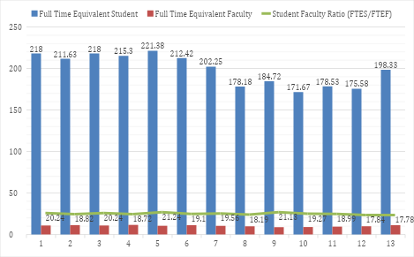

Tenure Density
Table 3-4 presents the tenure density trend for the department and SSU-campus-wide since the Fall 2019 semester, with the oldest data available through the Office of the Provost at SSU. The subsequent bar graph visually shows the data trend.
They both indicate that ECS has had lower tenure density scores than the average density score of the SSU campus-wide. This gap has existed continuously. Our ECS tenure density has dropped about 2 % over the years, from 60.61% in 2019 to 58.63% in 2023, whereas the SSU campus-wide tenure density has increased about 4 %. Combined with what the FTES/FTEF/SFR trend tells us, the tenure density data illustrates that our course offering heavily relies on lecturers. It partly explains the slight decrease in our SFR over the years and the increase in the FTEF.

Table 3-4. Tenure Density (for the Department and SSU campus-wide)
Fall term | ECS Tenure Density | SSU Tenure Density
2019 | 60.61% | 63.4%
2020 | 56.87% | 68.5%
2021 | 57.07% | 64.9%
2022 | 63.99% | 67.5%
2023 | 58.63% | 67.7%
Tenure Density = (Tenured and TT Faculty/All Faculty) %. Only Fall semesters. Data before 2019 is not available.

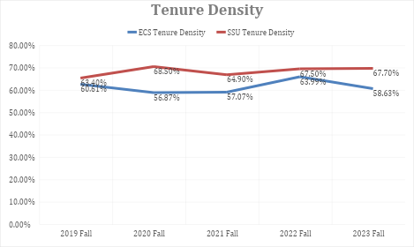
As we present these statistics to illustrate our program’s reliance on lecturers, we also should underscore that the number of tenured/tenure-track faculty available was lower than the numbers indicated in the data. For instance, one Associate professor was on sabbatical leave in Fall 2022, and two Associate Professors were absent in Spring 2023 (one on family leave; the other on sabbatical leave).
The current student-TT faculty ratio would not make our workload, teaching, advising, scholarly activities, and a myriad of service activities sustainable. For the last few years, the department has extensively and repeatedly requested that the University allow us to hire a new tenure-track faculty member. Nevertheless, it has been denied each year. Furthermore, the University recently imposed an instant hiring freeze, including for tenure-track faculty searches that were in progress due to the enrollment cliff and the subsequent budget deficit. Thus, it may take years for us to welcome new tenure-track faculty members to the Department. In the meantime, we will continue relying on lecturers for upcoming semesters.

ECS advising
All ECS tenured/tenure-track faculty members offer highly intensive advising. It involves recruitment/retention and equity-based, holistic mentoring on top of their full teaching load, service, and time to maintain their scholarly currency.
The lower-division standing ECS majors (i.e., completed 60 units or less), ECS minors, and Education minors work with our program advisor, Ms. Giselle Perry, as their advisors. The upper-division standing ECS majors work with their concentration-designated advisors for more continuity and accessibility in their mentoring experience until graduation. The caseload is spread relatively equally among the seven tenure-track/tenured faculty. More information about the advisor assignment is available on the ECS advising webpage (https://ecs.sonoma.edu/early-childhood-studies/early-childhood-advising).
The ECS advising focuses on helping students choose classes, providing career guidance, assisting students on academic probation or who are academically disqualified, staying on track for graduation, and preparing for post-baccalaureate employment or training programs, including a multiple-subject credential program and a graduate school. We often engage in "difficult dialogues" in our advising work, including mental health challenges, learning differences., discrimination, homelessness, immigration, roommate situations, and more. The holistic nature of our advising work illustrates our department-wide commitment to high-quality advising and mentoring work, which is an integral part of our effort to build a community and foster belongingness.

Evaluating Faculty Support: Workload, Mentorship, and Professional Development Opportunities
Since completing the previous WASC program review, we have thrived in addressing some of the challenges that emerged in our past review. First, one of the recommendations from the external reviewer is to create a field placement coordinator in the Department to continue providing high-quality, hands-on experiences to students that mirror what they will enact in their future workplace. Per the recommendation, we worked with the Deans of the School of Education (now College of Education, Counseling, and Ethnic Studies) to create this position with assigned time (two units each semester). The field placement coordinator is responsible for collaborating with field sites in our communities, communicating with instructors of field courses, ensuring that the requirements are met (e.g., fingerprinting, Child-mandated reporter training), and working with the Department Chair to update the field experience guidance materials for students and faculty members (located in the ECS student handbook and the ECS faculty/advisor handbook). This initiative has allowed us to ensure that students are sent to field experience placements thoroughly vetted for safety and quality while maintaining collaborative relationships with field sites.

Second, our previous review highlighted the "uneven quality of faculty for teaching and advising." For instance, our reviewer stated, “Although the Department takes great care to support and mentor lectures, as described in the Program Review Self-Study, students shared that the quality of faculty was often uneven. This disparity was evident in the students’ comments regarding having different experiences based on who the instructor was. The students also commented that lecturers were often hired at the last minute and had little time to prepare for their courses. The past review also pointed out that we need to improve students’ overall advising experience. In particular, we were recommended to develop action plans to improve the frequency and quality of advising provided to students, especially the quality of advising information and delivery for transfer students.
We implemented various initiatives over the years to address the uneven quality of faculty for teaching and advising and the uneven quality of advisors for advising transfers.

Availability of and participation in professional development opportunities
The Teagle grant that Drs. Bacigalupa and Murdock-Perriera received supported ECS faculty members' work to redesign their courses for online delivery as part of the initiative to put the ECS upper division courses online. Several of us completed the QOLT (Quality Online Learning and Teaching) certification in the CSU system by completing summer training in 2021. The scope of the training was to develop our teaching skills in course design, Canvas accessibility, and assessment practices. A combination of University, school of education, and department funding compensated for their summer work.
The Department receives funds from the Provost annually. These funds are used for tenure-track faculty professional development activities, and the bulk of these funds go to assistant professors.
Also, the Center for Teaching & Educational Technology (CTET) supports faculty in their professional development. They personalized consultations and targeted workshops to train faculty on how to use technology best to improve teaching, including instructional design, supporting diverse learners, classroom management, assessments, lecture video capture, and alternative pedagogical approaches (CTET, 2025). All faculty across the University have access to professional development and multiple resources that the CTET provides.

Mentoring
In addition to encouraging new tenure-track faculty and newly hired lecturers to participate in the professional development programs and workshops at CTET, each new faculty member in our department is assigned a faculty mentor (a tenured professor) with whom they meet regularly and who supports course development, questions about advising and registration, and other university questions.
The Department Chair orients new lecturers, informing them about university and department policies and evaluation procedures and explaining the requirements of the course they are expected to teach. We have the Faculty and Advisor Handbook as a one-stop resource for ECS faculty. The Department Chair updates the handbook every semester with information that reflects policy changes at the Department and the University. The handbook also outlines the support and resources available for ECS faculty, teaching responsibilities, and the list of student support services available at the University, including the writing center. It also includes information to support faculty advisors, a list of daily advising tasks and student advising needs, items including faculty evaluation, departmental policies and forms pertinent to their teaching activities, and classroom technologies. To make the handbook visible and accessible to faculty, including lecturers, we provide the hyperlink for the handbook in the department meeting agendas and meeting minutes.

Debrief and Planning (DAP) meeting
Each tenure-track faculty member is responsible for mentoring lecturers in specific courses. As a part of their mentoring work, they schedule a Debrief and Planning (DAP) meeting each semester, which is a time and space for faculty members who teach different sections of the same class to meet at the end of every semester and to “have everyone on the same page.” For instance, we use the DAP meetings to review the previous and current semesters, share concerns, and collaboratively plan for the next semester. DAP meetings are an excellent opportunity for all faculty members to discuss student engagement, grading criteria, readings, activity ideas, assignments' effectiveness in meeting learning objectives, and so forth. Faculty members also utilize DAP meetings to exchange ongoing, informal feedback on their teaching practices, often addressed in their self-assessments. It also helps us see the potential content overlap among multiple EDEC courses, giving us informative insights on how a program as a whole can address the breadth and depth of theories and competencies for various prominent standards, including the NAEYC Professional Standards and Competencies for Early Childhood Educators and the Child Development Permit TPEs.

Time allocation for course development, research, scholarship
Despite all those creative initiatives that we have implemented formally and informally, it is unfortunate that resources remain limited. Our new tenure-track faculty members can conduct research because they get a course release for the first four semesters. After the period when faculty receive the course release, faculty members spend a minimum of 60% of their time on teaching. However, the reality is that faculty probably spend about 90% of their time on teaching and service and then complete their research obligations by using their own time, especially over breaks and the summer. Some of the reasons for so much time spent on teaching and service are that the department is expanding (an undergraduate program with four concentrations, an ECE MA program, and the development of the PK-3 Credential program). There is a lot of start-up work to be completed, but part of the reason is that a 12-unit course load is demanding and requires much time to be done well. The workload concern has lately been exacerbated by the inadequate distribution of assigned time for essential leadership roles in the department and the inability to hire a new tenure-track faculty.

Faculty Trends Going Forward
As discussed in this section, our Department has a team of excellent scholars/educators with expertise, specialization, and deep commitment to equity, inclusion, and anti-racist practices. We are very proud of how our faculty meets and exceeds the program goals and missions overall and how we support each other to flourish as effective educators/scholars.
However, we recognize that it is critical to bring in new faculty, even though it is challenging for the University due to the current fiscal health and the decline in enrollment. ECS has only one Assistant Professor, and it has been three years since ECS had a new hire in the Fall of 2021. Hiring a new faculty will allow us to ensure that our future faculty can be fully mentored through the RTP process and into their roles as future leaders in the Department and at the SSU campus before our existing faculty retire. It is also critical for us to ensure support for both life and work for our newest colleagues as they make their way through the tenure and promotion processes here.
Also, none of the current ECS faculty are Latinx/Hispanic educators, whereas SSU is recognized as a Hispanic-serving institution. This demographic gap is another concerning situation that the department faces, primarily because of an exceptional record that our department has served Sonoma and adjacent counties as a higher education program that prepares future practitioners for young children and their families.
Another area impacted by the lack of faculty is our relationships with our community partners. Community relationships are vital to our work. For instance, Dr. Nagase attends the First 5 Sonoma County Leadership Advisory Roundtable meetings, and Dr. Xiang attends meetings for the Child Care Planning Council of Sonoma County as a member. Dr. Amini Virmani is an SSU advisory board representative for the Child Development Department at Santa Rosa Junior College, one of our "feeder" community colleges. Maintaining those relationships has been at the expense of individual faculty members on top of our department and university service, teaching, and scholarly activities. This situation raises serious concerns about our workload and the sustainability of our community partnership effort. With recent hires, we were able to distribute the community service commitments among more faculty. However, some important areas remain untended, such as regular check-ins with the programs hosting our student field placements.
SSU's looming enrollment and budget deficit will continue for some years. Nevertheless, we conclude this section by reiterating that our ability to recruit and retain a diverse faculty body is vital for our department's short—and long-term future. We must continue making high-impact contributions to the Early Childhood field in Sonoma County and beyond. For that, stronger partnerships with the Dean of the College of Education, Counseling, and Ethnic Studies and the University leadership will become even more pertinent.

Section 4: Program Resources

Student Support at the Program & Institutional Level
Advising within the ECS program is a collaborative effort involving both a professional advisor and faculty members to support students at various stages in the program. Our professional advisor is responsible for advising first-year and sophomore students, helping them navigate academic planning, including general education (GE) requirements and connecting them to campus resources. Tenure-track faculty advisors provide tailored support for junior and senior students, aligning their academic plans with career goals, guiding them through internships, research, and other developmental activities. Additionally, faculty support students by writing recommendation letters for graduate programs, scholarships, and job applications, as well as advising on advanced degree and credential program applications.
All ECS faculty and advisors support at-risk students by monitoring attendance and academic progress. We outreach to ensure students remain on track, and discuss concerning cases collectively during department meetings to develop appropriate solutions. New faculty typically begin advising in their second semester, with guidance and mentoring from the department Chair. The Chair and faculty also reach out to community colleges and professional groups to inform prospective students about the ECS major and assist with their transition into the major. Our department has taken the initiative to lead outreach efforts, ensuring every prospective student benefits from expert guidance and support. We remain hopeful that, in the future, we will get more support from the college to further enhance these efforts.
We evaluate advising effectiveness through student feedback, documented in the Program Exit Survey each semester through the following questions: “How satisfied are you with the advising you received from your ECS advisors?” a 4-point Likert-scale question rating from “not satisfied” to “fully satisfied” and two open-ended questions asking “In your opinion what are some of the strengths of Early Childhood Studies advising?” and “What are some suggestions to improve advising in the Early Childhood Studies Program?”. The past seven-year data show consistently high satisfaction rate and positive testimonials. For example, in the academic year 2023-2024, students reported an average of 95.5% satisfaction rate with 52.2% reported “highly satisfied”. A few examples of student testimonials include:
- My advising was extremely helpful! They always supported me in not only my classes but in general and I could tell they really cared for me! (Fall 23 Survey)
- Communication is clear, supportive of career goals, and helpful when planning for classes (Fall 23 Survey)
- Instructors were flexible and there to help and were always willing to explain and accommodate. (Spring 24 Survey)
- Very detailed focus, well prepared, welcoming (Spring 24 Survey)

Campus Support Services
The University and the ECS program provide a range of support services, including the Writing Center, Learning and Academic Resource Center (LARC), the HUB cultural center, library, University Advising Center, Counseling and Psychological Services (CAPS), Disability Services for Students (DSS), the DREAM Center, and Career Services. These resources are essential for fostering students' academic success, cultural engagement, and personal well-being. However, it is challenging to assess the extent to which and how often ECS students utilize these services or how effectively they address students' unique needs.
- The Writing Center and LARC play a critical role in academic support, particularly in assisting students with writing and tutoring. However, these services require additional resources to enhance their effectiveness. Students have reported mixed experiences, citing insufficient time with tutors or unclear guidance. The introduction of teaching assistants (TAs) within the ECS program could provide major-specific academic support. But currently, no TA positions exist within the program, because of the University policy on hiring TAs.
- CAPS delivers high-quality mental health services. But is hindered by insufficient staffing, resulting in long wait times and a limitation of 10 sessions per student per academic year. These constraints impact students’ ability to access timely and adequate psychological support.
- DSS ensures equal access to students with disabilities by providing appropriate accommodations and specialized support services, and by providing guidance to faculty, staff, and the campus community. However, accommodations for students are often delayed and follow a generalized approach that may not fully address individual needs. Tailoring services more closely to students' specific circumstances could be beneficial.
- Career Services offers general support, including resume writing and interview preparation, but lacks resources tailored to ECS students. Workshops focused on early childhood studies and ECS-specific career fairs would better prepare students for professional opportunities in their field.
- Orientation programs for incoming first-year and transfer students require improved coordination and clearer communication across the university. Currently, students are often overwhelmed by the volume of information, which can sometimes be inaccurate. ECS advisors have observed that inconsistent details about degree requirements and course sequences have led to student confusion. Additionally, the brief communication regarding orientation details leaves little time for adequate preparation. Although the university recommends that faculty attend these sessions, no compensation is provided during the summer when faculty are off contract.
- Programs such as the CARES team, the HUB, and the food pantry are valuable resources, particularly for LGBTQ+ and culturally diverse communities. However, these programs are operating at full capacity and require additional support to meet the needs of a growing student population effectively.
- The ECS program itself offers unique initiatives, such as ECS Resource Day, which consolidates important information and resources for students. Additionally, fieldwork, community engagement, and research opportunities allow students to develop practical skills and explore career paths. Expanding institutional support for these initiatives, particularly in career advising and mentorship, would further enhance their impact.
- Areas for Growth
While the current resources provide a strong foundation, addressing the following areas would significantly improve support for ECS students:
    - Advising: have focused study on understanding students’ needs raised from the ECS Exit Survey.
    - Academic Support: Increase resources for the Writing Center and LARC. Establish and train teaching assistants (TAs) and peer mentors within the ECS program to offer specialized academic support.
    - Career Services: Develop ECS-specific career fairs, workshops, and career preparation tools tailored to early childhood studies. Invite practitioners from various fields as a guest speaker.
    - Mental Health Services: Increase CAPS staffing to reduce wait times and expand the number of sessions available per student. Enhance efforts to raise awareness about mental health challenges and implement trauma-informed advising practices to reduce stigma.
    - Flexible Learning and Support Spaces: Create accessible study halls, both in-person and online, and develop programs specifically designed to support commuter and transfer students.
    - Enhance financial support for students in our major and minors by increasing the availability of scholarships and fellowships.

Support for Student Research & Community Engagement
Faculty-led research projects, supported by programs like the Koret Scholars, allow students to participate in advanced study and research-focused careers, for example, Dr. Rabadi-Raol worked with undergraduate students and presented at the American Educational Research Association (AERA) conference. Field-based courses, such as EDEC 347, provide practical exposure to community agencies serving children and families, while other courses like EDEC 220 and EDSP 432 deepen students' understanding of child development. In addition, courses like EDEC 290L, EDEC 291L, and EDEC 437 enable students to engage in curriculum design and apply their knowledge in real-world settings, focusing on children from birth through 3rd grade.
There are challenges in securing high-quality infant/toddler field sites for students. Our program would benefit from a greater variety of placements, including both private and state-funded programs, as well as sites that reflect diverse educational philosophies such as Reggio-inspired, Montessori, HeadStart, and inclusion programs. Additionally, funding for student research and fieldwork placements is limited, which impacts the quality of these experiences. The current field site coordinator receives only a small number of units for this role from the College of Education, Counseling and Ethnic Studies. The lack of adequate assigned time severely limits the capacity to expand and enhance field placement opportunities.

Library & Information Resources that Support Curricular & Research
The library and information resources at SSU provide substantial support for both students and faculty. Librarians have been proactive in purchasing requested books and online videos, ensuring that our academic needs are met. During the COVID-19 pandemic, the library adapted quickly to ensure students and faculty had access to online learning materials.
The library offers an extensive online subscription to academic journals, serving as an excellent resource for research and scholarly work. Its integration with Google Scholar and citation management tools like Zotero benefits both students and faculty. The library also provides course reserve services to ensure that essential texts are readily available for students at no cost. Quick and convenient interlibrary loan services further expand material access. The library's rich collection of children’s literature supports courses such as EDEC 407 Children’s Literature for Justice and EDEC 410 Language Development.
There is a designated librarian to assist with students in the ECS major. Workshops on essential topics such as academic literature searches and APA formatting are available to enhance research skills. For example, librarians are often invited to EDEC 460 Research in Early Childhood Studies to assist find empirical articles for their annotated bibliography projects.
In addition, the library offers 24/7 support through a global network of librarians, and offers flexible appointment slots for more personalized assistance.

Technology Resources that Support Teaching, Learning & Research
Overall, technology resources are adequate in supporting pedagogy and research/scholarship for students and faculty. The Center for Teaching & Educational Technology (CTET) offers a wide range of support, including consultations and workshops to help faculty on online course development, and use of tools like Canvas, Zoom, Google Apps, YuJa and TurnltIn etc, particularly during the times of disruption (e.g. Wildfire, COVID-19 Pandemic). Consultation is available during business hours. We need additional assistance in transforming course materials to ensure better accessibility for students.

Instructional Spaces & Facilities
- Classroom space
Classroom space has improved and we appreciate that we were consulted in terms of classroom design for the renovation of the Stevenson Hall. Room STEV 1108 was designed with additional storage, a sink, counter space, movable tables in groups, white boards, a projector, and a computer. Such design enables us to offer students authentic and hands-on experience with early childhood materials and tools in this room. We are able to prioritize ECS courses in this room. Most of our classrooms allow multiple modes of delivery and flexible layout. However, crowded rooms, rooms with forward facing desk arrangement, and the need to haul teaching materials to different rooms do not allow for the kinds of active pedagogy that all ECS faculty use. We are concerned that some classrooms cannot be locked in the event of campus lockdown.
- Instructional laboratories and studios
A lab school with observation mirrors and large rooms would be a great benefit for our students. We have close collaboration with the Children’s School on campus, which serves as a model program. They provide valuable field experience opportunities for our students. However, the current facility limits the number of students who can observe at any given time. We would benefit from a larger space and observation rooms equipped with one-way mirror and audio systems, allowing both students and faculty to observe children and teaching activities without disrupting the learning environment.
- Research/scholarship laboratories, studios, offices
The office space for faculty has improved following the renovation of Stevenson Hall. All tenure-track faculty have individual office space but not all adjunct faculty share office space. We are concerned that closing campus buildings and reallocating office spaces may reduce available space for our adjunct faculty, making it harder for them to meet with students. One other concern regarding office spaces is the lack of sound insulation. This may hinder focus and productivity. The thin walls make it challenging to conduct sensitive discussion, hold meetings, teach online and/or make phone calls without disruptions.
- Student study spaces
Student study spaces have been improved in Stevenson Hall. There are open spaces in the lobby and hallways and reserved study rooms for both academic and social activities. Study spaces are also available in the library.
- Instructional laboratories and studios
We have classrooms equipped with projectors, computers, sound system, and connections for laptops which are essential to our teaching. Wireless connections are strong and stable.

Staff Support for Program Operations
The program has an Administrative Coordinator, but this is not a permanent position and is shared with the Counseling program. It is essential that this position be made permanent and fully dedicated to the ECS major. Lara Herrera, the present administrative coordinator, has been exceptional in her work. She has significantly improved communication with students by managing the program’s social media accounts, responding to inquiries, organizing paperwork for field placements, coordinating department files, assisting with advising assignments, helping with orientation and senior portfolio presentation events, handling with permission codes for the courses, and assisting with departmental purchase and faculty travel.
In addition, staff from the College of Education, Counseling and Ethnic Studies are also very helpful and efficient. Given the growth of our program in recent years—including the addition of 2 concentrations to the undergraduate program, an education minor, an online Master’s program, and a developing PK-3 credential program, the need for expanded marketing, communication and collaboration has become clear. For example, our collaboration with the Credentials & Graduate Admissions Office and the Office of Graduate Studies grows evidently. To support these expanding responsibilities and continue our work effectively, it is crucial to have a permanent and standalone Administrative Coordinator, along with additional staff support within the College.

Future Budgetary Considerations & Resource Needs
SSU is currently facing significant financial challenges with a $23.9 million budget deficit. Since 2015, the enrollment dropped by nearly 39% which leads to reduced tuition revenue and the state funding allocated $3.6 million to other campuses. As a result, the university has taken several cost-saving measures—including voluntary separations, personnel reductions, operational streamlining, shared services, hiring freezes, and careful use of reserves. In an email dated January 22, 2025, SSU announced the non-renewal of 46 faculty contracts, additional staff layoffs, the closure of six departments, the termination of 23 major degree programs, and the elimination of intercollegiate athletics. These financial challenges will have a profound impact on the quality and sustainability of our department over the next review period.
- With limited resources, it would make it harder to recruit and retain students which could further worsen the enrollment.
- With budget cuts, we are concerned that some courses might not be offered and/or altered that would limit students’ choices.
- We need additional faculty positions to sustain our undergraduate program—which offers four concentrations, two minors, an online ECE M.A. program, and a developing PK-3 credential. Faculty cuts, limited time for key departmental service, and increased workloads are jeopardizing our ability to effectively maintain these programs, potentially compromising our commitment to student-centered teaching, quality advising, and overall student engagement.
- With increased demands and cuts to funding for faculty development and research, these could limit opportunities for research and development.
- With increased demands and fewer resources, we anticipate burnout which could affect teaching and engagement with students.
- We anticipate a cut of student and faculty services on all services which could negatively impact the learning experience for the ECS students.

Section 5: Student Success

Student Trends and Enrollment Strategy
This section analyzed the student demographic data from Spring 2019 to Fall 2024. The summary of key trends is presented below, with accompanying graphs enclosed.
- First-Generation Students
The proportion of first-generation students has significantly increased, rising from around 30% in earlier years to over 40% in the most recent term. This data underscores the growing number of students who are the first in their families to pursue higher education, highlighting the importance of providing tailored support services for their educational experience and career pathways.

- Students’ Gender
According to the data on their self-reported gender identity, the student population in our major remains overwhelmingly female, consistently exceeding 90% across all terms. Early Childhood Studies and Child Development have traditionally been a female-dominated profession, and this trend is reflected in the gender composition of our student body.

- Student Age
Most students fall within the 18-24 age range, but we have seen a slight increase in students older than the typical age bracket. The proportion of students aged 25 and above has grown modestly, suggesting a mixture of traditional college-aged students and those returning to school later in life. Our department is committed to offering holistic mentoring to students, recognizing that their lives tend to be complicated by responsibilities beyond being college students.

- Full-Time vs. Part-Time Status
Most students enroll full-time, with rates consistently above 85%, while the number of students enrolling part-time varies from time to time. This data indicates our students’ commitment to completing their degrees on time. It may be contributing to our relatively high graduation rate.

Figure 5-1. Student Demographics Spring19
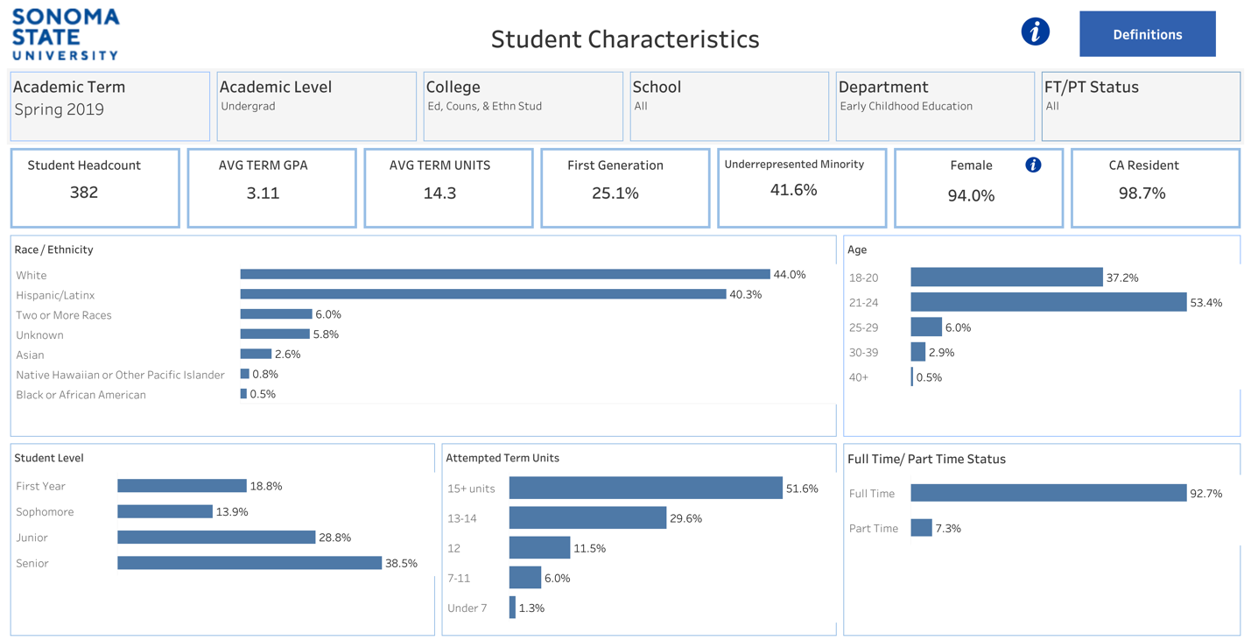

Figure 5-2. Student Demographics Fall 19
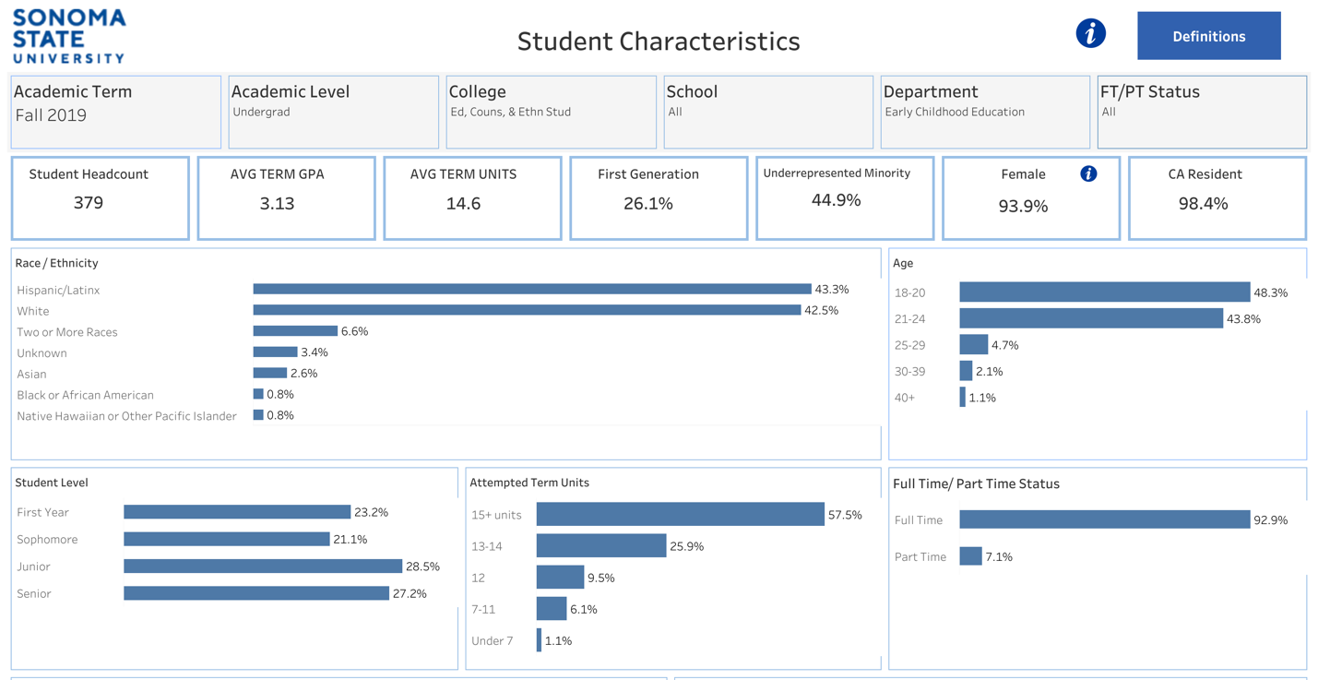

Figure 5-3. Student Demographics Spring 20
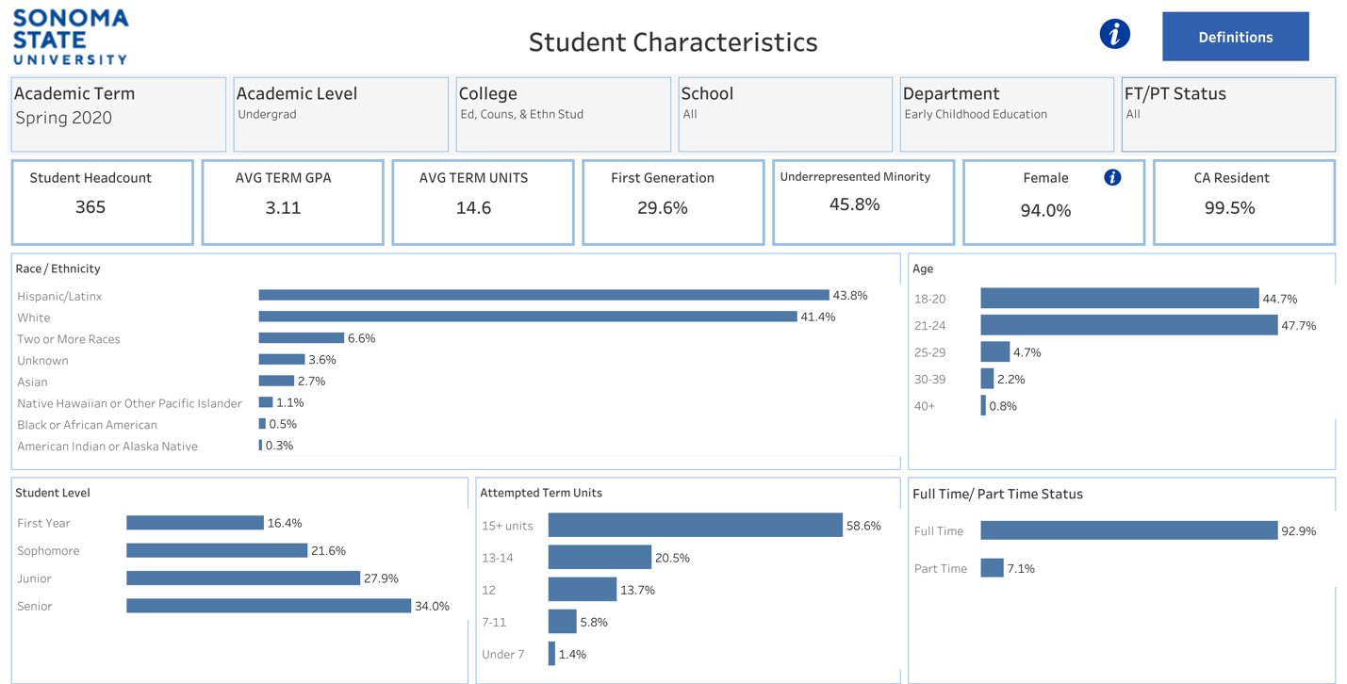

Figure 5-4. Student Demographics Fall 20
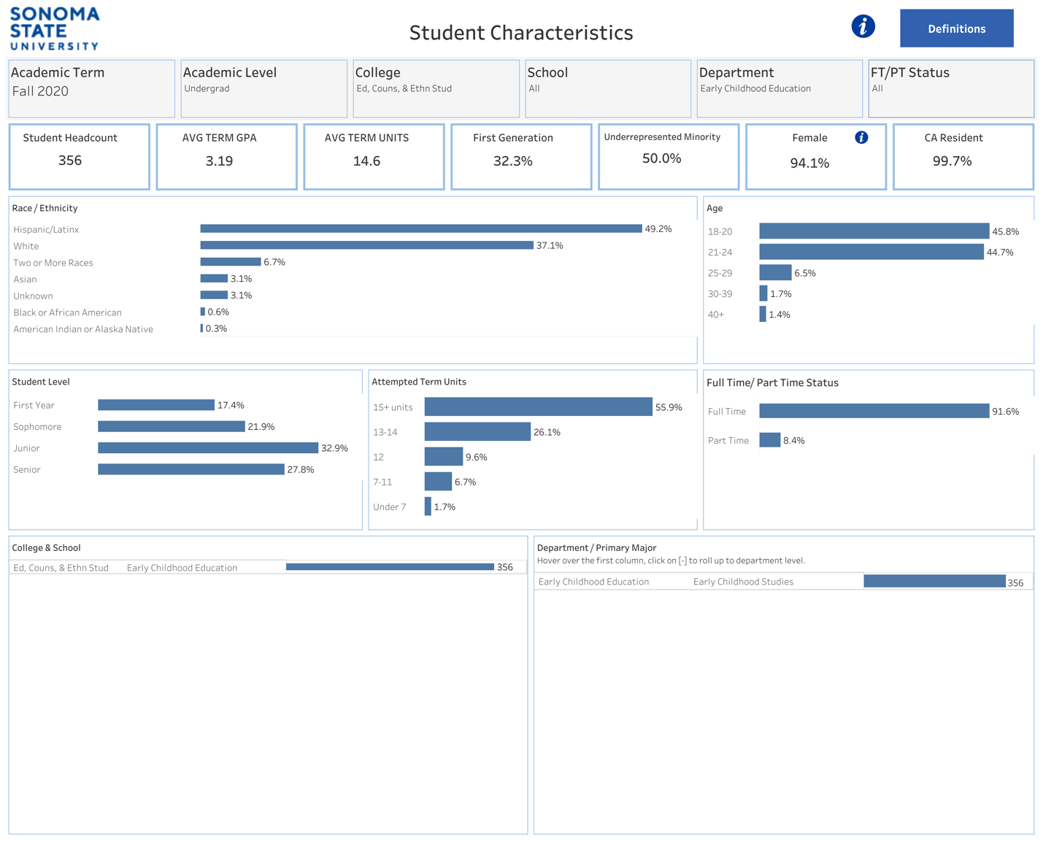

Figure 5-5. Student Demographics Spring 21

Figure 5-5. Student Demographics Fall 21
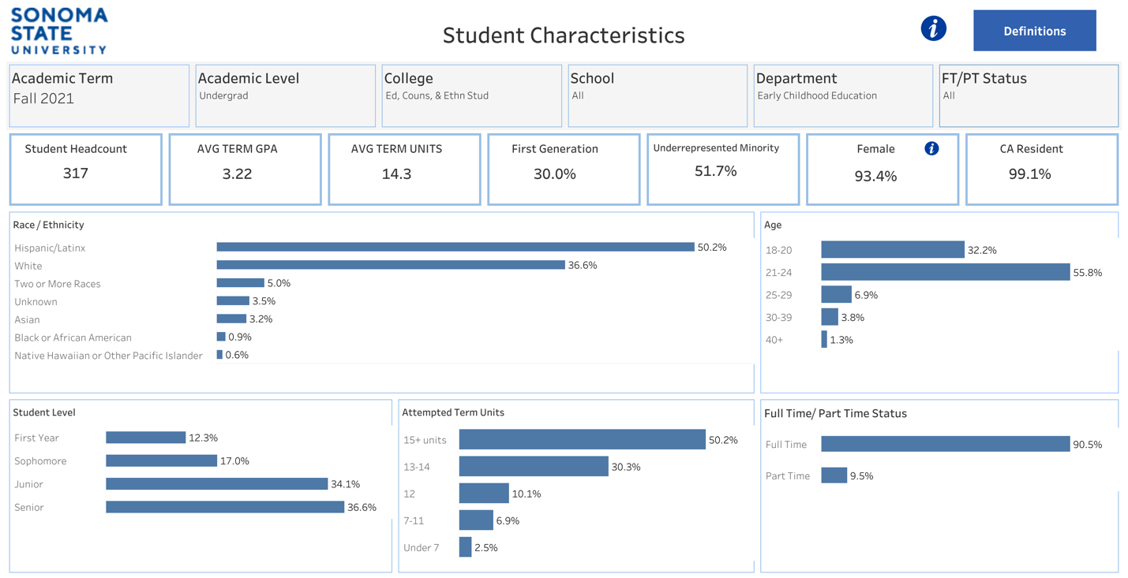

Figure 5-6. Student Demographics Spring 22
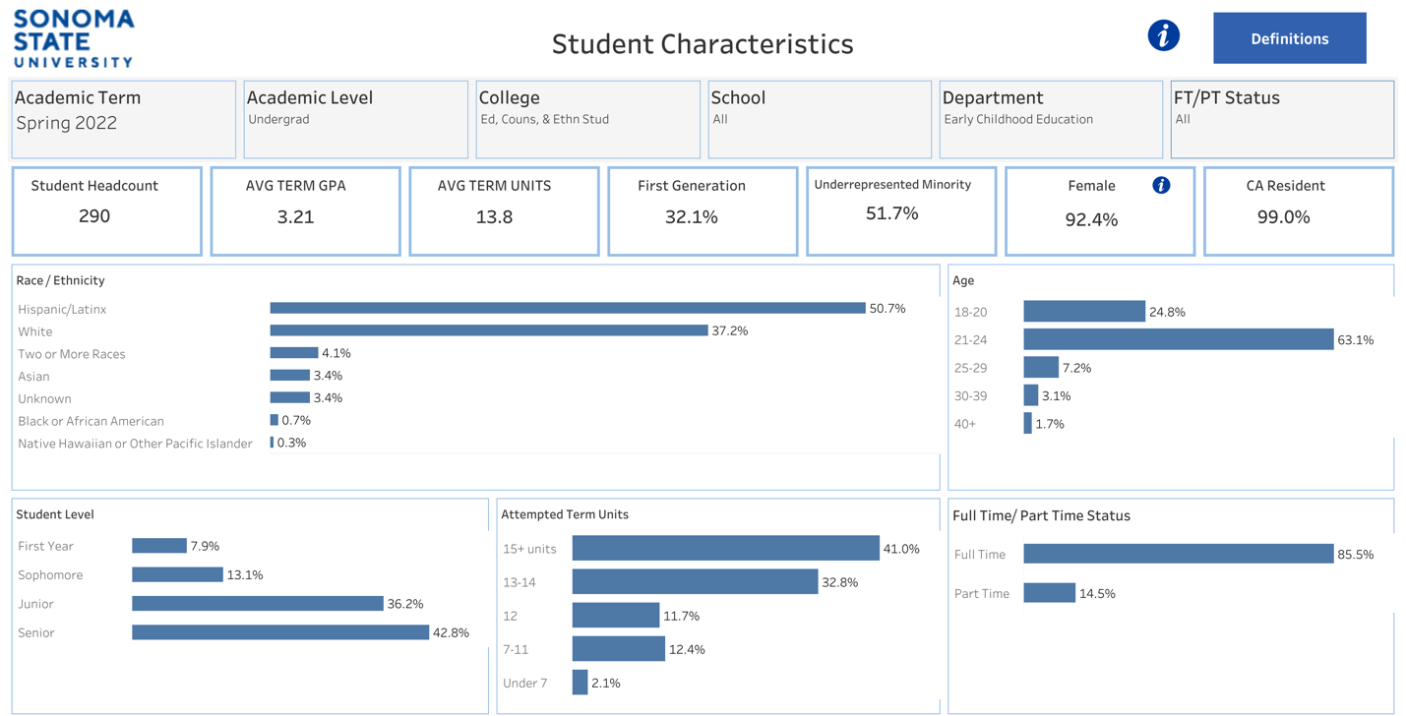

Figure 5-7. Student Demographics Fall 22
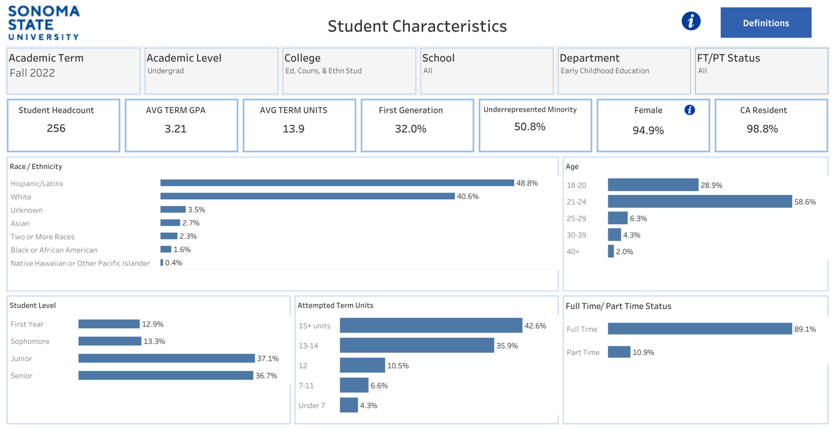

Figure 5-8. Student Demographics Spring 23
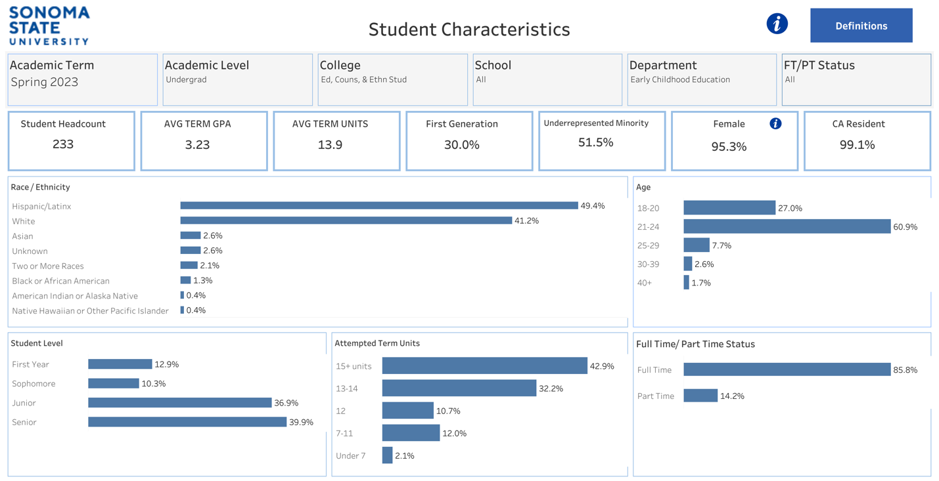

Figure 5-9. Student Demographics Fall 23
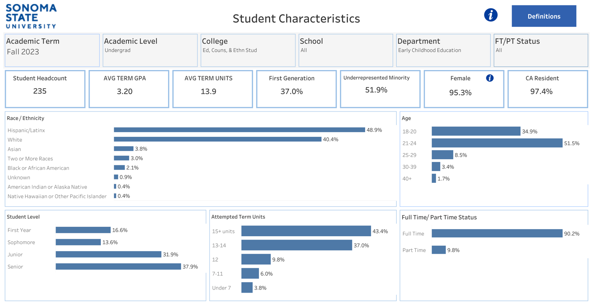

Figure 5-10. Student Demographics Spring 24
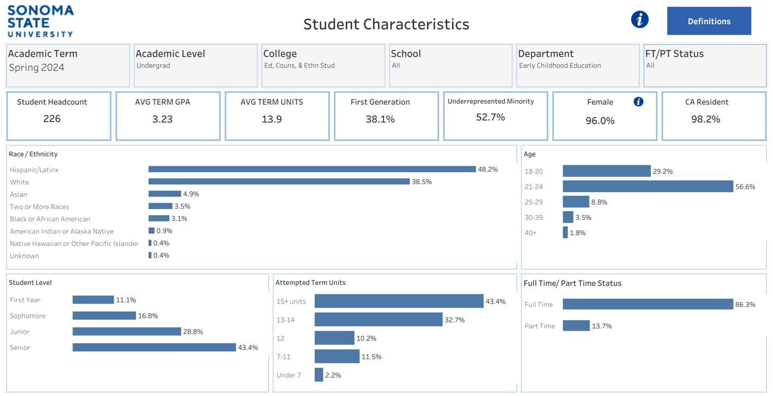

Figure 5-11. Student Demographics Fall 24
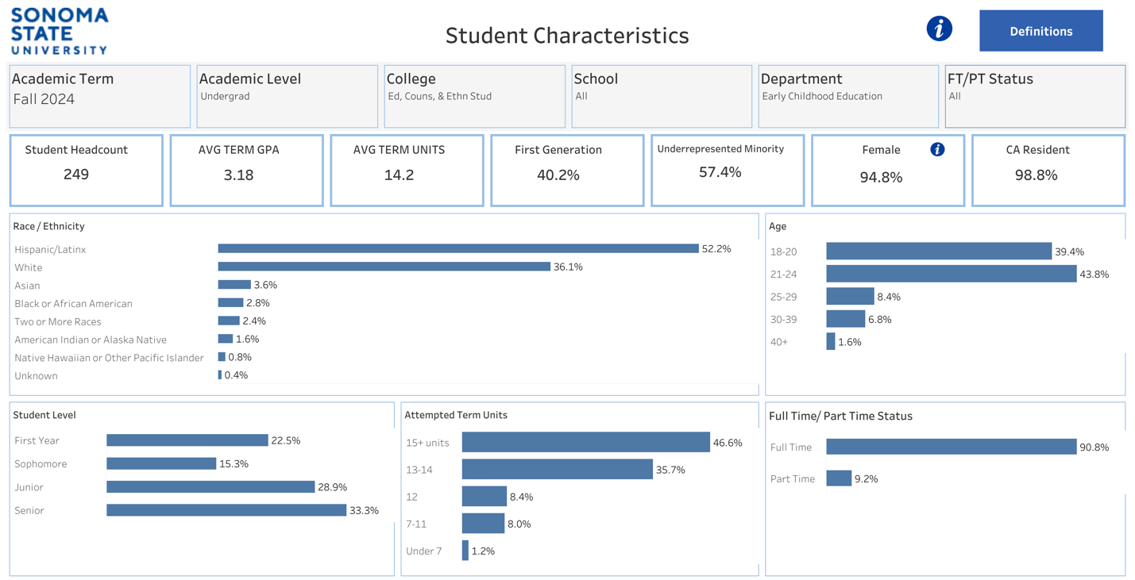

Student Race/Ethnicity
Figure 5-12. Race/Ethnicity Trends Spring Terms
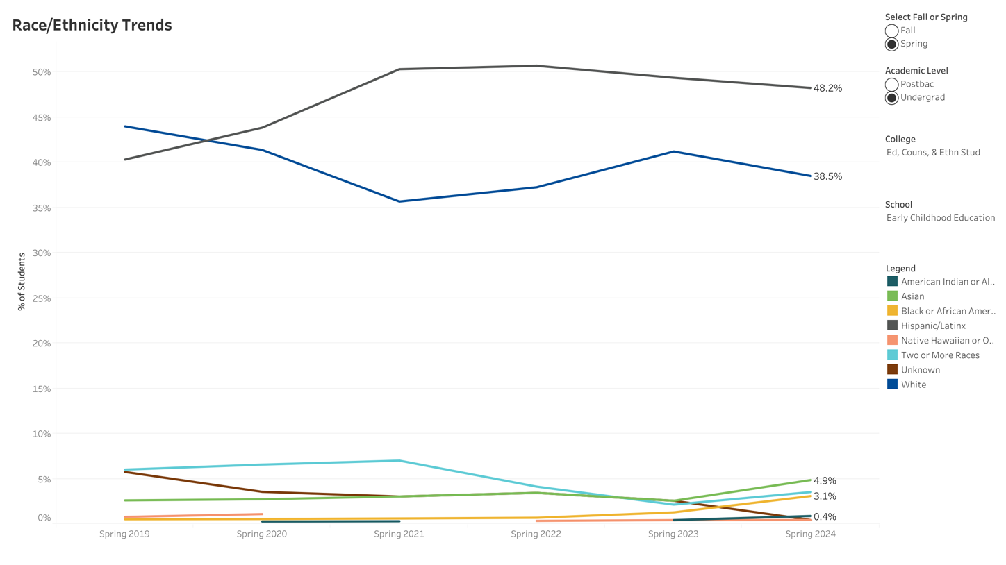
Figure 5-13. Race/Ethnicity Trends Fall Terms 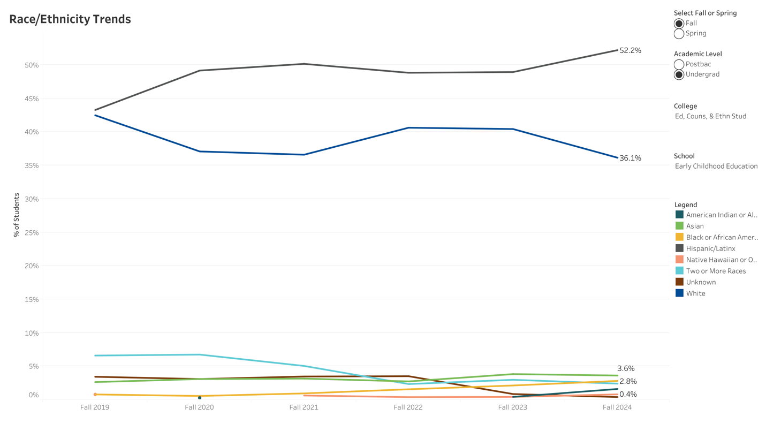
The data presented indicate that we have seen a shift in racial and ethnic composition over time. The percentage of Hispanic/Latinx students has increased, surpassing White students as the largest group in recent years. The proportion of White students has steadily declined, while smaller racial groups, such as Asian and Two or More Races, have experienced slight growth. Black/African American student representation remains low.

Underrepresented minority (URM) Trends
Figure 5-14. URM Students Spring Terms
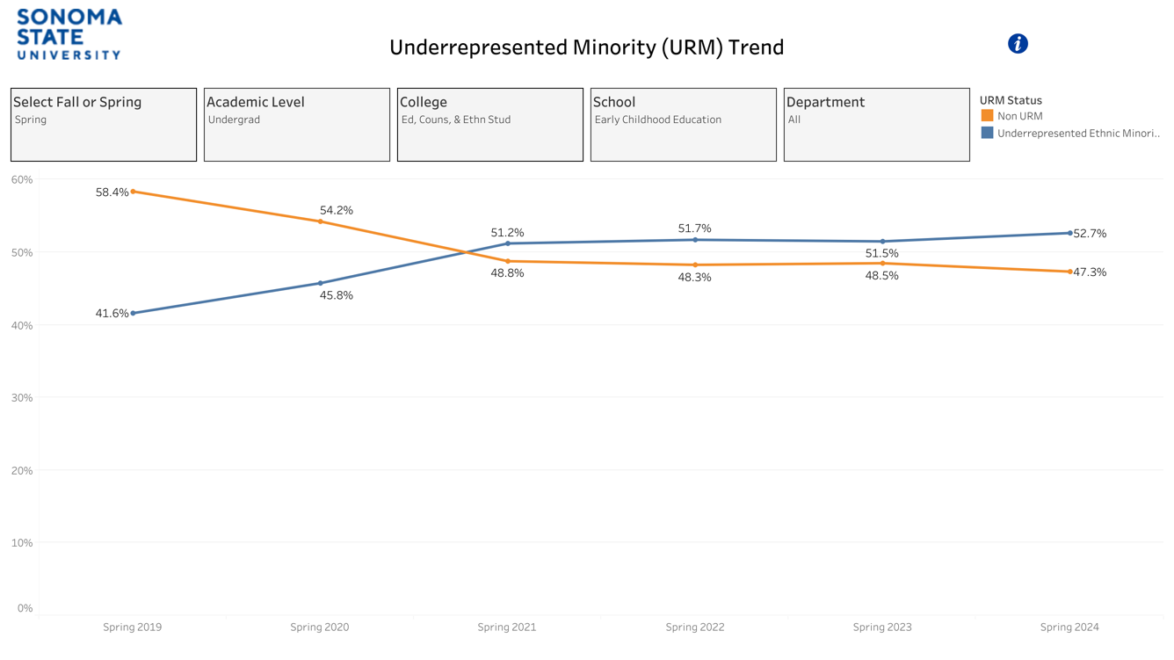
Figure 5-15. URM Students Fall Terms
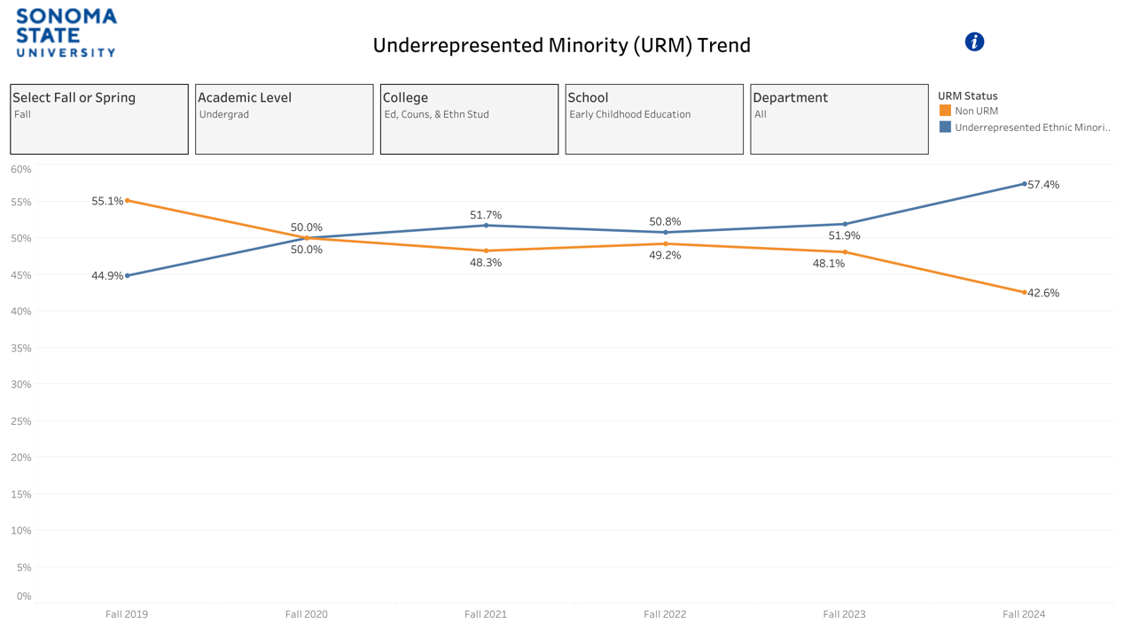
The percentage of URM students in the ECS major has steadily increased over time. In the spring semesters, URM representation grew from 41.6% in Spring 2019 to 52.7% in Spring 2024, surpassing non-URM students. A similar trend is observed in the fall semesters, where URM students increased from 44.9% in Fall 2019 to 57.4% in Fall 2024, while non-URM representation declined. By the Fall of 2020, URM and non-URM students were nearly equal. The URM students have since become the majority. This shift indicates a growing diversity in our student population.

Considerations on Future Enrollment Strategies
  - engage in more robust recruitment/retention efforts by building stronger partnerships with local community colleges and high schools, including improving information materials to make the transfer process and course articulation easier for prospective students to understand.
  - The numbers of first-generation students continue to rise. To support their transitions to a successful college experience, we recognize that it is vital for the department to ensure building a strong, close-knit community. For instance, we hope to facilitate further peer-to-peer networks and connections between students and faculty members,
  - As Hispanic/Latinx students surpass White students as the largest group, targeted outreach and support programs should reflect this change. In that sense, we are very fortunate to work with our program advisor, Ms. Giselle Perry. Her contribution as an English/Spanish bilingual/bicultural advisor is noteworthy, especially her work with prospective and current students who speak Spanish as their home language.
  - We are committed to diversifying our student body's race, culture, and linguistic orientation through more rigorous recruitment efforts. This proactive approach demonstrates our commitment to creating a diverse and inclusive learning environment.
  - There is an increase in older students in the major. Within the 18-24 age range, there’s a growing trend of students maintaining a full-time status and working for increasing hours. This suggests the importance of offering more flexible scheduling, a mixture of in-person, synchronous, and asynchronous course modalities, and career transition resources for non-traditional learners. We want our students to feel reassured that we are accommodating their diverse needs. Continuing to partner with campus resource programs is also vital.
  - With over 90% of students identifying as female, there is an urgent need to recruit more male students. The under-representation of men in ECEC workforces has long been a significant challenge in the US and other countries. However, recent research shows that children's experiences of positive and diverse male gender representations and their observation of male teachers working with female teachers may help children see care as necessary for all genders and challenge beliefs about male dominance (Mofokeng & Mukuna, 2023). It's our responsibility to address this imbalance.

2. Retention and Graduation Trends & Improvement Plans

Retention trends
For the first-time, first-year students (FTFY) retention rates, the ECS major has consistently been higher than the university-wide rates from Fall 2018 to Fall 2023. ECS's FTFY retention rate peaked at 92.3%, surpassing the university-wide rate of 67.8% in Fall 2023. The ECS second-year retention rates for ECS are generally higher than the university-wide rates but show a decline over time, dropping from 77.4% in Fall 2019 to 64.3% in Fall 2022. Overall, ECS demonstrates stronger first-year retention than the university, but second-year retention appears to be declining, similar to broader university trends.
Figure 5-16. FTFY Retention Trends AY18-19-AY23-24 University-Wide
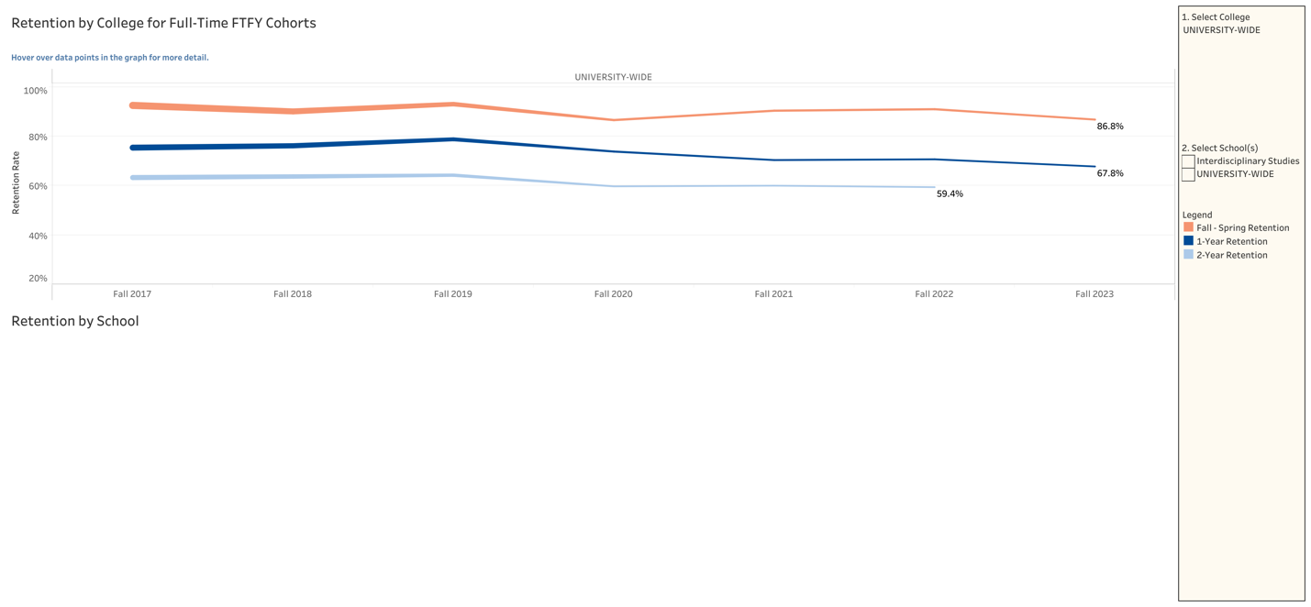
Figure 5-17. FTFY Retention Trends AY18-19-AY23-24 Early Childhood Studies
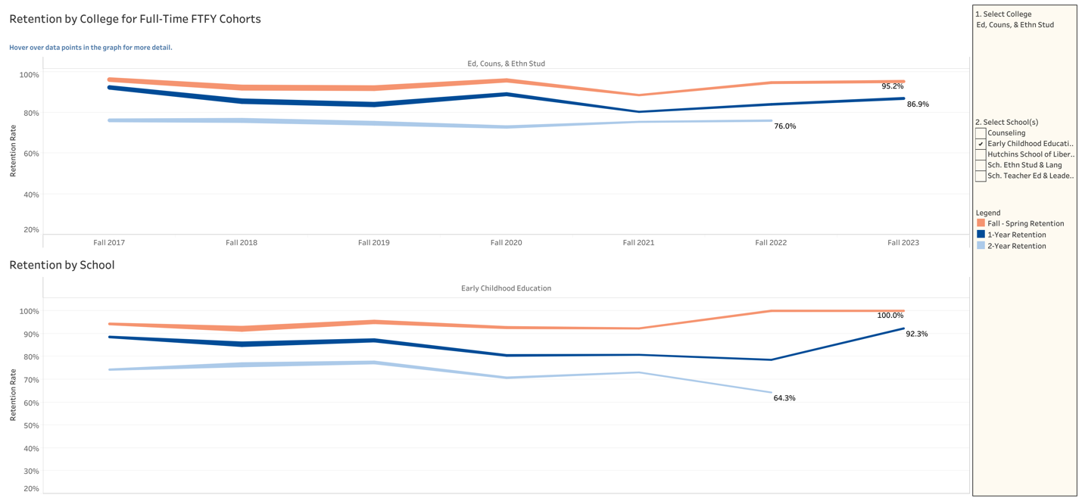
FTFY Retention Trends |  | Fall  18 | Fall  19 | Fall  20 | Fall  21 | Fall  22 | Fall  23
University-Wide | 1st year | 76.2% | 78.8% | 73.8% | 70.4% | 70.7% | 67.8%
University-Wide | 2nd year | 63.7% | 64.2% | 59.7% | 60.0% | 59.4% | NA
ECS | 1st year | 85.4% | 87.1% | 80.5% | 80.8% | 78.6% | 92.3%
ECS | 2nd year | 76.4% | 77.4% | 70.7% | 73.1% | 64.3% | NA
The ECS retention rate for transfer students has been relatively steady, ranging from the mid-to-high 80% to the low 90% over the years. The rate dropped slightly in Fall 2022 and rebounded to 88.9% in Fall 2023. Overall, ECS transfer retention has been strong and more stable than the university-wide trends.
Figure 5-18. Transfer Students Retention Trends Fall 2015-Fall 2023 University-Wide
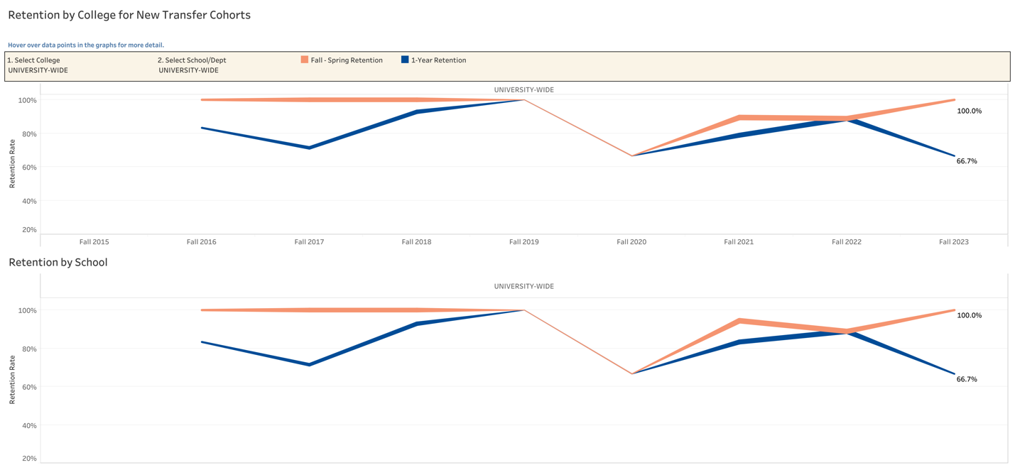
Figure 5-19. Transfer Students Retention Trends Fall 2015-Fall 2023 ECS
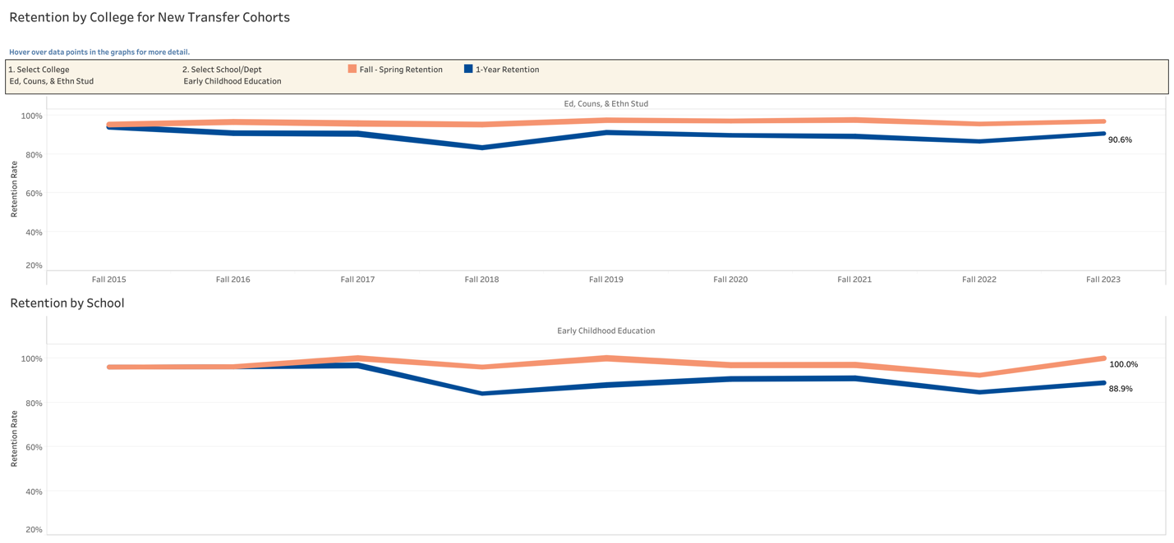
Transfer Retention Trends |  | Fall 18 | Fall 19 | Fall 20 | Fall 21 | Fall 22 | Fall 23
University-Wide | 1st year | 92.9% | 100% | 66.7% | 83.3% | 88.9% | 66.7%
ECS | 1st year | 84.0% | 87.9% | 90.6% | 90.9% | 84.6% | 88.9%

Time to Degree for FTFY ECS Students
For the FTFY ECS Students, 4-year graduation rates varied between 2018 and 2020, with 61% in 2018, a drop to 43% in 2019, and a rebound to 56% in 2020. These rates were identical to the college rates each year. ECS outperformed the overall campus in 2018 (61% vs. 39%) and 2020 (56% vs. 45%), but in 2019, both ECS and the campus had the same 43% rate. It illustrates that ECS FTFY students generally graduated at a higher rate than the overall campus.
Figure 5-20. FTFY ECS 4-year Graduation Rates 2018-2020
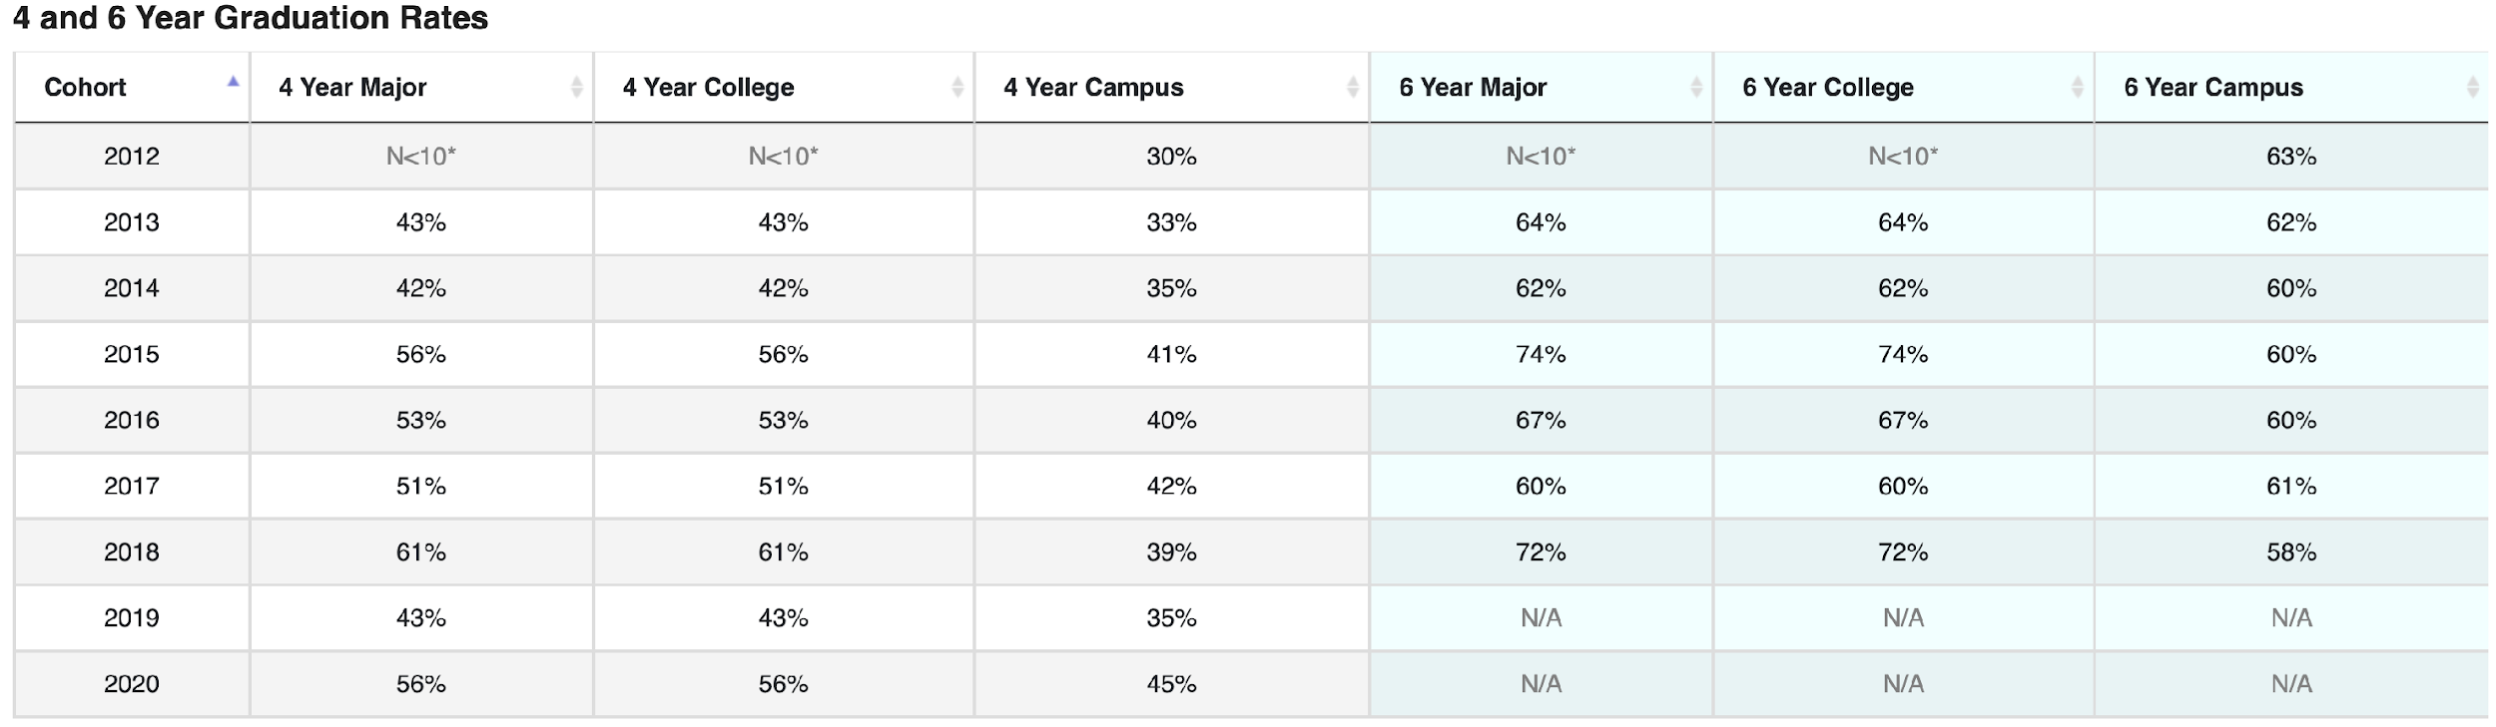
From 2018 to 2021, the graduation rates for ECS students who completed their degrees within 2 years after achieving junior status show a declining trend, starting at 74% in 2018, staying steady at 75% in 2019 and 2020, but dropping to 59% in 2021. For those who graduated within 2 years + 1 term, the trend was more stable, with rates at 83% in 2018, 85% in 2019, and peaking at 84% in 2020, but this number declined to 76% in 2021. These numbers suggest that while many students benefited from the extra term, overall graduation rates have slightly decreased. The notable drop in 2021 for both groups may reflect the post-pandemic impact, as many students took on more work hours alongside their coursework, making it harder to complete their degrees on time.

Figure 5-21. Graduation Timeline for FTFY ECS Students After Achieving Junior Status
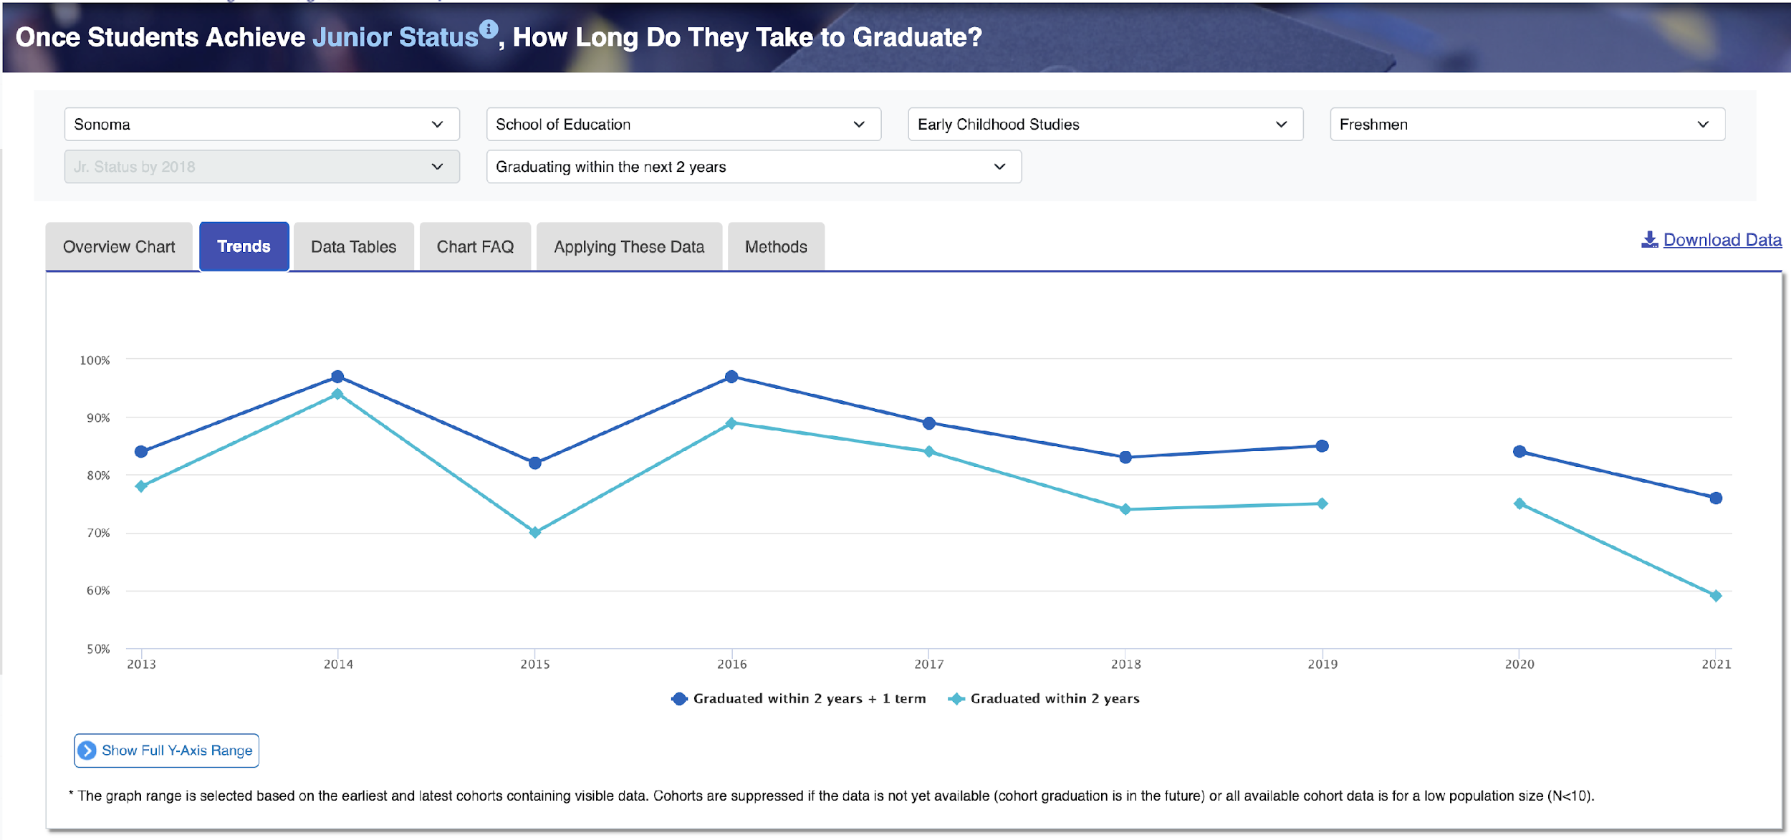
Table 5-1. Graduation Timeline for FTFY ECS Students After Achieving Junior Status
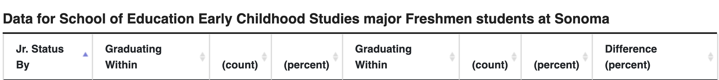
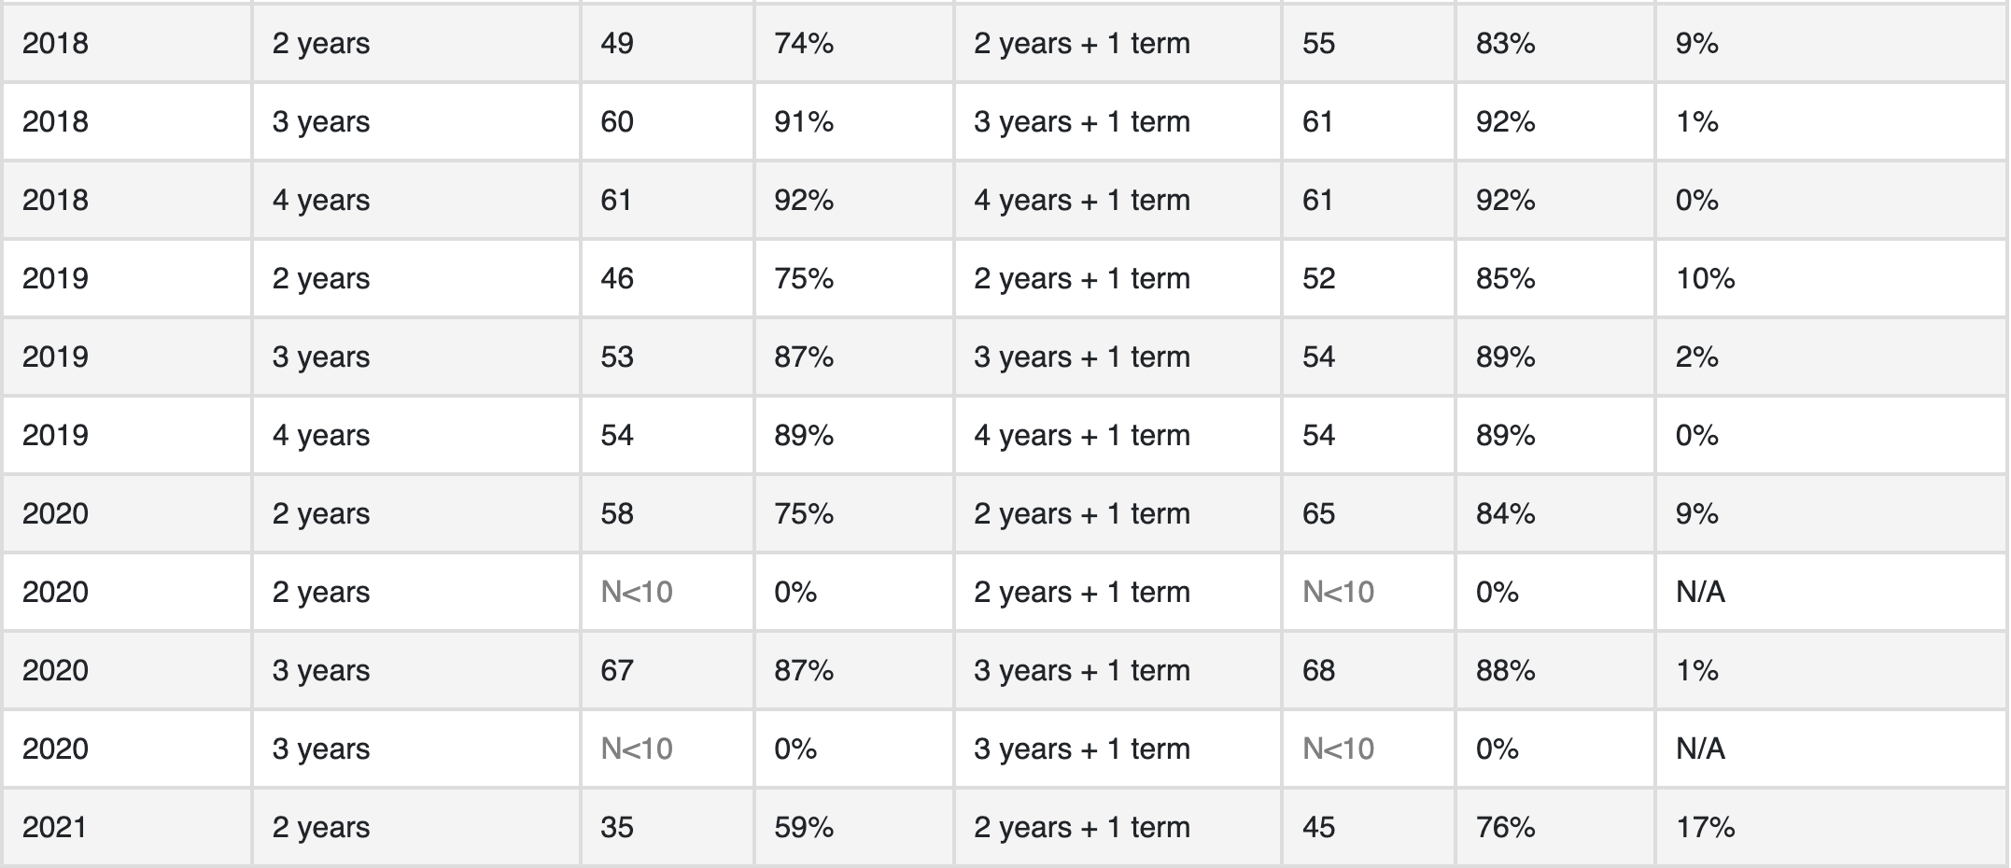

Time to Degree for the Transfer ECS Students
From 2018 to 2020, ECS 2-year graduation rates for transfer students varied, starting at 64% in 2018 and 2019, then rising to 69% in 2020. The 4-year graduation rate remained strong, increasing from 86% in 2018 to 91% in 2019 before slightly dropping to 88% in 2020. While shorter-term completion rates varied, the 4-year rates stayed consistently high, indicating that most transfer students eventually completed their degrees within a reasonable timeframe.

Table 5-2. ECS Transfer 2-4 year Graduation Rates 2018-2020
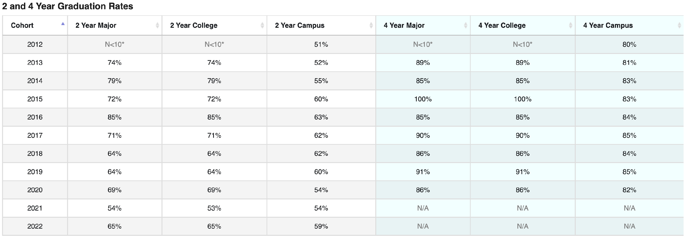
Graduation Timeline for Transfer ECS Students After Achieving Junior Status
From 2018 to 2021, the 2-year graduation rate for the transfer ECS students after achieving junior status showed a declining trend, starting at 69% in 2018, dropping to 58% in 2019, slightly recovering to 67% in 2020, but falling again to 55% in 2021. Similarly, the 2-year + 1 term graduation rate followed a downward trend, peaking at 83% in 2018 and 2020 but decreasing to 79% in 2019 and to 67% in 2021. The most significant drop occurred in 2021, likely reflecting post-pandemic challenges such as increased work commitments and academic disruptions. While some students benefited from an extra term, the overall trend suggests a growing challenge in completing degrees within this timeframe.
Figure 5-22. Graduation Timeline for Transfer ECS Students After Achieving Junior Status
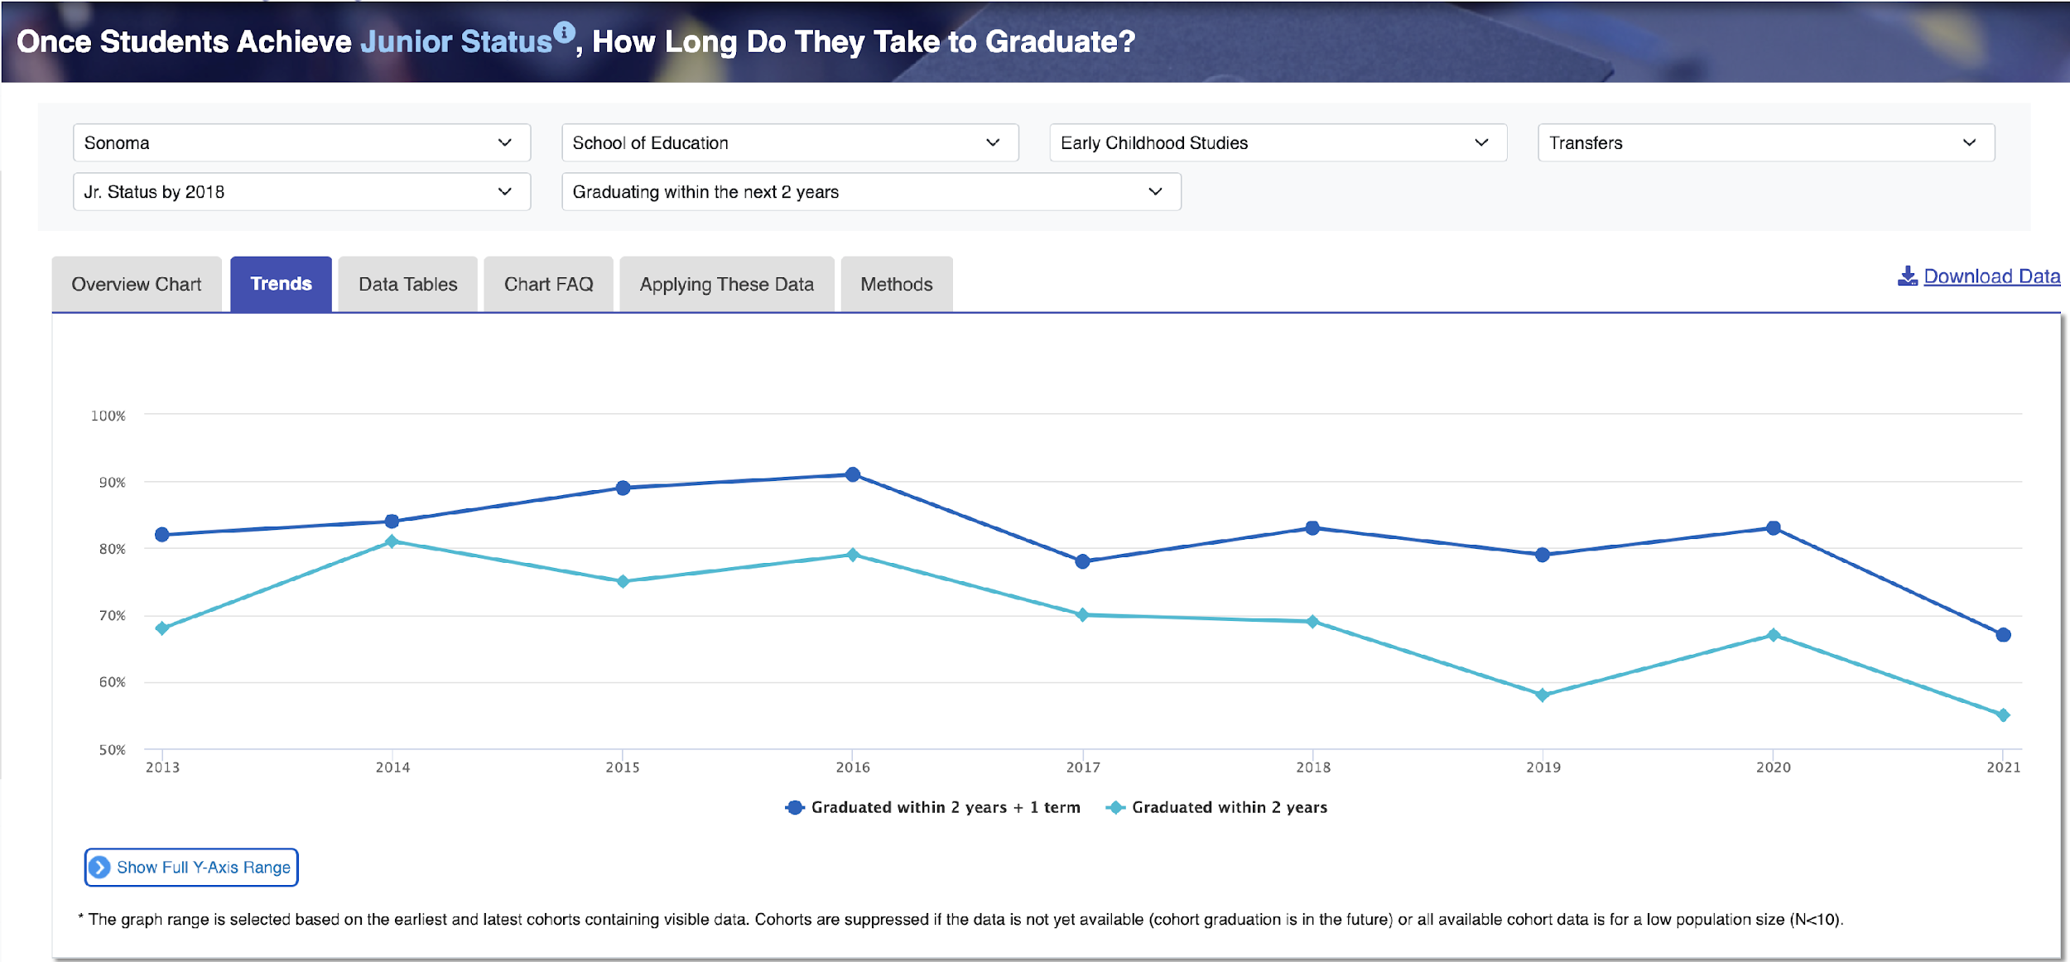

Table 5-2. Graduation Timeline for Transfer ECS Students After Achieving Junior Status
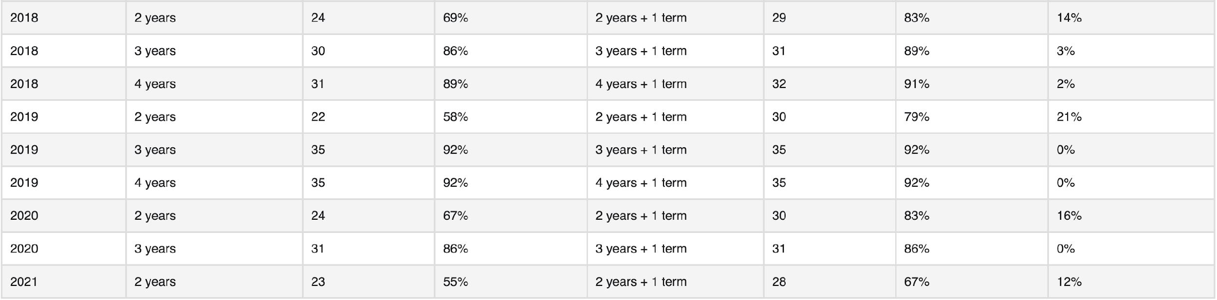

Degrees Conferred
From AY 2018-19 to AY 2023-24, the number of overall degrees awarded in Early Childhood Studies (ECS) showed a declining trend. The highest number of degrees was awarded in AY 2018-19 (147), followed by a steady decrease to 116 in AY 2019-20 and 98 in AY 2020-21. Although there was a brief recovery to 124 in AY 2021-22, the numbers dropped again to 89 in AY 2022-23 and 82 in AY 2023-24. The decline in degrees awarded in recent years suggests challenges in enrollment, retention, and program completion. This trend reflects broader patterns across the campus.
- The gender distribution of degrees awarded in ECS is overwhelmingly female-dominated, with 622 female graduates compared to 34 male graduates. It reflects the general trend in the early childhood care and education field. In terms of race/ethnicity, Hispanic/Latinx students (288 graduates) formed the largest underrepresented minority (URM) group, nearly matching the White student population (268 graduates). Other URM groups, including Black or African American (6), Native Hawaiian or Other Pacific Islander (3), and American Indian or Alaska Native (2), had significantly lower representation.
- When comparing URM and non-URM student degree trends, both groups experienced a gradual decline in degrees awarded over time. In AY 2018-19, URM students received 87 degrees, while non-URM students received 60. This number steadily decreased to 63 (URM) and 61 (non-URM) in AY 2021-22, and by AY 2023-24, only 42 URM and 40 non-URM students received degrees. The gap between URM and non-URM students has remained relatively small, but the overall decline suggests a drop in ECS enrollment or retention across both groups.

Table 5-3. ECS Degree awarded AY18-19 to AY 23-24
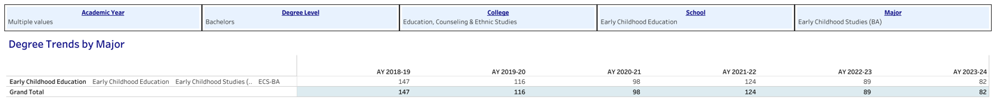

Figure 5-23. ECS Degree awarded AY18-19 to AY 23-24 by Demographics
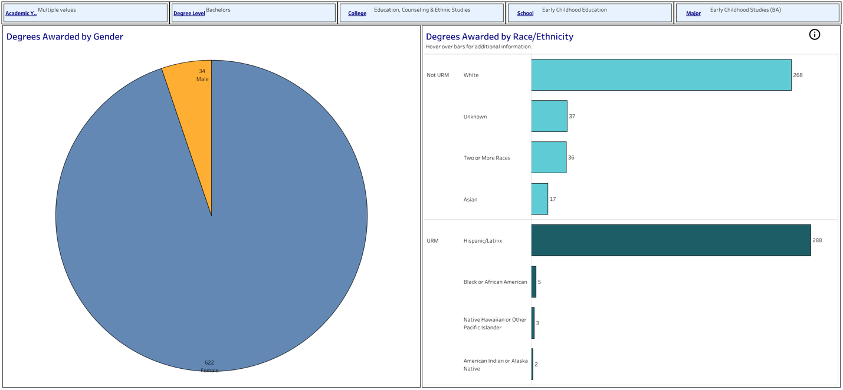
Figure 5-24. Degree Awarded Trend AY18-19 to AY 23-24 Traditional V.S. Underrepresented Minority Students
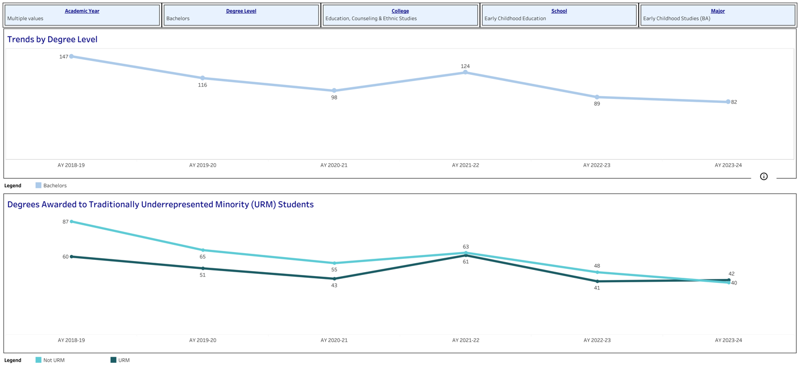

Considerations for Improving Retention and Graduation Rates in ECS
- To address declining second-year retention rates, we could implement targeted academic and advising interventions that provide structured support for students as they transition into upper-division coursework, such as peer mentoring programs and academic success workshops. Our second-year learning community course, EDEC 260, is already in place, and we hope it will enhance the second-year experience.

- The transfer retention rates have been relatively strong, suggesting our efforts to support this student population are working effectively. We should continue offering robust transfer orientation programs with more clarity on the course articulation process for prospective/incoming transfers. In addition, flexible course scheduling, course modality, and peer mentors would ensure that transfer students remain engaged and supported in the program.

- Post-pandemic challenges have impacted student retention and graduation. We are asking for support at the university and college levels, such as increasing access to financial aid, emergency grants, scholarships, learning support, and mental health and well-being, which can help students balance academic and work commitments.

- The declining trend in ECS degrees awarded suggests challenges in enrollment, retention, and program completion. This trend reflects broader patterns across the campus. To address this, we could expand mentoring, outreach, and partnerships with local schools and childcare centers to create internship and employment pipelines. Strategic recruitment efforts, including targeted marketing, community college partnerships, and financial aid expansion, are key to increasing enrollment.

- However, our faculty already manages a full teaching, research, and service load, making it difficult to sustain these efforts without additional support. We need to hire new TT track faculty members to share the load and potentially designate faculty members for student support and recruitment/retention.

Student Applications, Admits, and Enrollments Trends
Table 5-4. First-Time Students Applications to Enrollments Data Spring Terms
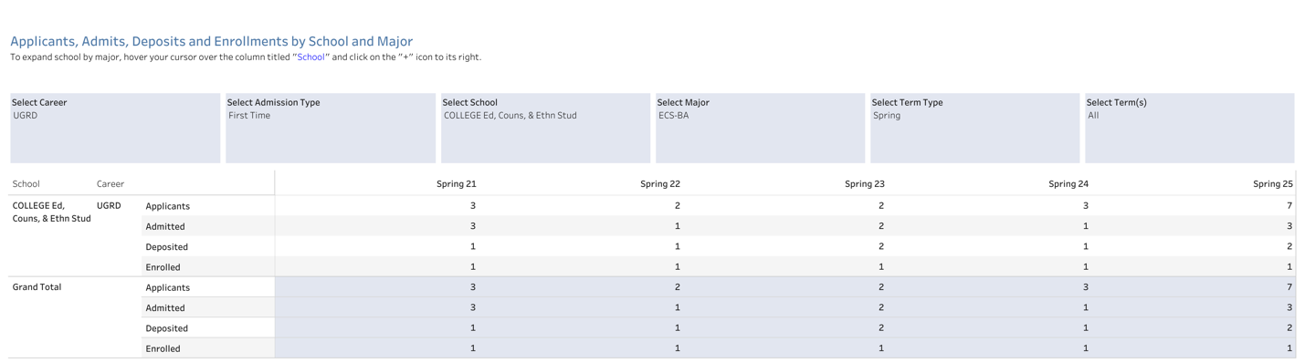

Table 5-5. First-Time Students Applications to Enrollments Data Fall Terms
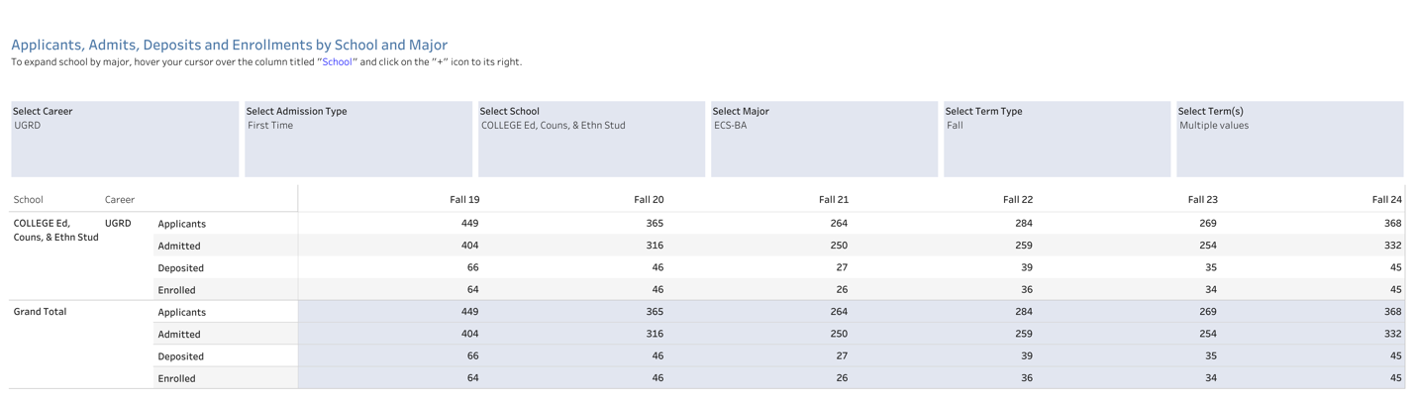
Table 5-6. Transfer Students Applications to Enrollments Data Spring Terms 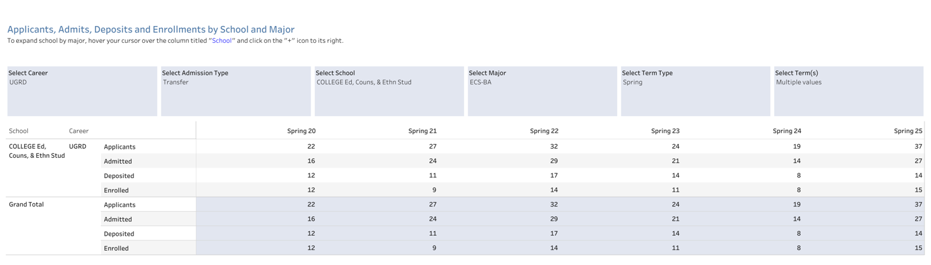
Table 5-7. Transfer Students Applications to Enrollments Data Fall Terms 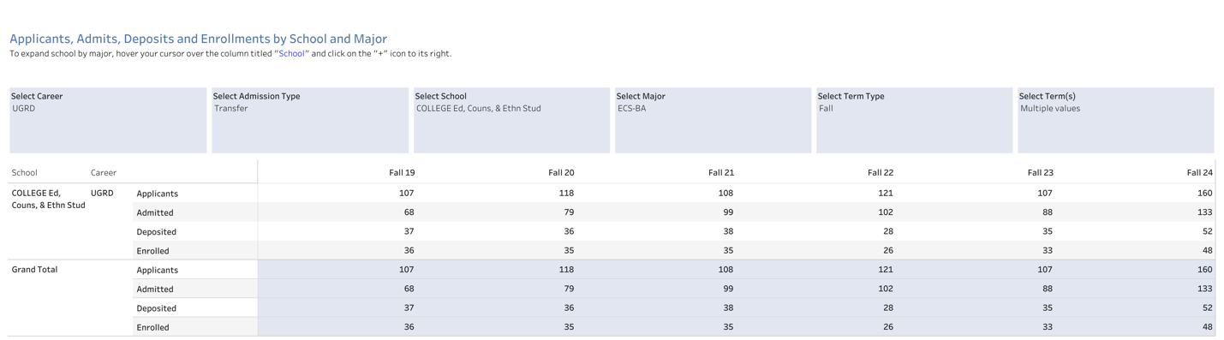

The ECS program has experienced an overall increase in applicants, with Fall applications rising from 449 in 2019 to 368 in 2024, including a notable jump from 269 in Fall 2023. Transfer applications also grew from 107 in Fall 2019 to 160 in Fall 2024, while spring transfer applications remained lower, fluctuating between 22 and 37 per term. Enrollment numbers have followed a similar trend, with first-time student enrollments gradually increasing and transfer student enrollments reaching 48 in Fall 2024. Spring 2025 saw the highest number of transfer applicants at 37, yet enrollments remained stronger in the fall. These trends highlight a growing interest in the program, particularly among transfer students in the fall semester.

Student/Alumni Perceptions of the Program

Regarding Advising
Over the years, students in the Early Childhood Studies (ECS) major have highlighted the strengths of academic advising, particularly in its responsiveness, knowledgeable faculty, and overall support. Many appreciated timely communication, frequent check-ins, and the willingness of advisors to help them navigate course selection, program requirements, and career pathways. Our students described the overall ECS advising as compassionate and encouraging, with some students noting that their advisors genuinely cared about their success beyond academics. Additionally, advisors were recognized for their ability to provide clear guidance on coursework, program expectations, and available job opportunities. Many students also valued their advisors’ expertise in early childhood education, which allowed them to receive well-informed recommendations tailored to their academic and professional goals. See Figure 5-25.
Figure 5-25. ECS Advising Satisfaction from Fall 18 to Fall 24
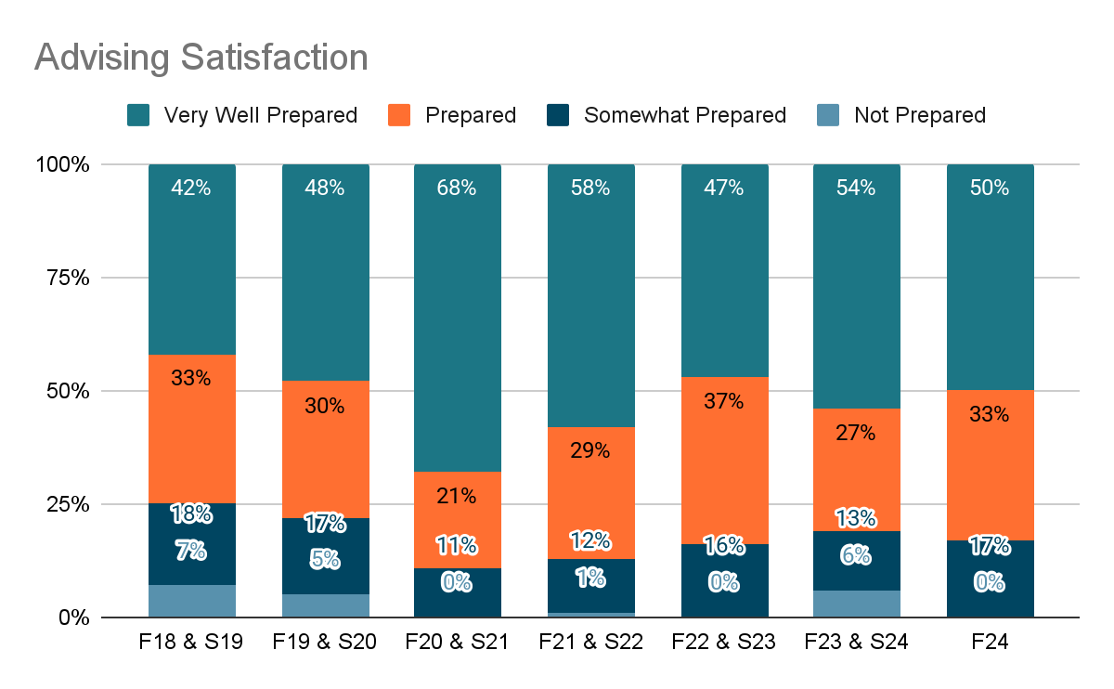
At the same time, we recognize that the frequent changes in assigned advisors have been a consistent concern among students. Over the years, we have tried different ways to establish a long-term advising assignment between faculty and students, including dividing students based on last names, concentrations, and transfer status. However, faculty leaves, the need to balance advising loads, and students changing their concentrations have all resulted in students working with different advisors. To address this, we have hired a full-time staff advisor primarily dedicated to working with first- and second-year students. Students transition to a faculty advisor based on their concentration as they advance. While this system aims to provide more stability, it is still unavoidable that students will work with different faculty advisors if they choose to change their concentration. We recognize this ongoing concern and hope the current system will alleviate some of these challenges while providing students better support throughout their academic journey.

Regarding Program Impact
Over the years, students in the Early Childhood Studies (ECS) major have consistently shared how the program has influenced their professional goals and career aspirations. Many have discovered a passion for working with children, families, and communities in various capacities, including teaching, social work, special education, school counseling, and advocacy. Guest speakers, fieldwork opportunities, and coursework have played a significant role in helping students refine their interests and gain confidence in their abilities. The program has also deepened students' understanding of inclusion, cultural diversity, play-based learning, and the importance of advocacy in early childhood education. Some students entered the program with a clear career path, while others discovered new possibilities through their coursework and experiences.
While most students felt well-prepared to accomplish their post-baccalaureate goals, some wished for more exposure to non-educational career paths within child development. In response to these needs, we have expanded our field placement sites, particularly in EDEC 347, allowing students to explore careers beyond teaching. Additionally, we offer CSU Fully Online courses tailored for students pursuing Child Life Specialist Certification, where they receive targeted support, including guidance on practicum and internship requirements, along with advising from a certified Child Life Specialist. Early courses such as EDEC 201 help students explore various career options by guiding them in interviewing professionals in fields such as speech therapy, child life specialization, behavioral analysis, and counseling. To further support students interested in non-educational career paths, faculty members with a strong developmental perspective serve as the advisors designated for students in the Community, Health, and Social Services for Children (CHSSC) concentration, providing targeted advising and career planning support.

Regarding Coursework
The coursework in the ECS major has been a defining strength, with students frequently highlighting the comprehensive and interconnected nature of their classes. Many have appreciated the emphasis on child development, learning theories, social justice, and hands-on field experiences. Students noted that courses provided a strong foundation in developmentally appropriate practices, assessment strategies, and working with diverse populations. They also valued the program’s commitment to student well-being, collaboration, and open communication with instructors. Over time, students have increasingly emphasized the importance of field placements, internship opportunities, and direct classroom experience in preparing them for their careers. Some suggested ECS should provide more explicit guidance on career pathways outside of teaching, more coursework on inclusion and behavioral management, and additional special education courses. As the program evolves, it remains dedicated to fostering a supportive learning environment that equips students with the knowledge and skills to make a meaningful impact in early childhood settings.

Post-Graduation Outcomes
Our Early Childhood Studies (ECS) graduates have been highly successful in pursuing further education and contributing to the field of serving children and their families. Using the graduating classes of 2018-2021 as an example, of the 361 students who received a B.A., 223 pursued additional education. Notably, 176 alumni continued their studies at four-year institutions, with 87% enrolling within two years of graduation and 96% within three years.
Figure 5-26. SSU Alumni Pursuing Further Education 2018-2021
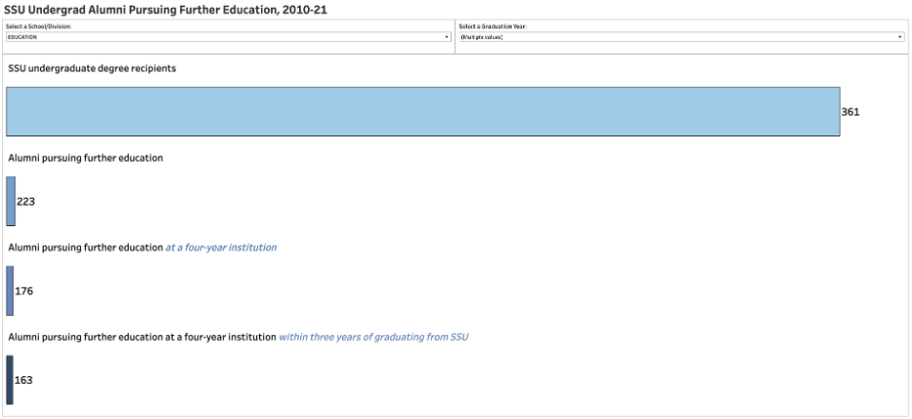
Figure 5-27. Years Between Graduation and Pursuing Further Study 2018-2021
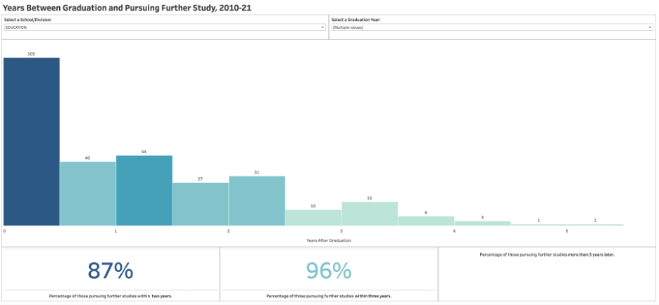

Many of these graduates have earned advanced degrees, including 57 Master’s degrees and 38 credentials, reflecting their commitment to professional growth. Our graduates have pursued diverse pathways in postgraduate education, including SSU’s Master’s program, Multiple Subject Credential programs, and specialized fields such as child life specialist, speech-language pathology, psychology, etc. These pursuits underscore the robust foundation provided by our program in preparing students for specialized and advanced roles.
Figure 5-28. Advanced Degree Earned by SSU Baccalaureate Alumni 2018-2021
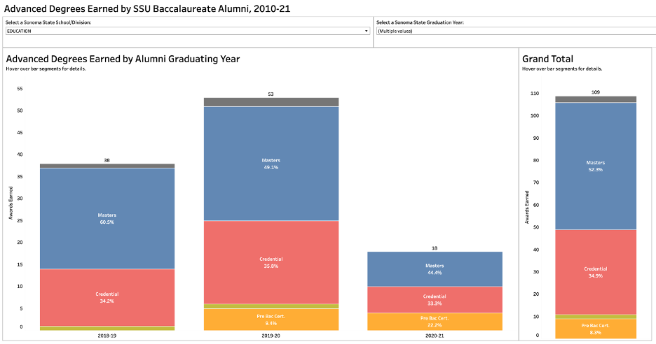

ECS graduates also significantly impact their professional lives, particularly in early childhood care, education, and community services. Examples of their contributions include:
- Early Intervention and Advocacy: Some of our graduates work for organizations such as the Early Learning Institute as Early Intervention Home Visitors or similar agencies that support families with young children who qualify for California’s Early Start services for developmental delays. Our graduates work for the Family Advocacy programs in Cotati/Rohnert Park.
- Community and Tribal Engagement: Graduates engage in tribal affiliative work with groups such as the Coast Miwok and Graton Rancheria Federation of Indians, demonstrating their commitment to serving diverse communities.
- Leadership and Administration: Alumni have taken on leadership roles, such as program directors at local preschools and positions within family advocacy programs, including the Los Angeles County WIC program.
- Early Childhood Education: Many are teaching in local preschools, including 4C’s, furthering the quality of early education in our region.
We support our students in achieving their goals during their time in the ECS program and after graduation. The goal is to ensure our students graduate with the skills, experiences, and support they need to excel in their chosen careers or further their education.
Our program offers four specialized concentrations tailored to students' career aspirations:
- Early Care and Education (ECE) prepares students for careers in early education settings, such as teaching in infant, toddler, and preschool classrooms or serving as administrators in early education programs. Practicum courses support eligibility for a California Child Development Permit and pathways to the PK-3 ECE Specialist Instruction Credential.
- Community, Health, and Social Services for Children (CHSSC): prepares students to work with children and adolescents in private and public programs. This concentration is perfect for students seeking certification as a child life specialist, enrolling in a graduate school for certification as a counselor, school psychologist, therapist, or social worker, or working at a public service agency.
- Elementary Pre-Credential (EPC): EPC is an interdisciplinary program that prepares students for entry into a Multiple Subject (elementary) credential program or an Education Specialist (special education) credential program. CSET requirements will be met through the coursework.
- Special Education Teaching (SET): an interdisciplinary program that prepares students for entry into a Multiple Subject (elementary) credential program or an Education Specialist (special education) credential program. CSET requirements will be met through the coursework.
Beyond these pathways, we actively support students’ career and academic preparations through targeted efforts:
- Targeted Advising and Mentorship: A professional advisor guides first-year and sophomore students through academic planning, ensuring they understand degree requirements and connecting them with campus resources. Junior and senior students receive personalized support from faculty advisors who align academic plans with career goals and encourage participation in developmental activities, such as internships and research. Faculty also assist with writing recommendation letters for graduate programs, scholarships, and job applications and advising students on advanced degree or credential program applications.
- Specialized Courses: Our curriculum incorporates specialized courses to prepare students to transition into their chosen careers or advanced study. We offer three child life courses for students pursuing Child Life Specialist Certification, and we have the course available for students on other CSU campuses through the CSU Fully Online system. Students in those courses receive targeted support, including guidance on practicum and internship requirements, with additional mentoring from a certified Child Life Specialist. Early courses, such as EDEC 201, guide students in career exploration, including interviewing professionals in fields they are interested in, such as speech therapy, child life specialization, behavioral analysis, or counseling. Field-based courses like EDEC 347 provide practical exposure to community agencies serving children and families. Other field-based classes, including EDEC 220, EDEC 290L, EDEC 291L, EDSP 432, and EDEC 437, allow students to deepen their understanding of child development and curriculum design through hands-on learning. Fieldwork courses give students great hands-on experience to build relationships with schools, teachers, and community organizations, often serving as pathways to employment. Many students seeking credentials work in these schools during their field placements, and those schools subsequently hire our students. EDEC 435 and EDEC 450 prepare students to work effectively with families and communities. Courses such as EDEC 492 and EDEC 483 guide students through researching graduate programs, drafting resumes and cover letters, and understanding application processes. EDEC 478 Senior Portfolio course provides students with tangible materials to showcase their skills and accomplishments that they can use for job applications or graduate school applications.
- Research Opportunities: We encourage students to engage in research projects to enhance their academic and professional preparation. Faculty-led initiatives, such as those conducted under the Koret Scholars program, have explored topics ranging from restorative practices in schools to the impact of reflective supervision on early childhood practitioners. These opportunities allow students to develop critical thinking and analytical skills, which are invaluable for those pursuing advanced degrees or research career

Section 6 Reflection and Plan of Action
This self-study process provided valuable insights into our program’s strengths and areas for growth since the last cycle of the program review. The findings highlight strong student retention rates, a commitment to social justice and equity in our pedagogies, and effective integration of experiential learning. However, they also reveal challenges in faculty workload, advising accessibility, field placement availability, and career preparation resources. This reflection outlines specific action steps categorized into program strengths, areas for improvement, potential collaborations, and future action plans we could implement.

Program Strengths/Growth since the Previous Review

Student Success & Retention
- Our program maintains high retention rates. For FTFYs, our retention rate reached 92.3% in Fall 2023, consistently surpassing university averages of 67.8%. For FTTs, retention rates consistently remain in the mid-to-high 80% to low 90% range.
- The student body continues to grow and diversify, with over 40% of students being first-generation and URM enrollment surpassing non-URM enrollment. Our commitment to diversifying our student body's race, culture, and linguistic orientation through more rigorous recruitment efforts reflects our inclusive values. This proactive approach demonstrates our commitment to creating a diverse and inclusive learning environment where every student feels valued and included.
- Students report outstanding satisfaction with advising, achieving a 95.5% satisfaction rate in AY 2023-2024. This data underscores the strength of our faculty-student partnerships, a source of pride for us all. The faculty’s dedication to providing tailored support services for their educational experience and career pathways is a testament to our shared commitment to student success.

Curriculum & Learning Experiences
- Our program has successfully introduced new concentrations, such as Elementary Pre-Credential and Special Education Teaching. These additions have significantly broadened students' career pathways in teaching, demonstrating our program's adaptability and commitment to student success.
- Our program's adoption of low-cost or free course materials makes coursework more accessible to students while maintaining the quality of our instructions.
- Classroom spaces in Stevenson Hall have been improved, providing an environment for active learning and hands-on engagement with learning materials.
- Our program integrates signature assignments and portfolios as one of the key assessment tools to measure students’ competency and overall curricular effectiveness across the department. Students in our major complete their senior portfolio when they take EDEC 478 in their last semester. Currently, EDEC 478 serves as a “mentoring course” to support their reflective portfolio development through a close partnership with their EDEC 478 instructors. Our analysis of portfolio entries reveals our students’ rich reflection on what they have learned about the ECS PLOs. This experience succinctly has significant ramifications outside the classroom, particularly regarding graduate school applications and job interviews. Keeping a smaller class size (12 students for one instructor) is critical for us to continue supporting individual students, especially those who struggle to make it to the finish line.

Faculty & Research Excellence
- Our faculty members are highly experienced and have expertise in literacy and language development, moral development, STEAM education, policy and advocacy in early care and education, infant mental health, family engagement, and early childhood teacher education.
- Our faculty engages in strong interdisciplinary collaboration, working alongside education, social work, and community organizations to enhance student learning and various career pathways.
- Our lecturers' depth and breadth of expertise and knowledge have contributed to the program's overall effectiveness. We are very proud of our close-knit partnership with them, as we all share values and philosophical beliefs aligned with the departmental mission statement.
- We have secured over $1 million in grants, a testament to our successful external funding efforts to support program development, course revisions, and student initiatives. This success provides a strong foundation for our future.
- Our program remains steadfast in its commitment to equity-focused and anti-racist foci. These values are embedded in our curricular development, research, and department initiatives, aligning with current educational priorities and enhancing the relevance of our program.

2. Areas for Improvement/Challenges

Student Support & Retention
- Second-year retention rates have declined, dropping from 77.4% in Fall 2019 to 64.3% in Fall 2022, which mirrors the broader trends across the CSU system.
- Graduation rates have decreased, especially among transfer students, who often struggle to complete their degrees within two years. We need to engage in more robust retention efforts tailored to needs and challenges unique to transfers.
- Our department still has limited resources and staffing in key areas that provide career support and experiential learning opportunities for students. We need to expand our career preparation resources, such as career fairs, workshops, and job placement support tailored to early childhood careers.

Advising & Academic Support
- Students’ access to advising has been inconsistent, partly because it is confusing when advisors change due to faculty leaves or workload shifts. To help establish continuity in advising assignments, we implemented a new advising system based on students' concentrations. We hope the current system will alleviate some of these challenges while providing students with a high-quality advising/mentoring experience until graduation.
- Students face challenges accessing academic support, such as tutoring resources at the Learning and Academic Resource Center (LARC). This issue is partly due to underutilization, which results from insufficient awareness of the variety of academic support services and how/when to access them.
- Faculty advising loads have been relatively higher than comparable programs, straining faculty time to reach every student in our department, especially less easy-to-reach student populations.

Curriculum & Fieldwork
- Securing high-quality field placements, particularly in infant/toddler settings and specialized educational environments, remains challenging. Therefore, further partnerships with local infant/toddler programs are necessary.
- Recent curriculum updates (EDEC 238, 290, 290L, 291, 291L) must further align with the ECS POLs. It is also essential to address initiatives in the Early Care and Education field across the state, such as the full implementation of DRDP 2025 (Desired Results Developmental Profile) in the summer of 2026, CLASS 2.0 (the Classroom Assessment Scoring System) and CTC’s revisions on the Child Development Permit structure and its requirements.
- Expand students' exposure to non-teaching career paths. For instance, we must strengthen career advising, partnerships with local agencies and practitioners, and resources for those pursuing careers in child advocacy, child life specialists, social work, speech-language pathology, and counseling.

Faculty Workload & Institutional Support
- Limited tenure-track hiring has restricted the department’s capacity to expand programs, enhance advising support, maintain currency in new initiatives across the state and the nation, and effectively manage faculty workloads. Expanding tenure-track faculty positions is necessary to maintain consistency in teaching and advising support and continue benefiting from our lecturers' expertise.
- Key departmental leadership roles, including the Department Chair, the field experience coordinator, and the assessment coordinator, need sufficient assigned time to fulfill their responsibilities effectively. Furthermore, service commitments need to be more evenly distributed, as some faculty carry heavier workloads in curriculum development, community engagement, and field placements under the current system.

3. Potential Collaborations
We could strategically strengthen our program through the following partnership initiatives:
- We need to develop more robust partnerships with student service programs across the SSU campus. For instance, partnering with the Career Center would allow us to develop ECS-specific career fairs, mentorship programs, and networking events, enhancing students' career readiness. Similarly, collaborating with the LARC and library would enable us to establish ECS-specific tutoring and academic support workshops, ensuring targeted academic assistance.
- More robust recruitment/retention efforts can be made by building stronger partnerships with local community colleges, high schools, ECS graduates, and early care and education agencies. It would entail improving information materials on the transfer application process and course articulation.
- More robust partnerships with local school districts, early care and education programs, and child advocacy organizations within the county for career pipelines and more vigorous experiential learning, especially for non-teaching careers.
- Engaging with interdisciplinary research teams in education, psychology, and social work to increase faculty research funding opportunities and enhance collaboration across disciplines.

4. Next Steps/Action Plans
SSU's looming enrollment and budget deficit will continue for several years. Nevertheless, we must continue making high-impact contributions to our students and the Early Childhood communities in Sonoma County and beyond, and we are committed to doing so. To be able to maintain our capacity as one of the robust departments at SSU, we propose the following action plans by leveraging both existing and additional resources strategically:

Action Plans with Existing Resources
- To further increase recruitment/retention/graduation rates
  - Initiate peer mentoring initiatives to provide additional student academic and career support.
  - Expand the first-year and second-year learning community courses to continue our retention efforts, especially for at-risk students.
  - Invest in flexible course scheduling options, such as hybrid and evening courses, to accommodate non-traditional and working students.
  - Refine advising delivery and advising/registration-related communication strategies to ensure that every student in our program has continuous access to effective and accurate advising until graduation. Removing barriers and fostering a sense of belonging are key.
- To further ensure faculty success in our department
  - Advocate for a better faculty workload compensation and distribution, ensuring that service commitments and our assigned time are more equitable across curricular development, advising, and field placements.
  - We need to keep office space for adjunct faculty to ensure they can effectively meet with and support students.
  - Advocate for additional administrative staff to support advising, recruitment/retention, and field placement coordination, alleviating faculty workload.

Actions Requiring Additional Resources
- As our student body has diversified over the years, so have the needs and challenges that modern-age, post-pandemic college students face. Thus, faculty members in our department face unique and significant challenges, such as advising coupled with mentoring and well-being checking-in, significant workload attached to the departmental assessment work for the WASC accreditation and overall curricular improvement, as well as expansion of experiential learning to address diverse career interests, to name a few. To address those newly emerging challenges since the previous program review, it is highly critical for us to build stronger partnerships with the leaders in the College of Education, Counseling, and Ethnic Studies and at the University. In particular, we ask for more up-to-date, accurate, and equitable recognition of the intensity of the assessment coordination and field experience coordination in our department, which needs to be reflected in the fairer compensation.
- We will continue our advocacy to hire additional tenure-track faculty to ensure the program's short—and long-term success and its high impact on local early care and education communities.
- Faculty need funding and support to ensure their capacity to maintain scholarly currency. Funding for faculty development, including research grants, conferences, and specialized training, is necessary.
- We need funding to establish more robust community partnerships. This funding may enable faculty members to visit local schools and early care and education agencies to learn about their practices. This will also strengthen our relationships with the community and deepen our understanding of partner sites, enhancing field experience opportunities for our students.
- Continue our advocacy effort to remove barriers for current and future students in our department and beyond. It would entail stronger partnerships with student support services and other stakeholders across the campus. For instance, the following are a few of the various items that we want to advocate for:
- Enhance financial aid and emergency grant access to students to reduce barriers affecting retention and graduation rates.
- Develop recruitment initiatives to attract more male students and diversify the student body.
- Expand CAPS funding to provide better mental health services and reduce long wait times and session limits.

